Capabilities of existing USA civilian radars to detect plumes

Part I

D. Zrnic, V. Melnikov, and R. J. Doviak

This interim report was prepared for the Oak Ridge National Laboratory. It contains a fairly detailed comparison of detection capabilities of the civilian USA radars: the WSR-88D, the TDWR, and experimental NOAA/NSSL X-band dual polarization radar. Suggestions are given on how to increase detection within the constraints of existing volume scan strategies.

**Capabilities of existing USA civilian radars to detect plumes**

D. Zrnic, V. Melnikov, and R. J. Doviak

**Prologue**

Plumes from fires, explosions, volcanic ashes, or other sources may indicate various hazards. For examples volcanic eruption can be remotely spotted by the lofted ashes which in turn are known to damage jet engines at distances far from the source. Progression of fires can also be tracked by radar. Inadvertent explosions at industrial complexes can create toxic plumes which drift with prevailing winds and present health risk. Similar potential threat could be posed by ground explosion purposely set off by groups engaged in subversive activities.

Plumes of various origins have been detected and tracked by radar and it is the purpose of this report to quantify the detection capability of civilian radar in the USA. Detection capabilities in standard operational modes of four networks are examined. A brief discourse about dependence on wavelength is presented. A detailed evaluation of the National Weather Services’ WSR-88D and Federal Aviation Administration’s TDWR are presented. The characteristics of the NSSL’s 3 cm wavelength mobile radar are exposed. Because of its mobility and quick set up the radar is suitable for agile field experiments. Recommendations about improvements that can be built on the existing operational modes of the WSR-88D and TDWR are given.

Most of this work was supported by the DOE.

**1. Introduction**

The sensitivities and detection capabilities of the following US weather surveillance radars are examined.

1). The FAA’s Airport Surveillance Radar (ASR-9/11) for detection and tracking of aircraft on approach and departure around airports (Fig. 1a and 1b). When precipitation is present the radar uses circular polarization and receives separately the left and right components. Both components carry returns from aircraft but only one component carries most of the precipitation returns. Thus the component without precipitation is used for tracking aircraft. The component with precipitation provides weather information. The radar operates in the 10-cm wavelength band.

2). The FAA’s Terminal Doppler Weather Radar (TDWR) for detection of low altitude wind shear along aircraft’s approach and departure corridors (Fig. 1c); operates in the 5-cm band.

3). The NWS’s Weather Surveillance Radar-1988 Doppler (WSR-88D) for detection and warning of weather hazards, measurements of precipitation fall rates, etc. (Fig. 1d); operates in the 10-cm band.

4). The Air Route Surveillance Radar (the Common ARSR and the ARSR-4) for long range surveillance of aircraft (Fig. 1f); operates in the 20-cm band. The ARSR-4 radars are deployed mainly along the USA coast, and USA Islands (Healy et al., 1997). A secondary



Fig. 1a) ASR-9s, the ones with weather processors are indicated with a star.

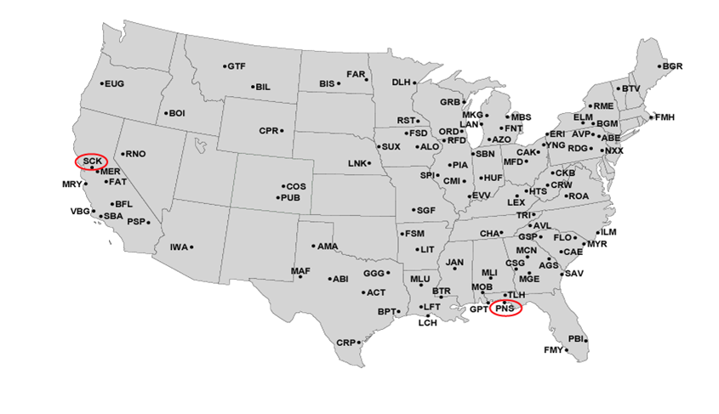

Fig. 1b) ASR-11s



Fig. 1c) Terminal Doppler Weather Radars (TDWR).

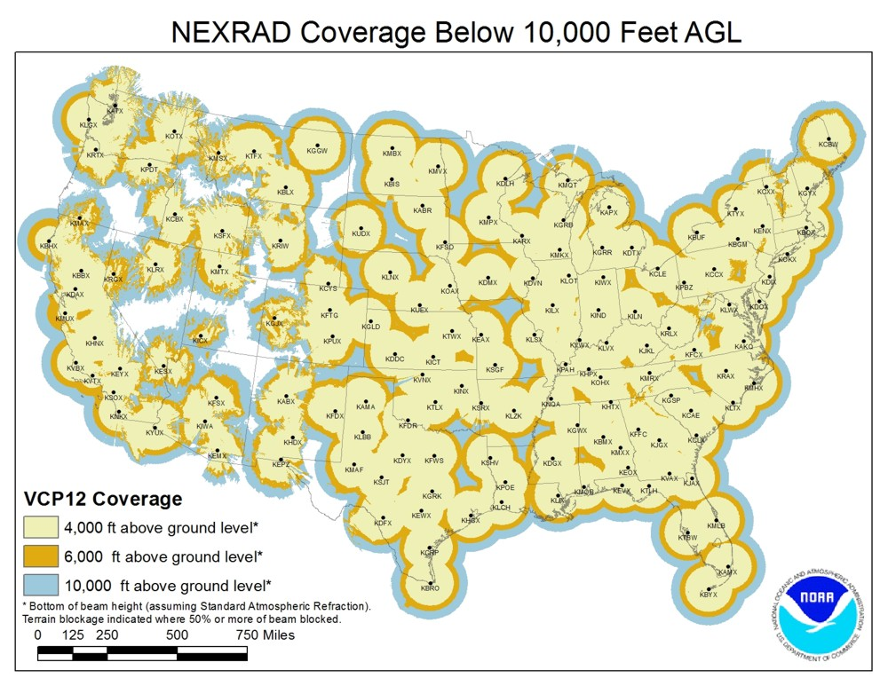

Fig. 1d) The WSR-88D network of weather radars. Coverage up to 4000, 6000, and 10000 ft above ground level is indicated.

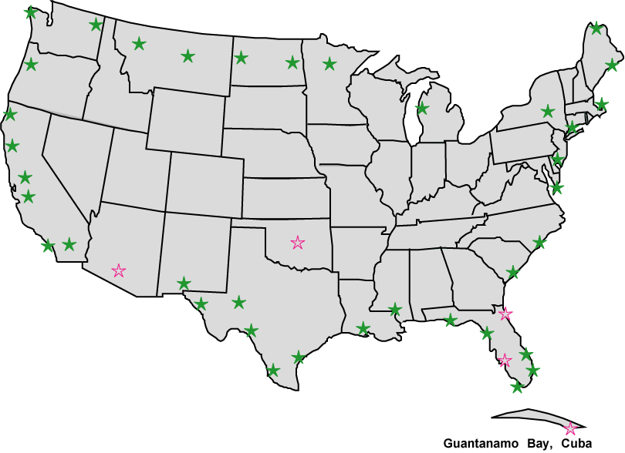

Fig. 1f) Air Route Surveillance Radars (ARSR-4s).

mission of the ARSRs is to detect and report weather within the coverage area. These radars are operated and maintained by the FAA, but serve both Homeland Security Functions (e.g., tracking aircraft crossing the USA/Mexican border), and Air Force defense goals.

The characteristics of the radars are succinctly compared in the Table 1 which is extracted from Doviak (2017). The listed values are, wherever possible, based on measurements.

Table 1: Present capabilities for weather and aircraft surveillance[[1]](#footnote-1)

|  |  |  |  |  |
| --- | --- | --- | --- | --- |
| Parameters | FAA’s  TDWR | FAA’s  ASR-9/11 | FAA’s  ARSR-4 | NOAA’s  WSR-88D |
| Frequency *F*c (GHz) (1) | 5.55.65 | 2.72.9 | 1.21.4  *F*c, *Fc+*83 | 2.7 3.0 |
| Peak power *P*­t (MW) (2) | 0.250 | 1.1 | 6.4 | 0.475 |
| Pulse width *τ* (μs) | 1.1 | 1.0 | 1 | 1.57 and 4.71 |
| 2-way beamwidth(3) *θ*6(o) | 0.55 | 1.4 (Az)  5 (El) | 1.4 (Az)  2 (El. rec.) | 0.950.85(4) |
| Antenna Gain (dB)(5) | 50 | 34 | 35(T.); 40(R) | 45.3646.32 |
| Range resol.;*r*6 (6a) (m)  Elevation resol. ΔE(6b):  Azimuth resol. ΔA(6c): | 150  0.55o  1.0o | 115  1.5o | 115  0.12o  1.9o | 235  1.0o  1.1o |
| Coverage (7); *r* (km) Z/ac  *r* (km) for *v*, σv  Elevation span (o)(8)  Max Height (km) | 0.25 111  0.25 111  0.2560  6.1 | 0.9111  NAp  030  7.3 | 9 460  NAp  -730  30 | 2460  2300  0.520  20 |
| Sys. Noise Temp. Tsy (K) | NAv | NAv | NAv | 730(9) |
| Detection(10a) Z10(dBZ): RCS(m2) at 460 km  w/o precip(10b):  with precip(10c,10d): | -25.6  0.6  NAp | -6  35  NAv | 0  0.14  0.30(10d) | -21  -27  0.150.12  0.230.18(10d) |
| Polarization | Linear H | Cir. or Lin | Cir. or Lin | Dual linear H, V |
| Polarization data mode(11)  On-axis copolar/Xpol (dB)  Patt. Match: at -20 dB(12) | NAp  NAp  NAp | NAp  NAp  NAp | NAp  >17  NAp | SHV  >45 dB  < 0.5 dB |
| Sidelobe levels (two-way; dB)(13) | -54;1st  -80; *θ’* > 5o | <-48 | EL: < -60;  AZ: < -70 | -64 1st @ 2o  <-100; *θ’* > 10o |
| Volume update rate(14) (s) | 60 lower  3 min. upper | 4.8 | 12 | 5 min. |

The numerals in parentheses refer to annotations listed in Appendix A where explanations are given for the entries. “NAp”: Non Applicable; “NAv”: Not Available at this time.

**2. Detection capability**

Pertinent for tracking plumes is the detection capability listed in the Table 1. Comparisons of the reflectivity factor *Z*10 at 10 km range for which the signal power from a single pulse equals the noise power (i.e., the SNR=0 dB) are made. From the Table 1 it is clear that the two weather radars, TDWR and WSR-88D have the best detection capabilities and that these are very comparable. The TDWR’s is -26.5 dBZ and the WSR-88D’s is between -21 and -27 dBZ with the average of -24 dBZ. The assumption behind these values is that the radar resolution volume if uniformly filled with scatterers (smoke particles or other plume constituents) and the matched filter is used in the receiver.

The values of detection capability at 10 km range are obtained from the estimates provided by the Radar Operation Center (Fig. 2) which are referred to the 50 km range. The detection capability at 10 km is better by 14 dB corresponding to the ratio of ranges squared (50/10)2 so that the mean *Z*10 becomes – 24 dBZ. Results for two pulse lengths are plotted in Fig. 2. One is 1.57 μs the other is 4.71 μs. The short pulse is used in routine surveillance of storms whereas the long pulse is used in the clear air mode. The increase in detection capability with the long pulse is caused by two factors. One is the assumption that scatterers fill the resolution volume therefore the power return from the longer pulse is 4.71/1.57 times larger than the return from the short pulse. Two, the filter matched to the longer pulse reduces the noise compared to the shorter pulse by the same factor 4.71/1/57. Therefore the improvement is 20log(4.17/1/57) = 9.5 dB which agrees with the average improvement seen in Fig. 2.

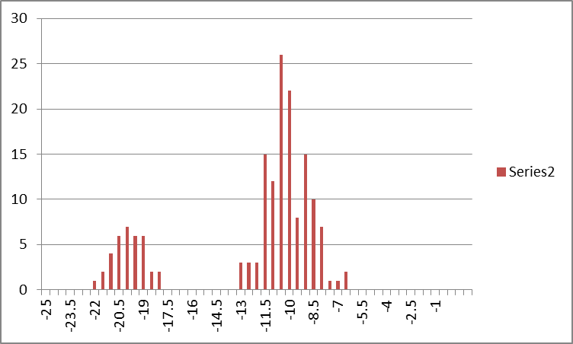

Detection Capability (dBZ at 50 km)

Radars

**Specification**

**Meets or Exceeds Specification**

**Out of Specification**

**Clear Air Mode**

**Including Long Pulse**

+/- 1 dB

Fig. 2 Histogram of the detection capability of the WSR-88D radars. The number of radars is listed on the ordinate (Figure courtesy of R. Ice, Radar Operation Center).

An explanation of the technical details about the WSR-88D is included as Appendix B. It is a reprint of the chapter by Zrnic (2012) in an open access book by InTech and describes the status prior to the upgrade to dual polarization. The detection capability listed in that chapter is

-8 dBZ at 50 km and represents the specification. Nonetheless, the actual performance exceeded by about 5 dB the specification. With the upgrade to dual polarization the detection performance per channel dropped by 3 dB because the transmitted power per channel is half of the total power whereas the noise power remains unchanged. The histogram in Fig. 2 is for the single channel detection capability. Clearly, most radars exceed the specification and in the sequel we will take the representative value of -24 dBZ as the detection capability for the short pulse at 10 km and

-34 dBZ as the detection capability for the long pulse.

**3. Wavelength dependence of the Detection Capability**

The weather radar equation (Doviak and Zrnic 2006, eq. 4.34) can be used to compare the detection capabilities of radars with different wavelengths. The assumption is that the radar resolution volume is uniformly filled with Rayleigh scatterers which would be the case for most plumes once the large debris has settled down. For simplicity we write the equation then isolate the pertinent terms to which the returned power is proportional while the rest of the terms are lumped in the constant *C*.

 (1a)

or

 (1b)

In (1a) the received power is on the left side, the transmitted power is *Pt*, the antenna gain is *g, gs* is a calibration factor, *θ*1 is the 3 dB width of the one way antenna power pattern. The speed of light is *c,* the pulse width is *τ,* the dielectric factor for water is *Kw* and *Ze* is the equivalent reflectivity factor. The variables in the denominator are, wavelength *λ,* range *r*0, one way propagation loss *l*, and the loss by the matched filter is *lr.*  We consider the same range (say 10 km) and the same equivalent reflectivity factor and the same beamwidth (lateral resolution) as well as range resolution. Thus the return power *P* scales with the transmitted power, gain, beamwidth, and wavelength as

. (2)

To proceed further we write the gain in terms of effective collection area of the antenna (Doviak and Zrnic 2006, eq. 3.21). Moreover, *Ae* is proportional to the antenna diameter *D* squared. And the beamwidth *θ1* is proportional to the ratio *λ* /*D*. Including these substitutions into (2) produces

. (3)

This equation succinctly presents the practical essence of wavelength dependence. The product of transmitted power and diameter squared is commonly referred to as “power aperture product” and in practice is constrained. At shorter wavelength the peak power is smaller to prevent arcing in waveguides. For a fair comparison assume that the beamwidth (lateral resolution) is the same. Then the dependence is inversely proportional to the square of wavelength and square of one way loss.

Table 2 summarizes the parameters and detection capabilities of three weather surveillance radars. Note that two pulse lengths are included in the WSR-88D row because these

Table 2. Characteristics of three radar types.

|  |  |  |  |  |  |  |  |  |  |  |
| --- | --- | --- | --- | --- | --- | --- | --- | --- | --- | --- |
| Radar | *λ*  cm | *Pt*  kW | *θ*1  deg | *Da*  m | *g*  dB | *τ*  *μ*s | Noise  dBm | *2La*  dB | *Z*10  dBZ | *r*0  km |
| WSR-88D1 | 10.7 | 2371 | 1 | 8.4 | 46 | 1.572 4.71 | -114 | 0.8 | -24  -34 | 10 |
| TDWR | 5.45 | 250 | 1 | 8.4 | 50 | 1.1 |  | 1 | -25.6 | 10 |
| XERES1 | 3.2 | 1001 | 1 | 2.5 | 46 | 1 | -112 | 1.2 | -19.7 | 10 |

1) Both the WSR-88D and XERES have dual polarization hence the powers and the detection capabilities are per channel.

2) The pulse widths are measured between the -6 dB points with respect to the pulse peak.

two are available. The XERES (X-band Experimental Radar for Environmental Studies) is the NSSL’s dual polarization mobile radar (Fig. 3). The peak power is about 250 kW which is a

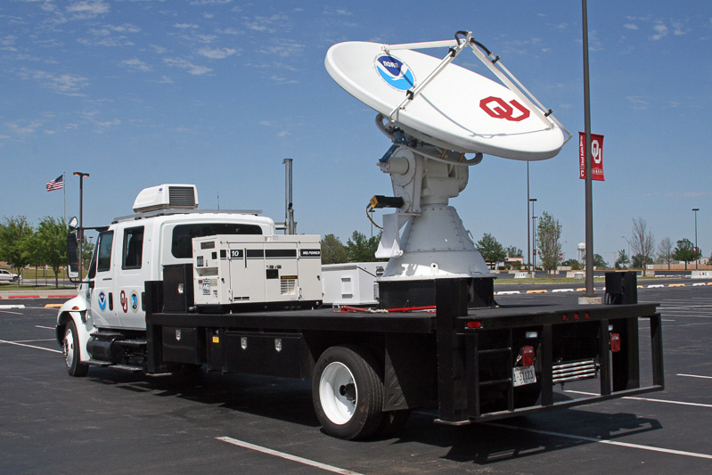

Fig. 3 The X-band Experimental Radar for Environmental Studies is a mobile 3 cm wavelength radar. The radar was made by NOAA/NSSL.

practical upper limit at a reasonable cost (about $ 200 k). Its detection capability has been

obtained from computations but has not been measured. We plan to make the measurements in the Fall 2017 after the radar comes back from the scheduled field experiments. Quick computation indicates that the wavelength dependence increases the detection capability by 10.5 dB compared to the WSR-88D. The 1 μs pulse length on the XERES compared to the 1.57 μs on the WSR-88D causes a -3.1 dB reduction, the noise level further reduces detection ( -2 dB), and the lower power causes another -3.7 dB reduction. With these parameters, the detection capability would be about 1.7 dB better than that of the WSR-88D. However, there are significant losses between the transmitter and the antenna. These are in the rotary joints and the circulators. Furthermore, the WSR-88D’s receiver is mounted on the antenna whereas on the XERES it is not. Hence there are no dual rotary joints on the WSR-88D. Our historical estimate is that the total power loss (two-way) between the transmitter and antenna on the XERES is about 6 dB. With that guess we estimate its *Z*10 to be about -19.7 dBZ. The XERES radar can operate with four pulse lengths, 0.25, 0.5, 1, and 2 μs.

The largest deficiency of short wavelengths is attenuation through precipitation. The specific attenuation multiplied by 2 to account for two-way propagation is plotted as function of reflectivity in Fig. 4 (see Zrnic 2017). The attenuations in Fig. 4 are for horizontal and vertical polarizations (except at the 11 cm wavelength for which it is at H polarization). For relatively modest reflectivity factor of 45 dBZ (rain rate of about 25 mm h-1 or 1“ h-1) the attenuation at the 3 cm wavelength is 1 dB km-1. If such conditions persist along a radial for 20 or more km, the 3 cm wavelength radar would likely miss detecting distant plumes.



Fig. 4 Specific attenuations multiplied by 2 versus *Zh* in rain at temperature 20o C. The wavelengths are indicated. From Zrnic 2016.

**4. Radar characteristics**

The critical features of the WSR-88D are presented in section 4.1 having in mind that the goal is to detect weakly reflecting plumes. NSSL personnel are very familiar with that radar because NSSL owns it and also because the personnel have contributed to several developments on the network. Brief introduction to the TDWR is also given in section 4.1. The volume coverage patterns of both radars are in section 4.2 and the detection capabilities with current operational processing are quantified. Section 4.3 quantifies enhancement in detectability if more sophisticated processing were to be applied.

**4.1** *Basic Radar*

Succinct description of the WSR-88D can be found in Zrnic (2012) included here for convenience as appendix B. The dual polarization upgrade to the WSR-88D was accomplished by mid-2013. The polarimetric mode of this upgrade is often referred to as Simultaneous Horizontal and Vertical (SHV) polarization (Doviak and Zrnic 1998). It is accomplished by splitting the transmitted power into an H and V component which are fed to the antenna via waveguides (Fig. 5). At the antenna the two components are combined so that the transmitted polarization is elliptical but with equal H and V amplitudes. The returned wave to the antenna is also elliptically polarized but due to reflection and propagation the two components differ in amplitude and phase. A comparison of these two components reveals characteristics of the scatterers that can’t be obtained with the single polarization radar. We defer discussion of polarization and polarimetric properties of plumes to the subsequent report. It is important here to note that the WSR-88D looks like two radars in which the transmitted power is one half of what it was in the single polarization variant. Other than that and the antenna everything else is symmetric.

Transmitter

Receiver V

V

H

Power splitter

Receiver H

Dual pol SNR ~P/(2N)

Single pol SNR ~P/N

Fig. 5 Simplified block diagram of the dual polarization implementation on the WSR-88D.

Very pertinent to plume detection is a) what can be achieved on the existing estimates of the radar variables, b) what can be achieved with minimal effort on the existing time series data, and c) what are the possibilities for the future. To illuminate these issues quick review follows on how the data are processed and stored. We consider the reflectivity factor *Z* which is obtained from the received power, the mean Doppler velocity *v*, and the Doppler spectrum width *σv*. All three and the other polarimetric variables are estimated from a sequence of *M* returns from *M* transmitted pulses that are collected while the antenna is rotating. This sequence of pulses is referred to as Inphase and Quadrature phase (I,Q) data, and in the jargon of NWS these are Level 1 data. The number of pulses, antenna rotation rate, the pulse repetition time *Ts*, the elevation sequence, and few other parameters are specified for each Volume Coverage Pattern (VCP). There are several VCPs and depending on the weather situation, operators chose the appropriate patterns. To facilitate discussion we present a block diagram of the operation and flow of radar data in Fig. 6.

Digital IF Receiver

and

Matched Filter

Signal Processor:

Clutter filter

Pol variables

Thresholds

Pre Processor

COMPUTER

Product Generation

Level 3

Products

Display

Users

CONTROL

Timing

Data flow

Control

AT THE RADAR

(Radar Data Acquisition)

CAN BE ANYWHERE

(Radar Product Generator)

Transmitter

Level 2

Moments &

Polarimetric Variables

Level 1:

I,Q time series

Fig. 6 Block diagram of the signal path from the Digital Receiver up to product displays.

The input in Fig. 6 consists of two data streams at the intermediate frequency (IF which was down converted from the radio frequency RF). One stream represents the horizontal component the other the vertical. These data are filtered in the Digital receiver and converted to baseband I,Q signals (Level 1). Provisions exist to record the Level 1 data at each radar site which is to the left of the dashed line (Fig 6). To record Level 1 a dedicated PC and high capacity storage are needed. Radar Operation Center (ROC) has few such hardware and can install these at any of the WSR-88D sites. The recoding is continuous and overwrites on itself after it fills the storage. The length of time that can be stored depends on the VCP and can be about thirty days.

*Recommendation* 1): If an experiment is planned for detection of plums, the nearest WSR-88D should be equipped with the time series recorder.

Radar estimates of spectral moments (reflectivity, mean Doppler velocity, and Doppler spectrum width) are computed in the Signal Processor and are transferred to the Radar Product Generator (RPG), a computer located at the Local Forecast Office. A very important free parameter at the disposition of the operators is the SNR threshold. Its smallest value is -20 dB and can be independently set for each radar variable. The default values of the threshold are 1 dB for reflectivity and 2 dB for velocity; the operators typically use these thresholds. Only the values of radar variables above the thresholds are passed to the RPG for further processing and recording.

*Recommendation* 2):If detection of plumes is attempted on level 2 data then the thresholds should be lowered possibly down to -10 dB. Our experience is that lowering the threshold to -7 dB and using speckle removal techniques can recover a significant amount of weak signals (Melnikov and Schlatter 2011). Although change of the threshold is trivial, the coordination among agencies (FAA, NOAA, DOD, and other) on how and when to do this may involve compromises that would need to be worked out.

A rudimentary description of the TDWR is presented next. The characteristics are listed in Table 1 hence are not repeated. The radar has single polarization and is situated near major airports. Its Level 2 data are also passed to the NWS for real time analysis as well as recording. Because the detection capability in regular mode is at par or better than the WSR-88Ds (other than in the long pulse mode) it should be an essential part of the plume detection arsenal. It is possible to record time series data similarly as on the WSR-88D. We have not yet investigated the logistics behind such recording.

*Recommendation* 3: Determine the procedure that one needs to go through to record the time series data and the availability of storage devices.

**4.2** *Volume Coverage Patterns* (VCPs)

The VCPs of the WSR-88D and the TDWR are briefly reviewed here.

WSR-88D VCPs: There are several VCPs available to the operators and two operating modes: one is the Clear air mode and the other is storm surveillance mode. Common to most of the VCPs are the lowest five elevations (Fig. 7).

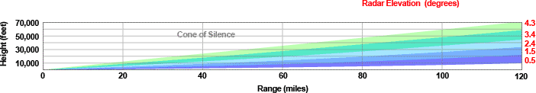

Fig. 7 The lowest elevations used in most VCPs on the WSR-88D

The clear air mode has two VCPs: VCP-31 which uses the long pulse and VCP- 32 which has the short pulse. The parameters of the VCP 31 are listed in the Table 1.

Table 3. VCP-31 (long pulse) characteristics.

|  |  |  |  |  |  |
| --- | --- | --- | --- | --- | --- |
| **Scan** | | | | | |
| **Angle (°)** | **AZ Rate (°/sec)** | **Period (sec)** | **WF Type** | **PRF No.** | **# Pulses** |
| **0.5** | **5.039** | **71.83** | **CS** | **1** | **63** |
| **0.5** | **5.039** | **71.52** | **CD** | **2** | **87** |
| **1.50** | **5.040** | **71.82** | **CS** | **1** | **63** |
| **1.50** | **5.062** | **71.52** | **CD** | **2** | **87** |
| **2.50** | **5.041** | **71.81** | **CS** | **1** | **63** |
| **2.50** | **5.062** | **71.50** | **CD** | **2** | **87** |
| **3.50** | **5.063** | **71.49** | **CDX** | **2** | **87** |
| **4.50** | **5.065** | **71.47** | **CDX** | **2** | **87** |

At the three lowest elevations the radar scans twice each elevation. One scan (continuous scan CS) is for measuring reflectivity. The PRF for this scan is 322 Hz corresponding to an unambiguous range of 467 km. At that distance the beam center is 17 km above ground; because heights of most storms are lower the beam would be free of range ambiguities. The PRF for the Continuous Doppler scan is 446 Hz and the unambiguous range is 336 km. This PRF is also used at the last two elevations.

The VCP-32 (Table 4) is the second VCP for the clear air mode. It has the same

Table 4. VCP-32 (short pulse) characteristics.

|  |  |  |  |  |  |  |  |  |  |  |
| --- | --- | --- | --- | --- | --- | --- | --- | --- | --- | --- |
| **Scan** | | |  | **Surveillance** | |  | **Doppler PRF No.** | | | |
| **Angle (°)** | **AZ Rate Period (°/sec) (sec)** | | **WF**  **Type** | **PRF**  **No.** | **# Pulses** | **4**  **#Pulse** | **5**  **#Pulse** | **6**  **#Pulse** | **7**  **#Pulse** | **8**  **#Pulse** |
| **0.5** | **4.961 72.97** | | **CS** | **1** | **64** | **--** | **--** | **--** | **--** | **--** |
| **0.5** | **4.544 79.66** | | **CD** | **--** | **--** | **188** | **220** | **238** | **256** | **278** |
| **1.50** | **4.961** | **72.96** | **CS** | **1** | **64** | **--** | **--** | **--** | **--** | **--** |
| **1.50** | **4.544 79.66** | | **CD** | **--** | **--** | **188** | **220** | **238** | **256** | **278** |
| **2.50** | **4.060** | **89.15** | **B** | **2** | **11** | **188** | **220** | **238** | **256** | **278** |
| **3.50** | **4.061** | **89.13** | **B** | **2** | **11** | **188** | **220** | **238** | **256** | **278** |
| **4.50** | **4.063** | **89.10** | **B** | **2** | **11** | **188** | **220** | **238** | **256** | **278** |

elevations, the pulse is short, the CS has the same PRF of 322 Hz, but the CD scans have variables PRF, and the default PRF = 220 Hz is underlined. At 2.5, 3.5 and 4.5 deg elevation the batch sequence is transmitted. It consists of 11 pulses at a PRF of 446 Hz followed by 220 pulses at the PRF of 1014 Hz. The time to accomplish a volume scan for VCP-31 of VCP-32 is about 10 min.

Several VCPs exist for storm observations and the NWS intends to consolidate these (see reference NWS 2017) into a much smaller number. The new VCPs will be based on the current VCP-212 which is the same as VCP-12 except in the CD scan phase coding is used to separate returns that are overlaid in range (Sachidananda et al. 1998). Therefore we list the VCP-12 as typical for storm surveillance. Important for plume observations are the lowest elevation angles which in the VCP-12 are 0.5, 0.9 and 1.3 deg. The beams from the consecutive low elevations overlap because the beamwidth is 1 deg. Thus, there are no gaps in the lowest levels of vertical coverage. At these elevations the PRFs are the same as in the VCP-32 and the main difference is in the speed of volume coverage which is faster in the VCP-12. Therefore the number of pulses *M* used to obtain the moments is smaller.

Table 5. VCP-12.

|  |  |  |  |  |  |  |  |  |  |
| --- | --- | --- | --- | --- | --- | --- | --- | --- | --- |
| **Scan** | |  | **Surveillance** | |  | **Doppler PRF No.** | | | |
| **Angle (°)** | **AZ Rate Period (°/sec) (sec)** | **WF**  **Type** | **PRF**  **No.** | **# Pulses** | **4**  **#Pulse** | **5**  **#Pulse** | **6**  **#Pulse** | **7**  **#Pulse** | **8**  **#Pulse** |
| **0.5** | **21.150 17.02** | **CS** | **1** | **15** | **--** | **--** | **--** | **--** | **--** |
| **0.5** | **25.000 14.40** | **CD** | **--** | **--** | **34** | **40** | **43** | **46** | **50** |
| **0.9** | **21.150 17.02** | **CS** | **1** | **15** | **--** | **--** | **--** | **--** | **--** |
| **0.9** | **25.000 14.40** | **CD** | **--** | **--** | **34** | **40** | **43** | **46** | **50** |
| **1.3** | **21.150 17.02** | **CS** | **1** | **15** | **--** | **--** | **--** | **--** | **--** |
| **1.3** | **25.000 14.40** | **CD** | **--** | **--** | **34** | **40** | **43** | **46** | **50** |
| **1.8** | **26.640 14.61** | **B** | **1** | **3** | **25** | **29** | **32** | **34** | **37** |
| **2.4** | **26.400 13.64** | **B** | **2** | **3** | **25** | **30** | **32** | **35** | **38** |
| **3.1** | **26.400 13.64** | **B** | **2** | **3** | **25** | **30** | **32** | **35** | **38** |
| **4.0** | **26.400 13.64** | **B** | **2** | **3** | **25** | **30** | **32** | **35** | **38** |
| **5.1** | **28.010 12.86** | **B** | **3** | **3** | **25** | **30** | **32** | **35** | **38** |
| **6.4** | **28.010 12.86** | **B** | **3** | **3** | **25** | **30** | **32** | **35** | **38** |
| **8.0** | **28.400 12.68** | **CDX** | **--** | **--** | **30** | **35** | **38** | **41** | **44** |
| **10.0** | **28.884 12.46** | **CDX** | **--** | **--** | **29** | **34** | **37** | **40** | **44** |
| **12.5** | **28.741 12.53** | **CDX** | **--** | **--** | **29** | **34** | **37** | **40** | **44** |
| **15.6** | **28.741 12.53** | **CDX** | **--** | **--** | **29** | **34** | **37** | **40** | **44** |
| **19.5** | **28.741 12.53** | **CDX** | **--** | **--** | **29** | **34** | **37** | **40** | **44** |

Pertinent features of the clear air VCP-31 and VCP-32 are extracted in Table 6 where similar features for the storm VCP-12 are listed.

Table 6. Characteristics of three VCPs at the lowest elevations. CS stands for continuous surveillance and CD for continuous Doppler and the parameters are extracted (deduced) from the tables 3, 4, and 5.

|  |  |  |  |  |  |  |  |
| --- | --- | --- | --- | --- | --- | --- | --- |
|  | *τ*  *μ*s | *M* | PRF  Hz | *va*  m/s | *Z*10  dBZ | SNR Incoh.  gain dB | SNR Coh.  gain dB\* |
| VCP-31 CS | 4.71 | 63 | 322 | 8 | -34 | 5.5 to 7 | 5 to 8 |
| VCP-31 CD | 4.71 | 87 | 446 | 11 | -34 | 5.5 to 7 | 6.4 to 9.4 |
| VCP-32 CS | 1.57 | 64 | 322 | 8 | -24 | 5.5 to 7 | 5 to 8 |
| VCP-32 CD | 1.57 | 220 | 1014 | 26 | -24 | 5.5 to 7 | 7.5 to 13.2 |
| VCP-12 CS | 1.57 | 15 | 322 | 8 | -24 | 2.4 to 3.9 | 5 to 8 |
| VCP-12 CD | 1.57 | 40 | 1014 | 26 | -24 | 2.3 to 3.9 | 6.5 to 13.2 |

\* Smaller enhancement is for the spectrum width of 2 m s-1, and larger is for 1 m s-1.

For estimating the returned power pertinent are the parameters of the scan and the Doppler spectrum width. The reduction in variance of power estimates is inversely proportional to the equivalent number of independent samples which is expresses as (Doviak and Zrnic 2006 eq. 6.12)

, (4)

where the correlation between samples *ρs*(*mTs*)=exp[-(4π*mσvTs*/*λ*)2]. Here *Ts* is the pulse repetition time (reciprocal of PRF), *σv* is the Doppler spectrum width, and *λ* is the wavelength. Take *λ=*11 cm (frequency of 2.73 GHz) and the plot of (4) in Fig. 8 for the clear air

5

Fig. 8. Equivalent number of independent samples (WSR-88D). Plotted are the cases of Continuous Surveillance (CS) and Continuous Doppler (CD) for the VCP31, Continuous Doppler for the VCP-32, and CS and CD for the VCP12. The Continuous Surveillance for the VCP-32 (not shown) is almost the same as the CS for VCP-31.

VCPs indicates that at modest spectrum width (< 4 m/s) all scans have the same number of independent samples given approximately by *MI* = 13*σv*. We expect that the plumes would have spectrum widths between about 1 m/s and 2 m/s. The (*MI* )1/2 can be considered as an equivalent enhancement of the signal to noise ratio (SNR) on linear scale compared to the return from a single pulse. This is because in the process of power (incoherent) averaging the reduction in in the standard error of power is proportional to the square root of the number of independent samples. Thus SNR enhancement (in dB) of gain via incoherent averaging would be equal to 10log[(*MI*)1/2] which becomes between 5.5 and 7 dB for the clear air VCPs.

For the VCP-12 the number of independent samples in the CS and CD is also plotted in Fig. 8. The approximate linear dependence on the spectrum width is *MI* = 3*σv*. Therefore for the range of spectrum widths 1 – 2 m/s the SNR gain becomes 2.4 to 3.9 dB which is about twice less than in the clear air mode. The main reason is that in the clear air VCPs the dwell time (product of the number of pulses with the PRT = *Ts*) is about 6 times larger than in the storm VCP-12. However, the long pulse VCP-31 has an additional advantage in detection of about 10 dB.

Conclusion of this discourse is that if the standard products of the WSR-88D are used, the best detection would occur under the execution of the VCP-31. Neither of the clear air VCPs is operated by the NWS if storms are in the radar coverage area. This, however might change in national emergencies?

*Recommendation* 4): Agencies in charge of detecting plumes should explore with NOAA the use of VCP-31 in case of emergencies.

TDWR Scanning strategy: The TDWRs have two basic scanning strategies. One is the Monitor strategy which surveils weather (Table 7) in absence of storms and Hazardous strategy (Table 8) which is used when storms are present. Because the TDWRs are located at different distances from the runways the elevation sequences differ from radar to radar; the lowest elevation scans are adjusted to cover well airspace close to the ground where wind shear presents the greatest hazard.

Table 7. The scanning strategy for monitoring the terminal weather at Atlanta (ATL)

Rot. Start End Valid PRI

Scan Elv. Rate Az. Az. CSLM CREM Range PRT Indi-

No. (deg) (d/s) (deg) (deg) # # Samples cator OBS SPK DA SS MA PR WS LE MB GF LP

------------------------------------------------------------------------------------------------------------

1 0.3 18.00 0.25 0.25 0 0 1981 3066 0 0 1 0 0 0 0 0 0 0 0 1

2 0.3 18.00 20.25 20.25 0 0 593 838 0 1 1 3 0 0 2 0 1 1 1 0

3 1.0 18.00 36.25 36.25 0 0 593 598 0 1 1 1 0 0 0 0 0 0 1 0

4 2.4 18.00 58.25 58.25 0 0 593 598 0 1 1 1 0 1 1 0 0 0 0 0

5 6.0 18.00 95.25 95.25 0 0 593 598 0 1 1 1 0 1 0 0 0 0 0 0

6 10.0 18.00 137.25 137.25 0 0 593 598 0 1 1 1 0 1 0 0 0 0 0 0

7 15.0 18.00 179.25 179.25 0 0 539 558 0 0 1 1 0 1 0 0 0 0 0 0

8 20.0 18.00 221.25 221.25 0 0 412 518 0 0 1 1 0 1 0 0 0 0 0 0

9 25.0 18.00 263.25 263.25 0 0 335 518 0 0 1 1 0 1 0 0 0 0 0 0

10 30.0 18.00 305.25 305.25 0 0 284 518 0 0 1 1 0 1 0 0 0 0 0 0

11 35.0 18.00 347.25 347.25 0 0 248 518 0 0 1 1 0 1 0 0 0 0 0 0

12 40.0 18.00 29.25 29.25 0 0 221 518 0 0 1 1 0 1 0 0 0 0 0 0

13 45.0 18.00 71.25 71.25 0 0 201 518 0 0 1 1 0 1 0 0 0 0 0 0

14 50.0 18.00 113.25 113.25 0 0 186 518 0 0 1 1 0 1 0 0 0 0 0 0

15 55.0 18.00 155.25 155.25 0 0 174 518 0 0 1 1 0 1 0 0 0 0 0 0

16 60.0 18.00 197.25 197.25 0 0 165 518 0 0 1 1 0 1 0 0 0 0 0 0

Table 8. The scanning strategy for hazardous weather at the terminal in Atlanta (ATL)

Rot. Start End Valid PRI

Scan Elv. Rate Az. Az. CSLM CREM Range PRT Indi-

No. (deg) (d/s) (deg) (deg) # # Samples cator OBS SPK DA SS MA PR WS LE MB GF LP

------------------------------------------------------------------------------------------------------------

1 0.3 21.40 0.25 0.25 0 0 1981 3066 0 0 1 0 0 0 0 0 0 0 0 1

2 0.3 21.40 11.25 11.25 0 0 593 838 0 1 1 3 0 0 2 0 1 1 1 0

3 1.0 21.40 22.25 22.25 0 0 593 598 0 1 1 1 0 0 0 0 0 0 1 0

4 2.4 30.00 41.25 41.25 0 0 593 598 0 1 1 1 0 1 1 0 0 0 0 0

5 4.9 30.00 70.25 70.25 0 0 593 598 0 1 1 1 0 1 0 0 0 0 0 0

6 0.3 21.40 104.25 104.25 0 0 593 598 0 1 1 1 0 0 2 0 1 1 0 0

7 7.4 30.00 146.25 146.25 0 0 593 598 0 1 1 1 0 1 0 0 0 0 0 0

8 11.5 30.00 183.25 183.25 0 0 593 598 0 1 1 1 0 1 0 0 0 0 0 0

9 15.9 30.00 222.25 222.25 0 0 510 518 0 0 1 1 0 1 0 0 0 0 0 0

10 0.3 21.40 286.25 286.25 0 0 593 598 0 1 1 1 0 0 2 0 1 1 1 0

11 22.1 30.00 6.25 6.25 0 0 375 518 0 0 1 1 0 1 0 0 0 0 0 0

12 31.1 30.00 61.25 61.25 0 0 275 518 0 0 1 1 0 1 0 0 0 0 0 0

13 1.0 21.40 162.25 162.25 0 0 593 598 0 1 1 1 0 0 0 0 0 0 1 0

14 0.3 21.40 173.25 173.25 0 0 593 598 0 1 1 1 0 0 2 0 1 1 0 0

15 2.4 30.00 196.25 196.25 0 0 593 598 0 1 1 1 0 1 1 0 0 0 0 0

16 4.9 30.00 225.25 225.25 0 0 593 598 0 1 1 1 0 1 0 0 0 0 0 0

17 7.4 30.00 254.25 254.25 0 0 593 598 0 1 1 1 0 1 0 0 0 0 0 0

18 0.3 21.40 296.25 296.25 0 0 593 598 0 1 1 1 0 0 2 0 1 1 0 0

19 11.5 30.00 349.25 349.25 0 0 593 598 0 1 1 1 0 1 0 0 0 0 0 0

20 15.9 30.00 28.25 28.25 0 0 510 518 0 0 1 1 0 1 0 0 0 0 0 0

21 22.1 30.00 74.25 74.25 0 0 375 518 0 0 1 1 0 1 0 0 0 0 0 0

22 0.3 21.40 154.25 154.25 0 0 593 598 0 1 1 1 0 0 2 0 1 1 0 0

23 31.1 30.00 257.25 257.25 0 0 275 518 0 0 1 1 0 1 0 0 0 0 0 0

Note that as on the WSR-88D on the TDWR in both modes (Monitor and Hazardous weather) two scans at the lowest elevation are made. One is for surveillance with a Pulse Repetition Time (*Ts*) of 3066 μs, the other is for Doppler measurements with *Ts* of 838 μs. Also, in the Hazardous mode the sequence of ascending elevations is interrupted by a Doppler scan at 0.3 deg for detecting wind shear. In the Table 9 we summarize the characteristics of the VCPs of the TDWR at Atlanta

Table 9. Characteristics of VCPs on the TDWR in Atlanta. M stands for Monitoring VCP and H is for Hazard VCP. CS is continuous surveillance, CD is continuous Doppler and the parameters are extracted (deduced) from the tables 7 and 8.

|  |  |  |  |  |  |  |  |  |
| --- | --- | --- | --- | --- | --- | --- | --- | --- |
|  | *τ*  *μ*s | El  deg | *M* | PRF  Hz | *va*  m/s | *Z*10  dBZ | SNR Incoh.  gain (dB) | SNR Coh.  gain (dB) |
| CS M | 1.1 | 0.3 | 18 | 326 | 4.4 | -25.6 | 4.7 to 5.7 | 2.4 to 5.4 |
| CD M | 1.1 | 0.3 | 62 | 1193 | 16 | -25.6 | 4.7 to 5.7 | 8 to 11.1 |
| CD M | 1.1 | 1 | 93 | 1672 | 22.6 | -25.6 | 4.7 to 5.7 | 9.5 to 12.6 |
| CS H | 1.1 | 0.3 | 15 | 326 | 4.4 | -25.6 | 3.9 to 5.4 | 2.4 to 5.4 |
| CD H | 1.1 | 0.3 | 55 | 1193 | 16 | -25.6 | 3.9 to 5.4 | 8 to 11.1 |
| CD H | 1.1 | 1 | 77 | 1672 | 22.6 | -25.6 | 3.9 to 5.4 | 9.5 to 12.6 |

As in the case of the WSR-88D we express the equivalent number of independent samples as functions of the spectrum width and plot it in Fig. 9. At spectrum width smaller than 2 m/s and for the Monitor mode the equation is *MI* = 7*σv* whereas in the Hazard mode it is *MI* = 6*σv*. From these we compute the incoherent gain (or SNR enhancement) in the Table 9. The enhancements are comparable to the ones in the clear air VCPs on the WSR-88D but about 2 dB better than the ones for storm surveillance (VCP-12) on the WSR-88D.



Fig. 9 Equivalent number of independent samples (TDWR). Plotted are the cases of a) Monitoring scan and b) Hazard scans each in the CS, and CD modes at indicated elevations.

**4.3** *Detection improvement with spectral processing*

Spectral analysis enhances the signal to noise ratio if the noise is white (uniformly distributed in the spectrum). This happens because the plume signal has small spectrum width hence is concentrated in the narrow portion of the unambiguous velocity interval 2*va*. The ratio of the spectrum peak *Sp* to the noise level *Nl* in the spectrum is the enhancement.

Assume a Gaussian shape of the spectrum which comprises about 75 % of weather returns (Jansen and Van der Speak 1985) and should be a fair representation of spectra from plumes. For the purpose of our analysis the relative comparison of results as function of spectrum width, SNR, and number of samples matters. And the Gaussian spectrum is a good etalon. Consider the following two scenarios: a) largest (best) enhancement when the spectrum peak coincides with a spectral line produced by the Fast Fourier Transform (FFT), and b) when the spectrum peak is at midpoint between two spectral lines. Assume that the single return signal power is *S* and noise power is *N.* The Gaussian signal spectrum is

. (5)

This spectrum is centered on zero Doppler velocity and its peak value is *Sp*=*S/*[(2π)1/2 *σv*], whereas the noise level is *NL* = *N/*(2*va*). Clearly the enhancement in case of the spectrum peak centered on the FFT line is computed from

*Sp*/*NL*=(*S/N*) 2*va/*[(2π)1/2 *σv*], (6)

and it is

2*va/*[(2π)1/2 *σv*]. (7)

If the spectrum peak is midway between two spectral lines and there are *M* spectral lines (coefficients) the value *Sp/2* at the two adjacent spectral lines is

, (8)

and the enhancement becomes

. (9)

Evaluation of (9) for various values of the operational parameters on either WSR-88D or TDWR and spectrum widths of 1 m/s and 2 m/s indicates that the term (7) which multiplies the exponent in (1) contributes the most to the enhancement. The exponential term in (9) causes a small decrease which is discussed for the case of TDWR and WSR-88D in the following paragraphs.

TDWR: On the TDWR and at 1 m/s spectrum width this decrease (negative gain in dB) is between -0.12 and -0.19 dB. At the larger spectrum width of 2 m/s the decrease is between

-0.5 and -0.74 dB. This is insignificant compared to the values of the term (7). Therefore the values of (7) in dB and for the two spectrum widths are entered in the Table 6. At first it may appear strange that the incoherent gain is larger than the coherent one in first and fourth rows. This is because we chose to quantify the coherent case by the value of the peak spectral coefficient as opposed for example by summing the powers of all the coefficients that are due to the signal (plume). In this case of very small unambiguous velocity the spectral powers in other than the spectrum peak are significant hence ignoring these causes inferior performance compared to the incoherent case. Note that in the latter case the total power of the signals is included. There are better spectral processing options such as matching the spectrum shape of the signal by weighting it in proportion to the expected value of powers or similar. Such optimum techniques would produce better results. But our purpose here is to make comparative evaluations for cases in which simple spectral processing is clearly advantageous. This occurs if the unambiguous velocity interval is significantly larger that the spectrum width of the signal. This is clearly the case in columns 2, 4 and 5, 6 whereby the gains are larger than 8 dB.

*Recommendation* 5: To enhance detection on the TDWR spectral processing is recommended for the Doppler scans (CD).

WSR-88D: Similar analysis for the WSR-88D indicates that the exponent in (9) causes smaller than 0.6 dB loss in most cases except the following. At *σv* = 2 m/s and row 5 in Table 6 the gain loss is – 2.5 dB and in row 6 it is -3.6 dB. These two are accounted for in filling the column 8 in Table 6. Clearly the continuous Doppler (CD) of the VCP-32 and VCP-12 offer potentially largest coherent gains. But the VCP-31 is not far behind in coherent gain but overall it enhanced detectability by an additional 10 dB due to the long transmitted pulse.

Next we discuss Doppler spectra from precipitation that were collected with the NSSL’s research WSR-88D (frequency 2.705 GHz). The almost equivalent to Level 2 reflectivity data are in Fig. 10. These were computed without automatic identification of range overlaid returns

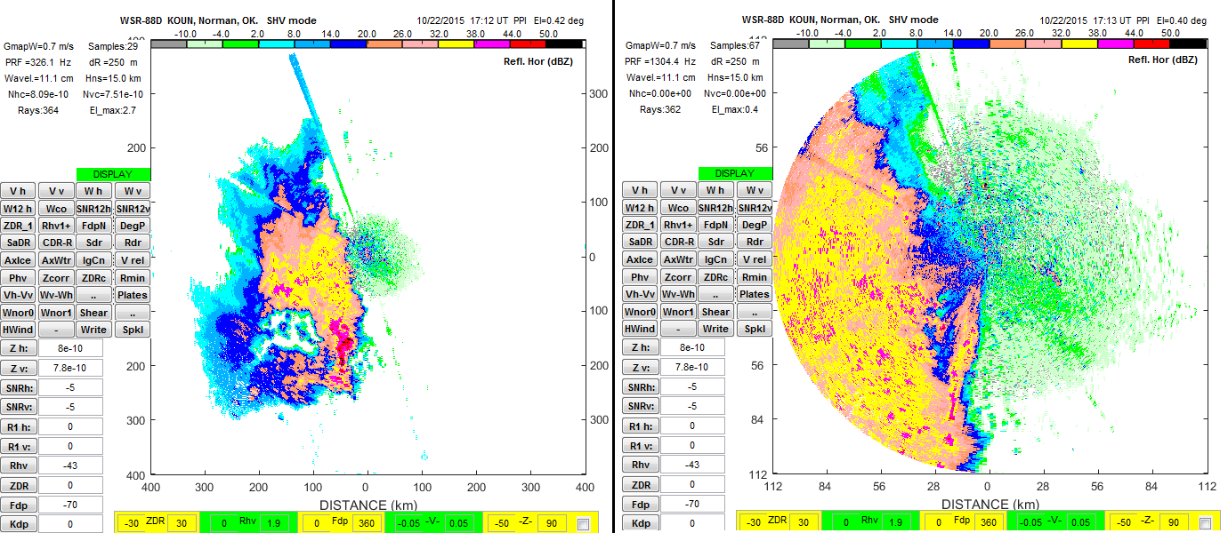

(a) (b)

Fig. 10 Reflectivity field at 0.4o elevation obtained with the WSR-88D research radar (KOUN) in Norman OK, Oct 22, 2015. The color bar on top of each figure indicates levels of reflectivity in dBZ. a ) This field was collected in the CS scan; PRF=326 Hz and the corresponding unambiguous range is 460 km. The furthest point from the radar where the beam exceeds the top of this storm is about 350 km hence there are no ambiguous returns. b) This field was collected in the DS: PRF=1304.4 Hz and corresponding unambiguous range is 115 km. Note that data end at the unambiguous range of 115 km. The elongated echoes in b) within the ellipse are actually from the second trip. Their true location is within the ellipse in a). The small circles indicate the approximate location from which the Doppler spectra are calculated.

which is done on the WSR-88D. In Fig. 10a is the *Z* from a continuous scan (CS) in which the parameters were: PRF=326 Hz, *M*=29, *va*=9 m/s, and unambiguous range of 460 km, hence the data are plotted up to 400 km in range. In Fig. 10b is the *Z* field from the same storm collected in the CD scan one minute later. The parameters were: PRF=1304 Hz, *M*=67, *va*=36 m/s, and unambiguous range is 115 km. The data end at this unambiguous range. The returns from beyond 115 km are overlaid on data from close range. These are encompassed with the ellipse; that is the data within the ellipse in a) are at the correct range locations. The same data appear 115 km closer to the radar (within the ellipse) in b). Provisions exist on the WSR-88D to identify such overlaid data and even restore the proper range (Zrnic 2012) but these provisions have not been applied to this example. The small circles indicate the approximate location from which the Doppler spectra are computed and presented in Fig. 11.

E:\ORNL-OAK RIDGE\ONRL-2017\Spectrum_2015_1022_both.tif

Fig. 11 Doppler spectra from the KOUN research WSR-88D (frequency 2.705 GHz). Top: Continuous Doppler scan, with PRF=1304 Hz, *M*=67, *va*=36 m/s. Bottom: Continuous Surveillance scan, with PRF=326 Hz, *M*=29, *va*=9 m/s. The blue graph indicates horizontal polarization and the red indicates vertical.

The spectra on top of Fig. 11 were collected in the CD mode and on the bottom of Fig. 11 the scan was in the CS mode. The SNR is 30 dB and the von Han (raised cosine) window has been applied to the time series data (I, Q) before spectral processing. Spectra from H and V channels are plotted. In this case the two polarizations produce small but still noticeable differences in the spectra but these are inconsequential for further discussion.

Concerning the high PRT spectrum (top), its width computed using autocovariance (pulse pair) processing turns out to be 1.3 m/s. One sees in the spectrum that the peak signal to noise level is about 43 to 44 dB, whereas the total SNR (per pulse) was 30 dB. Clearly the coherent gain is about 13 to 14 dB which agrees well with the value in Table 9 row 6 (which applies to somewhat different parameters than on the KOUN). Computation using the exact parameters for the KOUN in (7) predicts this gain to be 13.4 dB.

The spectrum collected with the low PRF (i.e., CS) from the same location is constrained to the – 9 to 9 m/s unambiguous velocity interval which is 4 times smaller than in the high PRF case. And the pulse pair computed width is 2.3 m/s indicating positive bias due to small number of samples and low PRF. Furthermore, the total noise power is distributed within a four time smaller frequency (velocity interval) hence its level is 6 dB higher. Visual inspection of the bottom figure indicates a peak signal to noise level of about 36 dB; the corresponding enhancement is 6 dB and within the range in Table 6 row 5. Computation using the exact parameters for the KOUN in (7) predicts this gain to be 7.4 dB. (The spectrum width of 1.3 m/s obtained in the high PRF mode is substituted in (7) because it has much smaller bias).

The sample example of the Doppler spectra in CD and CS scans confirms the benefits of coherent spectral processing which manifest as an increase in detectability by roughly 10 dB. This increase is achieved in the simplest possible manner by comparing the spectral peak to the noise level. More sophisticated processing could combine weighted spectral powers near the peak to perhaps increase the gain. Other optimum techniques exist but these, however, remain to be explored.

**References:**

Blake, L. V., 1970: Prediction of Radar Range, Chapter 2 of *Radar Handbook*, Skolnik ed. McGraw-Hill Book, NY.

Doviak, R. J., 2017: [A Memorandum on Comparisons of Weather and Aircraft Surveillance Radar Requirements to Determine Key Features for a 10-cm MPAR (A Basis for a Cylindrical Polarimetric Phase Array Radar Design)](http://www.nssl.noaa.gov/publications/mpar_reports/Comparisons%20of%20weather%20and%20aircraft%20surveillance%20radar_6%28D3%29wc_2016.doc). NSSL report, 41 pp.

Doviak, R. J., and D. S. Zrnic, 2006: Doppler Radar and Weather Observations, Academic Press, 562 pp.

Doviak, R. J., and D. S. Zrnic, 1998: [WSR-88D Radar for Research and Enhancement of Operations: Polarimetric Upgrades to Improve Rainfall Measurements](http://www.nssl.noaa.gov/publications/wsr88d_reports/2pol_upgrades.pdf). NSSL report, 110 pp.

FAA, 1988: Specification; ARSR-4 Radar System, Report FAA-E-2763b, 303 pp. Updated 13 Nov. 1992.

Istok, M. J., J. T. Ferree, R. E. Saffle, and B. Bumgarner, 2005: 32nd AMS Conference on radar meteorology, 24-29 Oct. Poster P10R.10, 8 pp.

Jansen, L.H. and Van der Speak, 1985: The shape of Doppler spectra from precipitation*. IEEE Trans. Aerosp. Electron. Syst*., **AES-21**, 208-219.

Melnikov, V.M., and P.T. Schlatter, 2011: Enhancing sensitivity on the polarimetric WSR-88D. 27th Conference on Interactive Information Processing Systems (IIPS), American Meteorological Society annual meeting, Seattle, WA.

Melnikov, V. M., D. S. Zrnić, R. J. Doviak, P. B. Chilson, D. B. Meachem, and Y. L. Kogan, 2011: Prospects of the WSR-88D for Cloud Studies. *J. Appl. Meteor. and Climate.*, **50,** 859-871.

NWS, 2017: WSR-88D Volume Coverage Pattern (VCP) Improvement Initiatives, internal report, 8 pp.

Paramax, 1992: Test Report, Antenna/Pedestal, Part 1 of 4, Linear Polarized Antenna First Article, Document #: TR1218305, prepared for :U.S. Department of Commerce, Office of Procurement, Washington, DC 20230.

Raytheon, 1999: Digital Surveillance Radar, System Specification and SRD Cross Reference, Rev-D: SSG708688; Cage Code 49956, RFP No.F19628-95-R-0007. Raytheon Electronic Systems, 528 Boston Post Road, Sudbury, MA 01752-3789

Roulston, K., 2013: Regulus Group, Email communication.

Roulston, K., and K. Hardina, 1995: ARSR-4 Doppler Filter Implementation and Analysis. 26 pp.

Sachidananda, M, D.S. Zrnic, R.J. Doviak, and S. Torres, 1998: Signal design and processing techniques for WSR-88D ambiguity resolution. Part 2. NSSL report. 105 pp.

Taylor, J. W. Jr., and G. Brunins, 1985: Design of a New Airport Surveillance Radar (ASR). Proceedings of the IEEE, Vol.73, No, 2, 284-289.

Troxel, S.W., J. Cho, R. Frankel, M.P. Matthews, and JU. Shaw, 2006: C-Band Aerosol Release Detector (CBARD) Algorithms Description. Report by the Lincoln Laboratory, MIT, Lexington, Mass. 63 pp.

Weber, M. E. 2000: FAA Surveillance radar data as a complement to the WSR-88D network. *Preprints, 9th Conference on Aviation Range and Aerospace Meteorology.* American Meteorological Society. J1.10, 5 pp.

Zrnic, D., [S, C, and X Bands For Weather Surveillance](http://www.nssl.noaa.gov/publications/mpar_reports/S-C-X%20Bands%20for%20Weather%20SurveillFINAL.docx) (.docx, 7.9 MB), NOAA/NSSL report, 32 pp.

Zrnic, D, (2012): Doppler Radar for USA Weather Surveillance, chapter in the book

“Doppler Radar Observations - Weather Radar, Wind Profiler, Ionospheric Radar, and Other Advanced Applications”, InTech, Rijeka, Croatia.

1. [↑](#footnote-ref-1)