Nonlinear Receivers and Impact on ZDR
Report on Tech Transfer SLA: FY22 Task7
Valery Melnikov, Lindsey Richardson, Walter Zittel, Donald Rinderknecht, and Dusan Zrnic
Contents
1. Introduction 2
2. Impacts of nonlinear receivers on ZDR from clouds and precipitation 2
2.1. Linearity of radar receivers 2
2.2. Impacts of KOUN’s nonlinear receiver on ZDR from clouds 4
3. Temperature dependence of the system ZDR offset and ZDR Bias 6
3.1. System ZDR offset and ZDR Bias 6
3.2. Input data 7
3.3. Presentation of the results 8
3.4. Types of temperature dependencies of ZDR_{off} 9
3.5. Failed temperature sensors 12
3.6. Summary on the temperature dependencies of ZDR_{off} and ZDR_{Bias} 13
4. Strong temporal variations in ZDR_{off} and ZDR_{Bias} 13
5. On the ZDR calibration using dry snow aggregates 14
6. ZDR measurements at high antenna elevations 23
7. Summary 25
Appendix 27
A. Sites with correlations between ZDR_{off} and temperature. 27
B. Sites with anti-correlations between ZDR_{off} and temperature 41
C. Sites with undetermined correlation between ZDR_{off} and temperature. 59
D. Sites with no temperature impact on ZDR_{off} 61

Introduction
The WSR-88Ds’ receivers are linear for the reflectivity measurements. This means that correspondence between input and output powers is linear with an accuracy of 1 dB which is the specified accuracy of reflectivity measurements. The accepted accuracy of ZDR measurements is 0.2 dB and the receivers are not linear with this accuracy as the engineering measurements show. ZDR nonlinearity means that the ZDR values depend on the power of input signals and different ZDR values can be measured at the same input (aka intrinsic) ZDR. A nonlinear ZDR receiver can produce different ZDR from the same weather scatterers located at different distances from radar because the power from the scatterers changes with range. One of the goals of the Task is to study linearity of the KOUN radar receiver at low to moderate signal-to-noise ratios. The results are presented in section 2 of this report.
Some radar hardware is located on the antenna where temperature can change significantly from day to night, season to season, and from the passage of fronts. Automatic calibration procedures implemented on the WSR-88D are performed at the end of each VCP and at designated Performance Check times to compensate for any hardware changes including possible temperature drifts. Observations of possible temperature influence on hardware and its impact on system ZDR Bias is discussed in section 3.
In section 4, examples of sharp temporal variations in the system ZDR offset are presented. The cause of these variations is unknown and should be found to make system ZDR self-calibration more stable.
Another objective of this task is analysis of the ZDR calibration method using radar returns from dry snow aggregates located above the melting layers. Possible modifications to this procedure are discussed in section 5.
In section 6, a new approach to calibrate ZDR from high antenna elevations is discussed.
The Appendix contains results on the temperature dependence of the system ZDR offsets and ZDR Bias for all CONUS sites in February 2021, a month with wide temperature variations.

Impacts of nonlinear receivers on ZDR from clouds and precipitation

Linearity of radar receivers
Weather radar receivers should cover a wide input power interval of about 100 dB. In the reflectivity measurements, the return power from the horizontal channel is used. The accuracy of these measurements is specified at 1 dB for the WSR-88D. This means that a dependence of the output power on the input power should be linear with an accuracy of 1 dB. The WSR-88D receivers meet this requirement. Fig. 2.1(a) shows a linear dependence of the output power for WSR-88D KOUN. The dynamic range of the receiver is about 93 dB for the noise corrected measurements.
ZDR measurements should be taken with an accuracy of 0.2 dB. To achieve this accuracy, the receiver transfer function should be linear with an accuracy of 0.1 dB. From here on we call this difference a “receiver ZDR response”. This means that ZDR should not depend on the input powers with an accuracy of 0.1 dB. The input power is typically measured as signal-to-noise ratios (SNR, typically expressed in dB), i.e., this is the power relative to radar noise power. Fig. 2.1(b) schematically depicts the output ZDR (the red curve) of a linear receiver for which variations in the measured ZDR values do not exceed 0.1 dB at all SNR values. An ideal receiver would have a ZDR response in a form of a straight horizontal line (like the thick black line in Fig. 2.1(b)). The mean ZDR value of linear receivers is the system ZDR offset which is used in the ZDR measurements. The mean ZDR offset is the thick black line in Fig. 2.1(b).
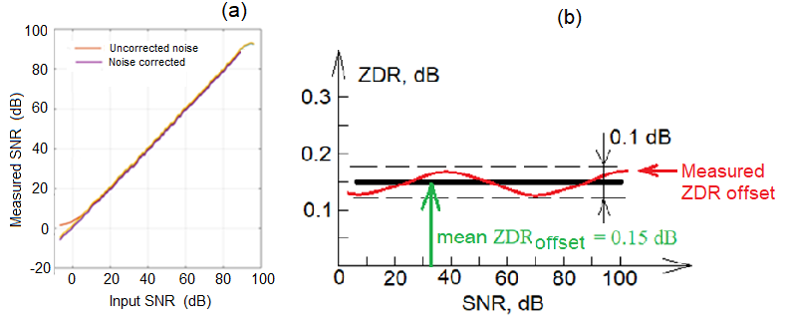
Fig. 2.1. (a): Measured output SNR as a function of input SNR. KOUN 09/15/2021. (b): Sketch illustrating a linear receiver ZDR response.

Fig. 2.2. presents ZDR response of KOUN measured 15 Sep. 2021. One can see that it is linear over the input SNR interval from 20 to 90 dB. At SNR weaker than 20 dB, ZDR increases with decreasing SNR and reaches 0.65 dB at the SNR of 7 dB. So, KOUN’s receiver is not linear in terms of ZDR measurements. This nonlinearity means that the same precipitation observed at different distances from the radar produce different ZDR. For instance, a weather target with an SNR of 40 dB and ZDR of about 0 dB (Fig. 2.2) would produce ZDR = 0.6 dB at a distant range with SNR of 10 dB.
Fig. 2.2. ZDR characteristic of KOUN measured 15 Sep 2021.

Impacts of KOUN’s nonlinear receiver on ZDR from clouds
Does receiver nonlinearity impact measured ZDR? The KOUN receiver exhibits nonlinearity in the SNR interval 0 – 20 dB. Therefore, an impact is expected in that SNR interval. The problem with observing this effect is that clouds and precipitation are not uniform, and their hydrometeors have their own ZDR. So, to observe the nonlinearity effect, nearly uniform weather targets should be analyzed. Potential targets include clouds above the melting layers where radar echoes are more uniform than below the melting layers. RHI images are more convenient for such a study than PPI ones because the melting layer and uniformity of echoes above the layer can be assessed by eye. Radar returns from stratiform clouds would be, probably, the better target for such a study. KOUN’s archive contains data collected as RHIs. An example of stratiform precipitation is shown in Fig. 2.3. Three images in the figure are: reflectivity, SNR, and ZDR. The melting layer is easily identified at a height of 3 km. It is seen that reflectivity and SNR are not uniform below the melting layer, but above it, the reflectivity field is more uniform. Collected data above the melting layer indicates with more confidence the dependency ZDR(SNR). To eliminate ZDR dependence on the antenna elevation angle, radar data from elevations below 30º have been collected. The result is depicted in the left column of Fig. 2.4. The three upper panel are those from Fig. 2.3, and the bottom panel shows ZDR(SNR).

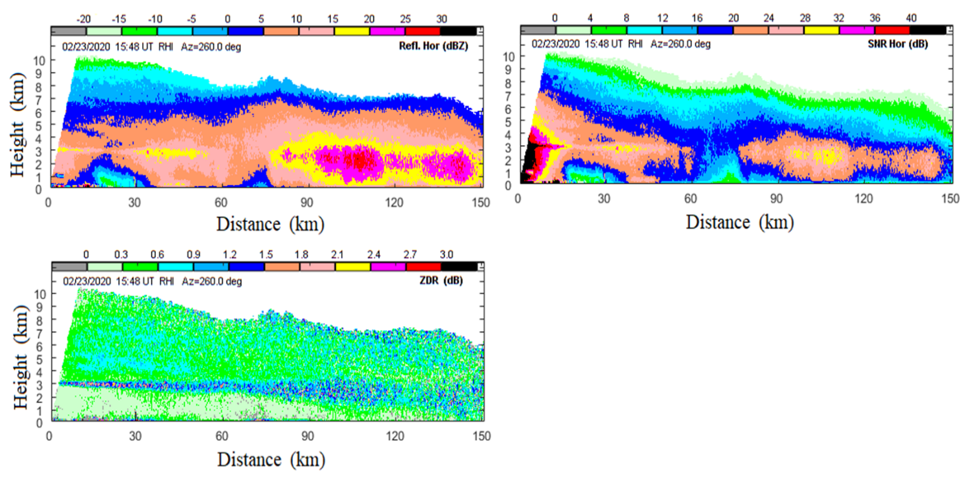
Fig. 2.3. RHI collected with KOUN 23 Feb. 2020 at 1548 UTC at an azimuth of 260º.

Having ZDR KOUN’s response (Fig. 2.2), one can expect that the measured ZDR should increase with decreasing SNR. Such a dependence is seen in the bottom panel in the left column of Fig. 2.4. The latter curve does not exactly replicate the one in Fig. 2.2, but the general tendency is the same.
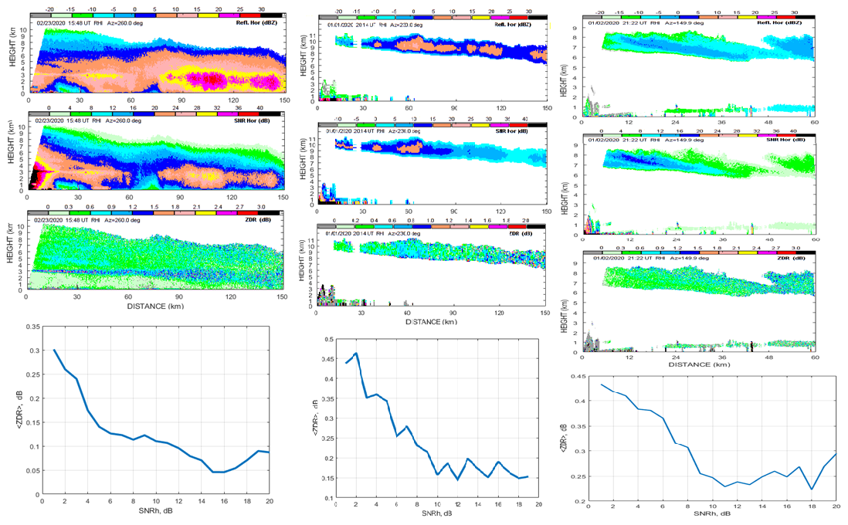
Fig. 2.4. Three cases observed with KOUN on 24 March 2020, 2 January 2020 at 2133 UTC, and 1 February 2020.
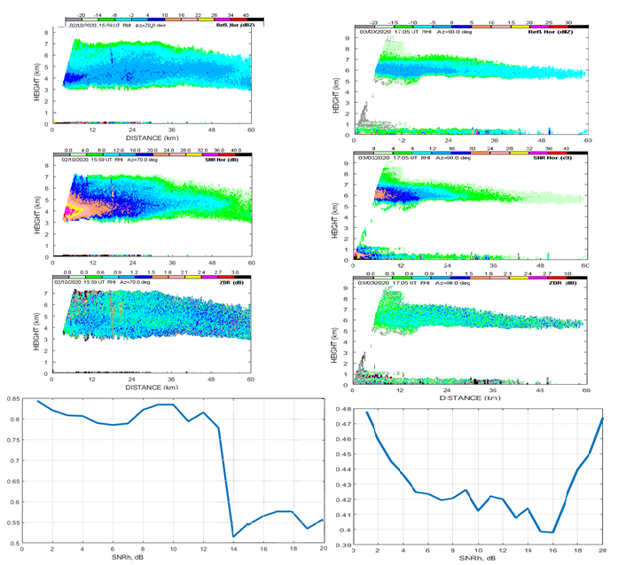
Fig. 2.5. As in Fig. 2.4 but observed 10 Feb 2021 and 3 March 2020.
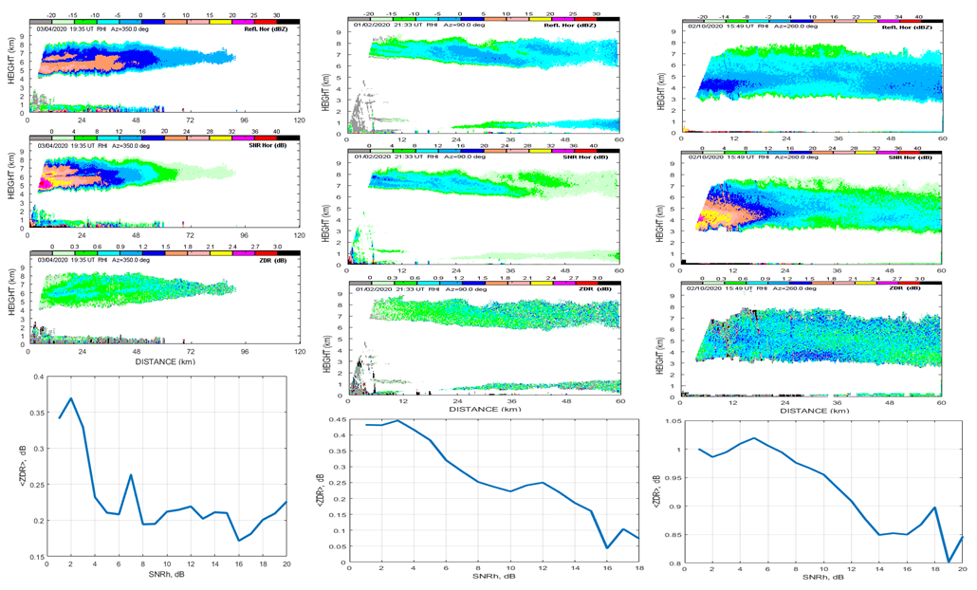
Fig. 2.6. As in Fig. 2.4, but observed 23 February 2020, 1 April 2020, and 2 January at 2122 UTC.

Figs. 2.4 – 2.6 depict several cases observed with KOUN. In all analyzed cases, the increase in the measured ZDR values with decreasing SNR are obvious. The ZDR(SNR) dependencies do not follow KOUN’s ZDR response (Fig. 2.2) because particles in clouds have their own ZDR, but the general trends of ZDR(SNR) are similar. To obtain a more accurate ZDR(SNR) dependence, a weather targets with certain intrinsic ZDR should be utilized. Bragg scatter has intrinsic ZDR of 0 dB and can be used for such a study. The results are summarized in RPI- 2022 report on Task 9.2.

Temperature dependence of the system ZDR offset and ZDR Bias

System ZDR offset and ZDR Bias
There are two major terms relevant to ZDR measurements: the system ZDR offset (ZDR_{off}) and ZDR Bias (ZDR_{Bias}). The system ZDR offset is automatically measured by the system after every VCP and is applied in ZDR calculations in the next VCP. ZDR_{off} contains three contributions:
ZDR_{off} = TXB + RCB + 2 SMB, (1)
where TXB, RCB, and SMB are ZDR offsets from the transmitter, receiver, and antenna. SMB enters in eq. (1) with a coefficient 2 because SMB is measured in receive, but it also affects the transmitted radar waves.
The system ZDR_{Bias} is obtained from radar observations of weather. Three methods have been developed by the ROC to obtain ZDR_{Bias}. The first method is based on observations of light rain and climatic correspondence between its reflectivity and ZDR. The second method is based on observations of dry aggregated snow just above the melting layers assuming the ZDR values there are about 0.15 - 0.20 dB. The third method is based on ZDR values from Bragg scatter with an intrinsic ZDR of 0 dB. If measured ZDR values from any of these targets do not deviate from the expected values by 0.2 dB, the system ZDR calibration is acceptable (0.2 dB is current accuracy of the measurements).
The objective of the Task is revealing possible temperature dependencies of ZDR_{off} and ZDR_{Bias}.

3.2. Input data
A temperature dependence of ZDR_{off} can be obtained from the Level II data, where TXB, RCB, and SMB data are stored. There are three temperature sensors in the system: one measures temperature in the radome area, the second measures the outside temperature, and the third measures the temperature in the transmitter. An example of the data is shown in Fig. 3.1.
Fig. 3.1. (left): Time series of temperatures in the transmitter, radome, and outside in February 2021 for KTLX. (center): Temperature dependences of TXB, RCB, SMB, and ZDR_{off} marked by “Total”. (right): Time series of ZDR_{off} and radome temperature in February 2021.

One can see from the left panel in Fig. 3.1 that the transmitter’s temperature is quite stable because the transmitter is in a temperature-controlled shelter. The radome temperature closely follows the outside temperature. The radome temperature is above the outside temperature till 14 Feb because the built-in heater warms the radome area. After 14 Feb, these temperatures coincide with a time where the heater could have been failing.
The central panel in Fig. 3.1 depicts contributions TXB, RCB, and SMB to ZDR_{off}. The latter is obtained from eq. (1) and marked by “Total” in the panel. The SMB appears stable because it was not measured in February 2021. It is seen that the main temperature variations are caused by the receiver.
The right panel presents time series of ZDR_{off} and radome temperature. The ZDR_{off} changes by about 0.4 dB (from about -0.2 to 0.2 dB) with strong temperature correlation. Since the ZDR_{off} variations exceed 0.2 dB, ZDR_{off} is considered to be dependent on temperature.

Presentation of the results
To shorten the figures, only panels with ZDR_{off} and temperatures are presented below (Fig. 3.2). The results are shown with two panels: the left one is the ZDR_{off} and temperature and the right one depicts time series of the temperature and ZDR_{Bias} obtained from weather objects. Fig. 3.2 (right panel) shows the temperature along with ZDR_{Bias} obtained from dry snow and Bragg scatter.
The standard deviations in ZDR_{Bias} obtained by the dry snow method is shown above the right panel (Z_{DRB}) along with the maximal deviation in ZDR_{Bias} (designated with Δ). ZDR_{Bias} from light rain is not shown in the panel because there are too few rain estimates collected with KRLX in Feb. 2021.

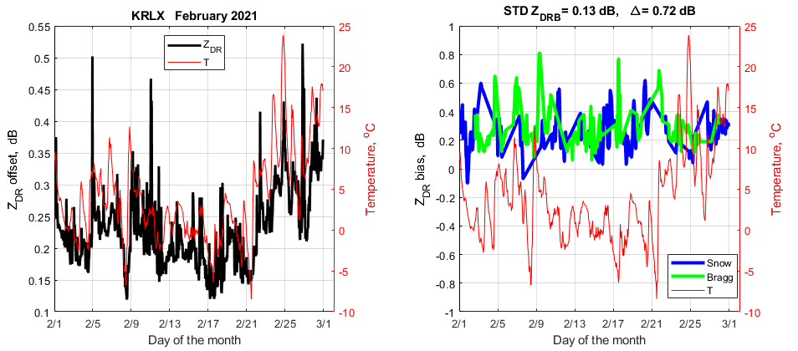
Fig. 3.2. (left): Time series of the temperature (red) and ZDR_{off} (black) from KRLX in Feb 2021. (right): Time series of the temperature (red) and ZDR_{Bias} obtained from dry snow (blue) and Bragg scatter (green).

  - Types of temperature dependencies of ZDR_{off}
A few types of the dependencies ZDR_{off}(T) were observed in the CONUS sites in February 2021. One is a strong dependence (Fig.3.3 and 3.4). In such a case, ZDR_{off} strongly correlates with temperature. ZDR_{Bias}, however, does not exhibit any temperature dependence. In February 2021, 55 sites (38% of the sites) exhibited such a dependence. Data from two radar sites are shown in Fig. 3.3 and 3.4. Figures for other CONUS sites are placed into the appendix.
Two examples of an anti-correlation dependence are shown in Figs. 3.5 and 3.6, where an increase in the temperature decreases ZDR_{off} and vice versa. In February 2021, 5 sites (3% of the CONUS sites) exhibited such a dependence. For this type of ZDR_{off}(T), no correlation between ZDR_{Bias} and T is observed.
Examples of a mixed correlation are shown in Figs 3.7 and 3.8. In such cases, there is no determined correlation between ZDR_{off} and T. In February 2021, 45 sites (17%) exhibited such a dependence. Sometimes positive correlation is observed, but at other times, anti-correlation is obvious. No obvious temperature variations in ZDR_{Bias} are observed.
Some sites exhibit no noticeable temperature variations in ZDR_{off}; examples are in Figs. 3.9 and 3.10. In February 2021, 30 sites (21%) exhibited such a dependence. In such cases, variations in ZDR_{off} did not exceed 0.2 dB. No temperature dependence of ZDR_{Bias} is observed on these sites. Some isolated strong variations in ZDR_{off} are observed (e.g., Fig. 3.10, left panel), but such variations are not caused by temperature and this issue is discussed in section 4.

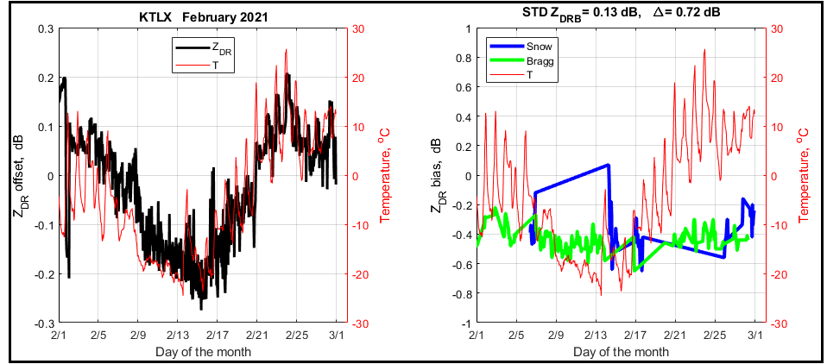
Fig. 3.3. Time series of ZDR_{off} and ZDR_{Bias} for KTLX in Feb. 2021. Strong correlation between ZDR_{off} and T.
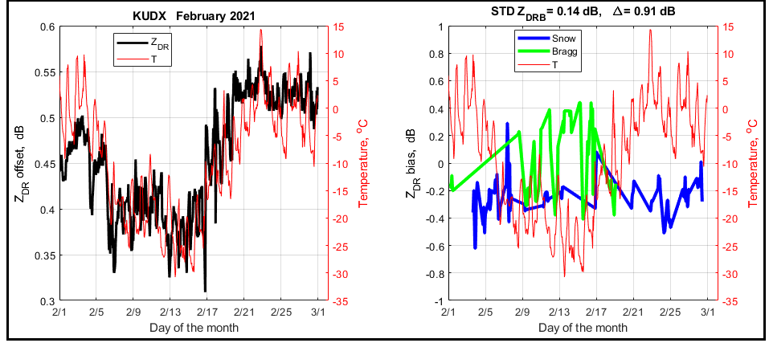
Fig. 3.4. As in Fig. 3.3, but for KUDX.
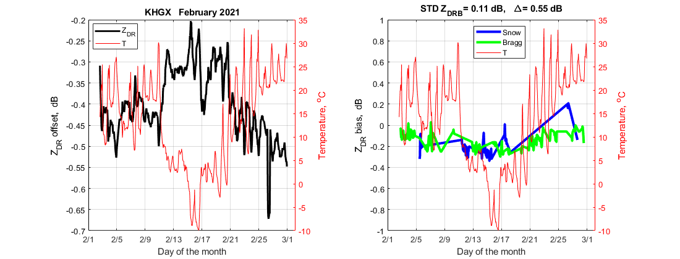
Fig. 3.5. Time series of ZDR_{off} and ZDR_{Bias} for KHGX in Feb. 2021. Anti-correlation between ZDR_{off} and T.
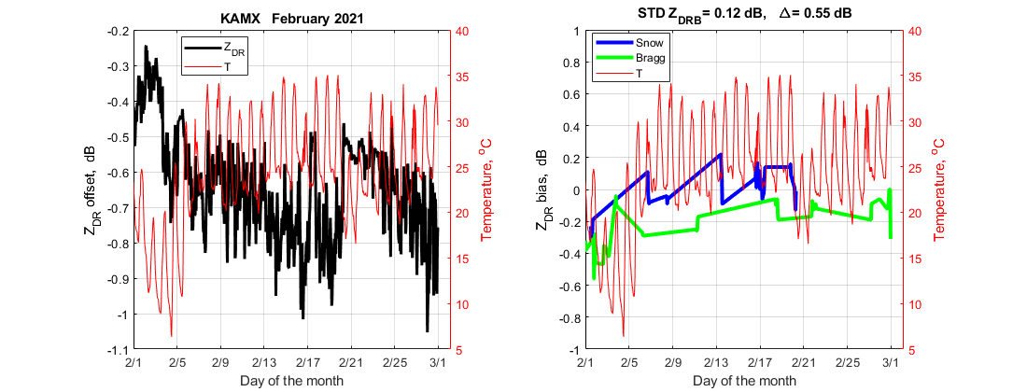
Fig. 3.6. As in Fig. 3.5, but for KAMX.
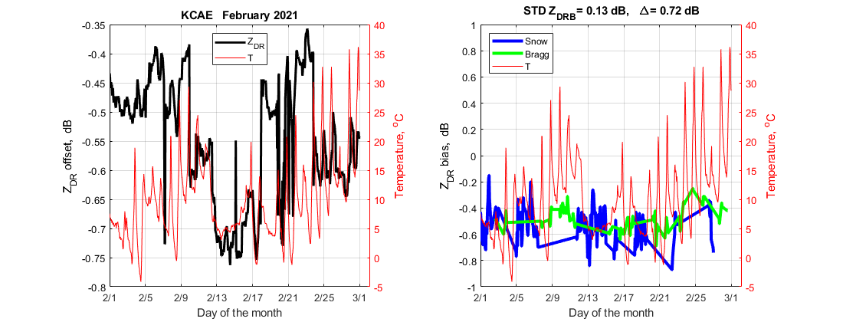
Fig. 3.7. Time series of ZDR_{off} and ZDR_{Bias} for KCAE in Feb. 2021. (left): Mixed correlation between ZDR_{off} and T. (right): ZDR_{Bias} and temperatures.
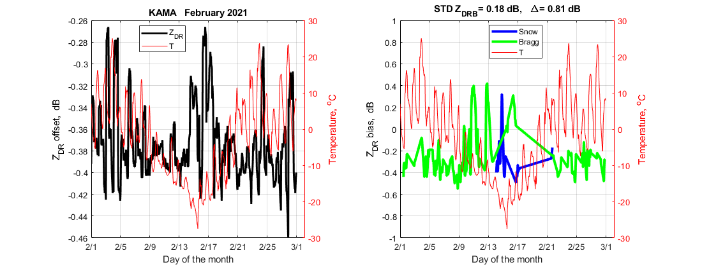
Fig. 3.8. As in Fig. 3.7, but for KAMA.
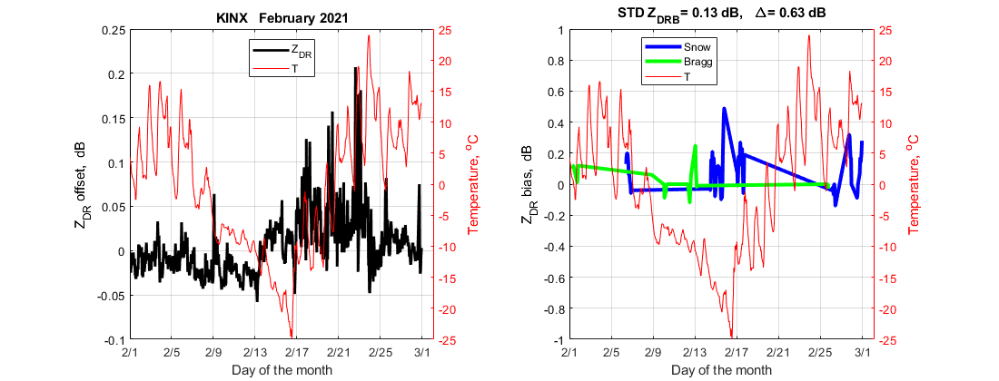
Fig. 3.9. Time series of ZDR_{off} and ZDR_{Bias} for KINX in Feb. 2021. (left): No temperature impact is observed on ZDR_{off}. (right): ZDR_{Bias} and temperatures.
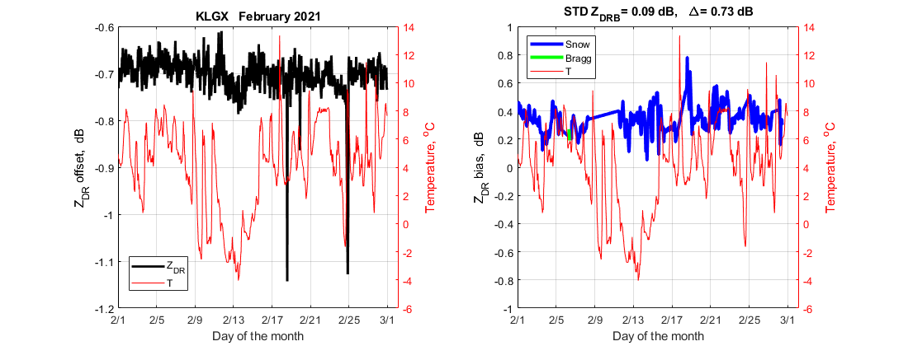
Fig. 3.10. As in Fig. 3.9, but for KLGX.

Failed temperature sensors
The WSR-88Ds are equipped with radome and outside temperature sensors. If the radome sensor fails, its reading is at -50 ºC (Fig. 3.11).
A malfunctioning outside temperature sensor produces temperatures of 50 ºC (e.g., Fig. 3.12). We speculate that the sharp variations over short time periods are also faulty, but have no explanation.
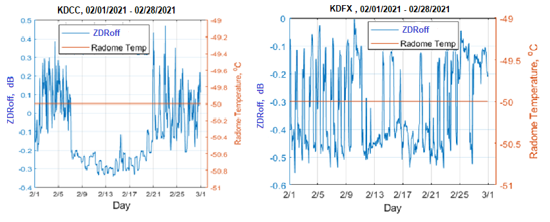
Fig. 3.11. Readings of the radome temperature sensors from (left) KDCC and (right) KDFX in February 2021.

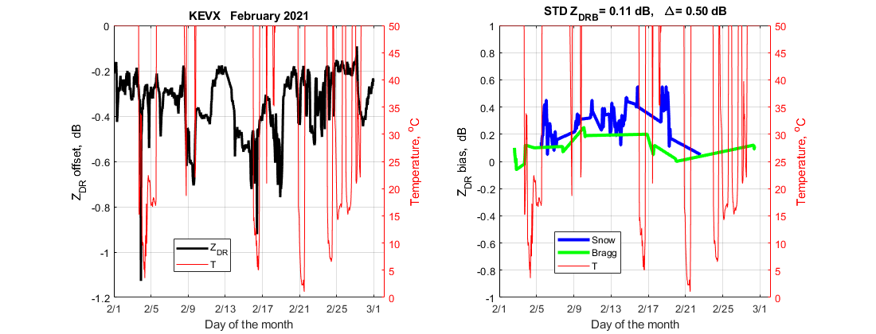
Fig. 3.12. Readings of the outside temperature sensors from KEVX in February 2021.

Summary on the temperature dependencies of ZDR_{off} and ZDR_{Bias}
79% of the CONUS sites exhibit temperature dependence of their ZDR offsets. Most likely, this is caused by the LNAs located outside the temperature-controlled boxes. The two LNAs in the radar receive channels may behave differently at various temperatures that leads to various types of the temperature dependencies of the ZDR offset.

No temperature dependence of the system ZDR Biases have been observed. This means that the systems correctly measure variations in the ZDR offsets and apply these in the ZDR calculations. The measurements of the ZDR offset are designed to compensate for possible variations in the system hardware. The data show that these measurements are quite correct and compensate for the temperature variations in hardware.

Strong temporal variations in ZDR_{off} and ZDR_{Bias}
Some systems show large variations in ZDR_{Bias} not connected to temperature. Examples are shown in Figs. 4.1 and 4.2. In Fig. 4.1 one can see sharp drops of ZDR_{off} from values of about -0.9 dB down to -1.4 dB (14 Feb), i.e., the drop is about 0.5 dB. ZDR_{off} is used in the ZDR measurements. Thus, such fluctuations in ZDR_{off} affect ZDR_{Bias}. Strong variations in ZDR_{Bias} (Fig. 4.1, right panel) could be due to the variations in ZDR_{off}. ZDR_{Bias} is obtained as a sliding average of data from several VCPs. So, impacts of variations in ZDR_{off} can have a longer impact on ZDR_{Bias}.

Fig. 4.2 exhibits frequent variations in ZDR_{off} between 0.3 and 0.8 dB (left panel). It looks like such variations get smeared by data averaging and do not lead to frequent variations in ZDR_{Bias} (right panel).

The analyzed data show that sharp variations in ZDR_{off} are not caused by temperature. The source of these variations should be found. These variations must be reduced or eliminated to make ZDR calibration more stable and more reliable.

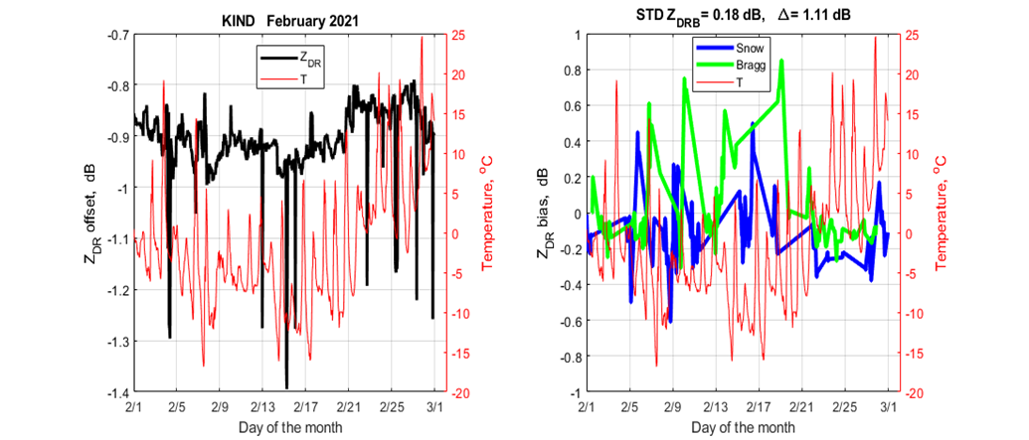
Fig. 4.1 (left): Strong temporal variations in ZDR_{off} not correlated with the temperature.

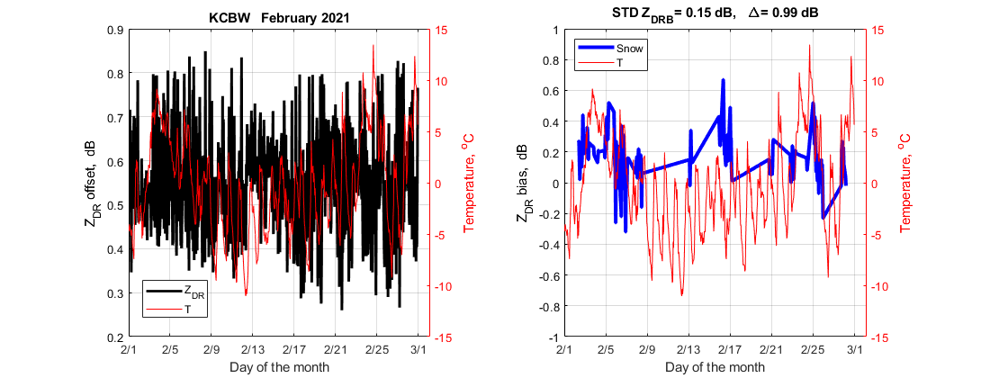
Fig. 4.2. As in Fig. 4.1, but for KCBW.

On the ZDR calibration using dry snow aggregates
The ROC has developed a method to assess/calibrate ZDR from dry snow aggregates. This method is based on the mean ZDR in a 1-km layer above the top of a melting layer (ML) and is applied to data from Quasi Vertical Profiles.
Fig. 5.1 illustrates the base of this approach. One can see a layer of low ZDR just above the ML (right panel). PPIs from KTLX at the time do not show that layer so clear (Figs. 5.2-5.5), but one can agree that the ZDR values above the ML are lower than those below the ML, i.e., in rain.
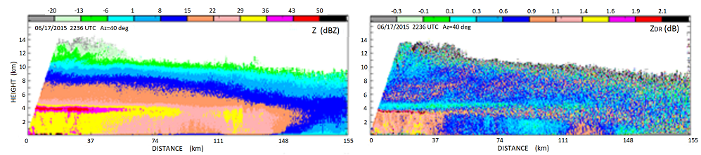
Fig. 5.1. RHI collected with KOUN 06/17/2015.

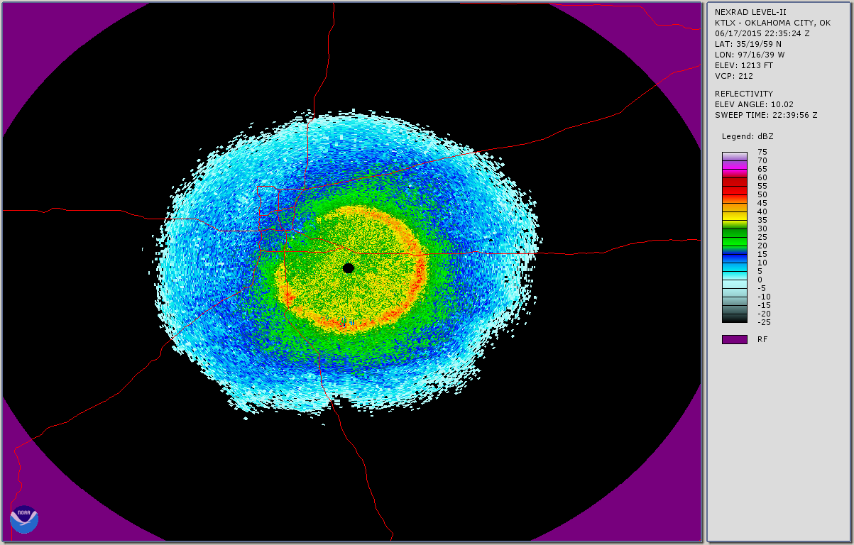
Fig. 5.2. Reflectivity from KTLX on 06/17/2015 at an elevation of 10º.
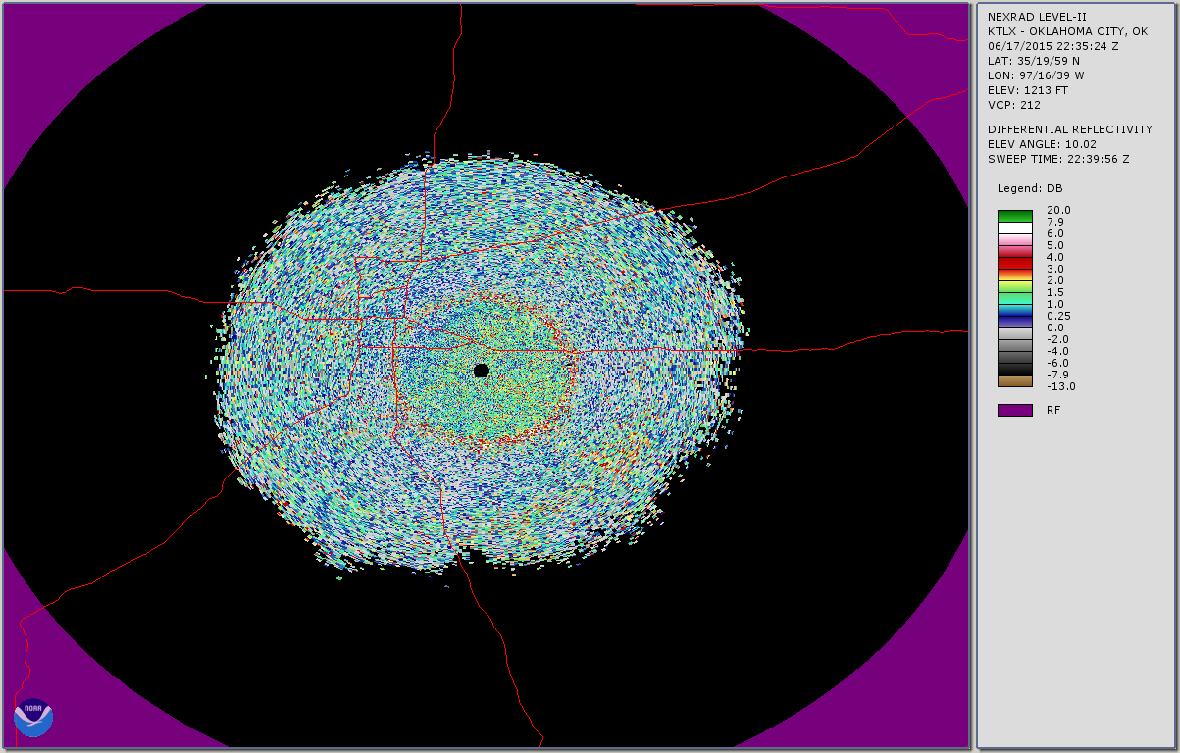
Fig. 5.3. As in Fig. 2 but for ZDR. El = 10º.
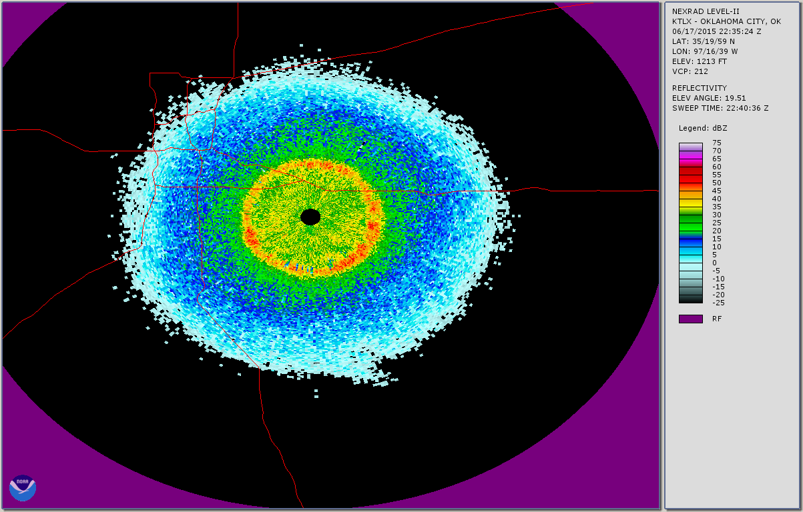
Fig. 5.4. Reflectivity from KTLX on 06/17/2015 at an elevation of 20º.
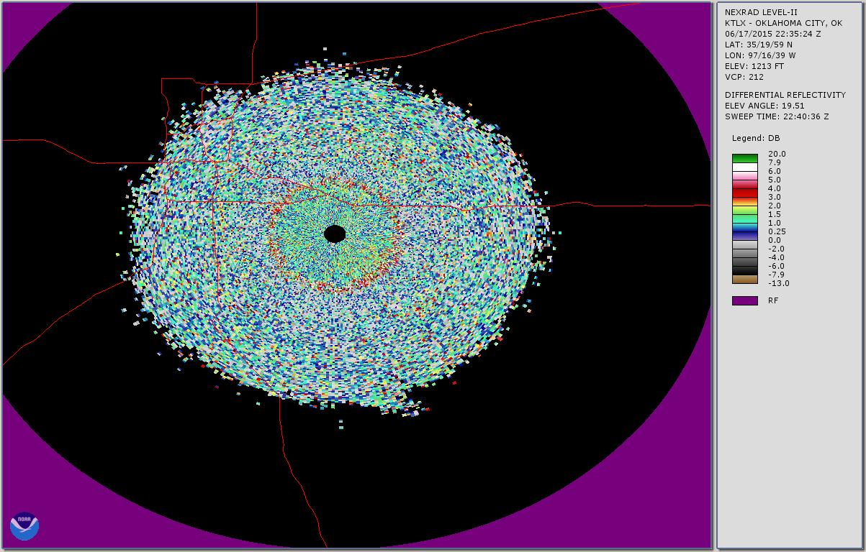
Fig. 5.5. As in Fig. 4, but for ZDR. El = 20º.

The method assumes that ZDR values in the 1-km layer above MLs is 0.2 dB. To obtain the ZDR value of 0.2 dB, radars with a very good ZDR calibration (the accuracy of 0.1 dB or higher) should be utilized. For now, WSR-88Ds are not calibrated with this accuracy. The German weather service report about this accuracy for their C band radars, but, to our knowledge they did not documented observations of ZDR above the MLs.
Below, a few cases exhibiting ZDR values smaller than those in a 1-km layer above the ML are shown. First case is in Fig. 5.6. This is an RHI collected 23 Feb 2020 in widespread precipitation. The ML is at a height of 3 km, and it is clearly seen in the reflectivity and ZDR fields. One can see that ZDR values above the ML are higher than those below the ML. Reflectivities are in a range of 10-20 dBZ in areas below the ML and closer than 30 km. The ZDR values in this area are smaller than 0.3 dB. In areas above the ML, ZDR values are in an interval of 0.3-0.9 dB, which are larger than 0.2 dB assumed in the method.

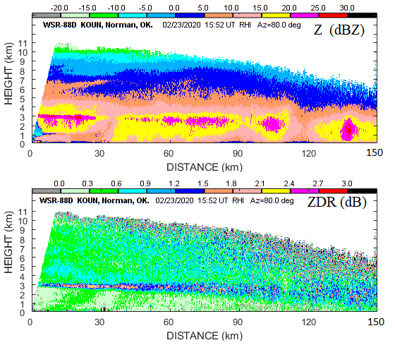
Fig. 5.6. RHI from KOUN collected 02/23/2020 at 1552 UTC in an azimuth of 80º.

In the dry snow method, data should be collected in a PPI scans. Figs. 5.7 and 5.8 present Z and ZDR field collected at about the same time with KTLX. One can see that ZDR values below the melting layer are smaller than those just above the ML. The mean ZDR below the ML suggests a ZDR Bias of about -0.3 dB for KTLX. If this ZDR Bias is accepted, the ZDR values just above the ML become about 0.5 dB, i.e., greater than 0.2 dB assumed by the dry snow method.
A modification can be proposed for the application of the method: ZDR values below the ML should also be analyzed; and if these are lower than the ZDR values obtained above the ML, they should be used for the assessment of system ZDR Bias.

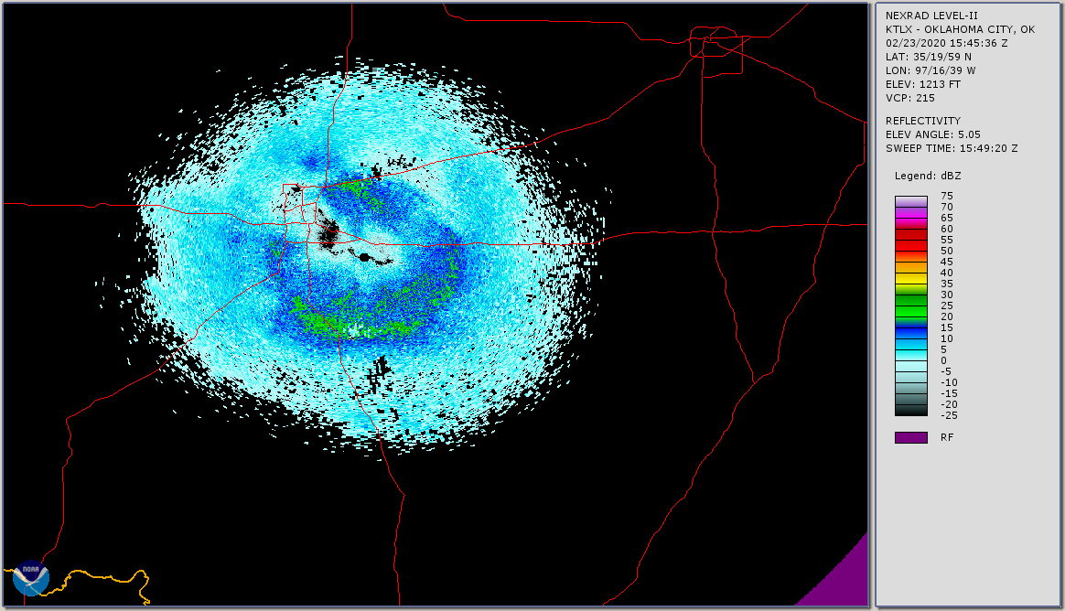
Fig. 5.7. Reflectivity field from KTLX obtained 23 Feb 2020 at 1545 UTC at an elevation of 5º.

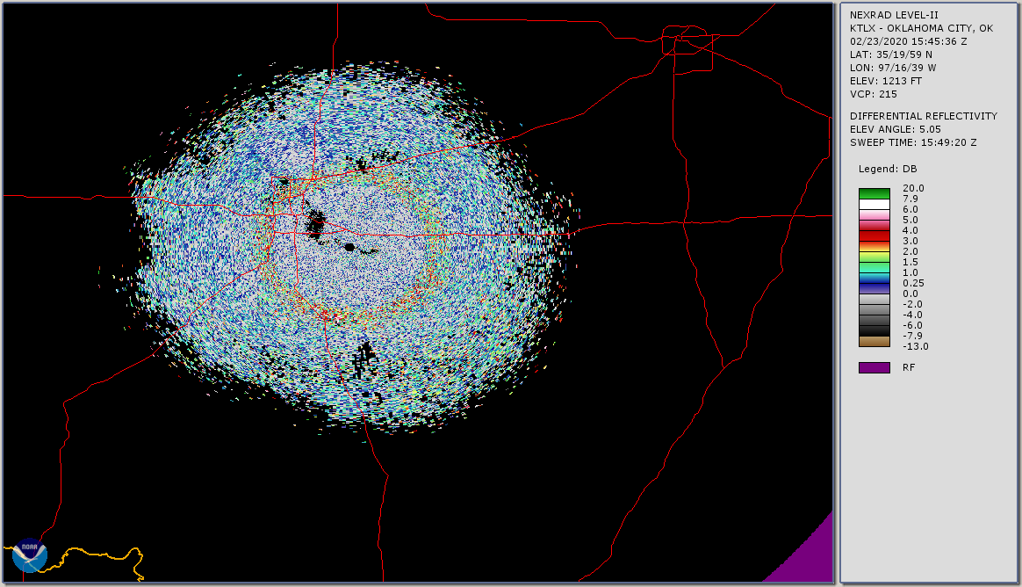
Fig. 5.8. ZDR field for the case in Fig. 5.7.

Another ZDR field obtained with KTLX on 22 March 2022 is shown in Fig. 5.9. The mean ZDR value in areas just above the ML is about 0.3 dB, but one can see wide areas with lower ZDR, for instance, to the north from the radar where ZDR values lie in the interval -0.2 to -0.4 dB. Further study is needed to determine if and how other types of ice crystals could be used for ZDR Bias estimation.

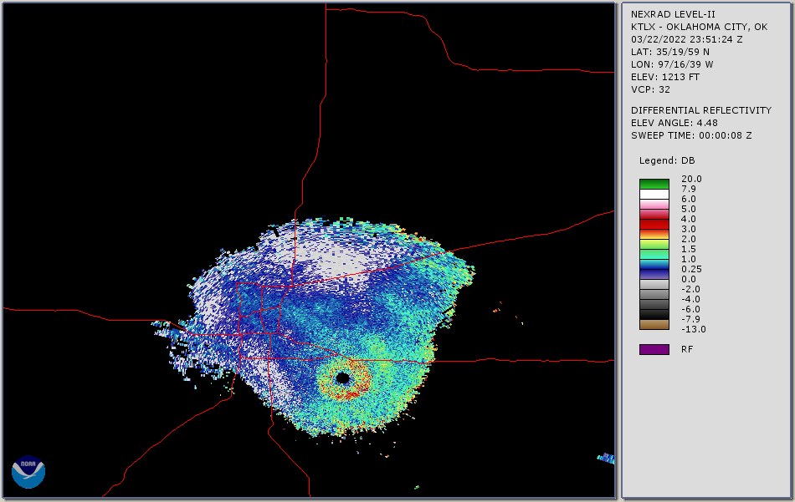
Fig. 5.9. PPI of ZDR from KTLX on 03/22/2022 at an elevation of 4.5º.

One more recent example is shown in Figs, 5.10 and 5.11. One can see that ZDR below the melting layer (Fig. 5.11) is lower than that above the layer. A second ring of enhanced ZDR is also seen above the melting layer (Fig. 5.11). This is the layer of larger ice crystals. This case is similar to that in Figs. 5.7 and 5.8. An RHI cross section from KOUN (Fig. 5.12) at about the same time shows clearly that ZDR values above the melting layer are greater than those measured below the layer. The images from short distances are shown to observe data from high antenna elevations.
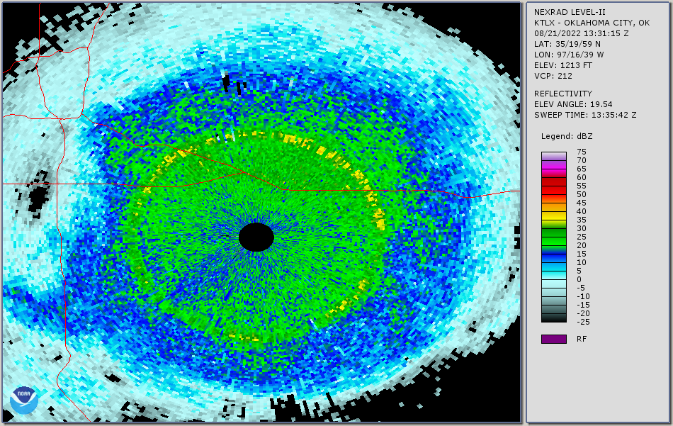
Fig. 5.10. Reflectivity field from KOUN on 21 Aug 2022 at 1331 UTC, elevation 19.5º.
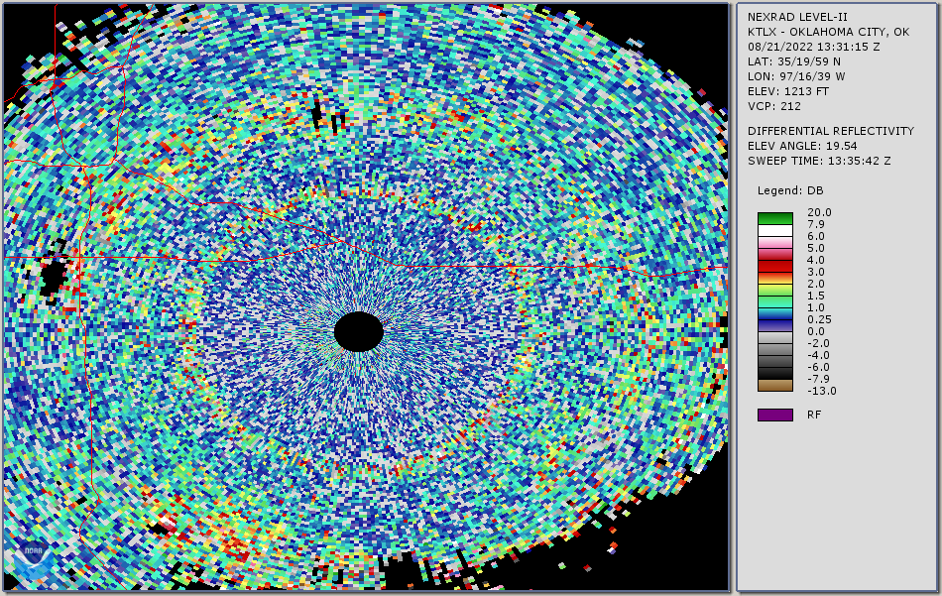
Fig. 5.11. As in Fig. 5.10, but for ZDR.
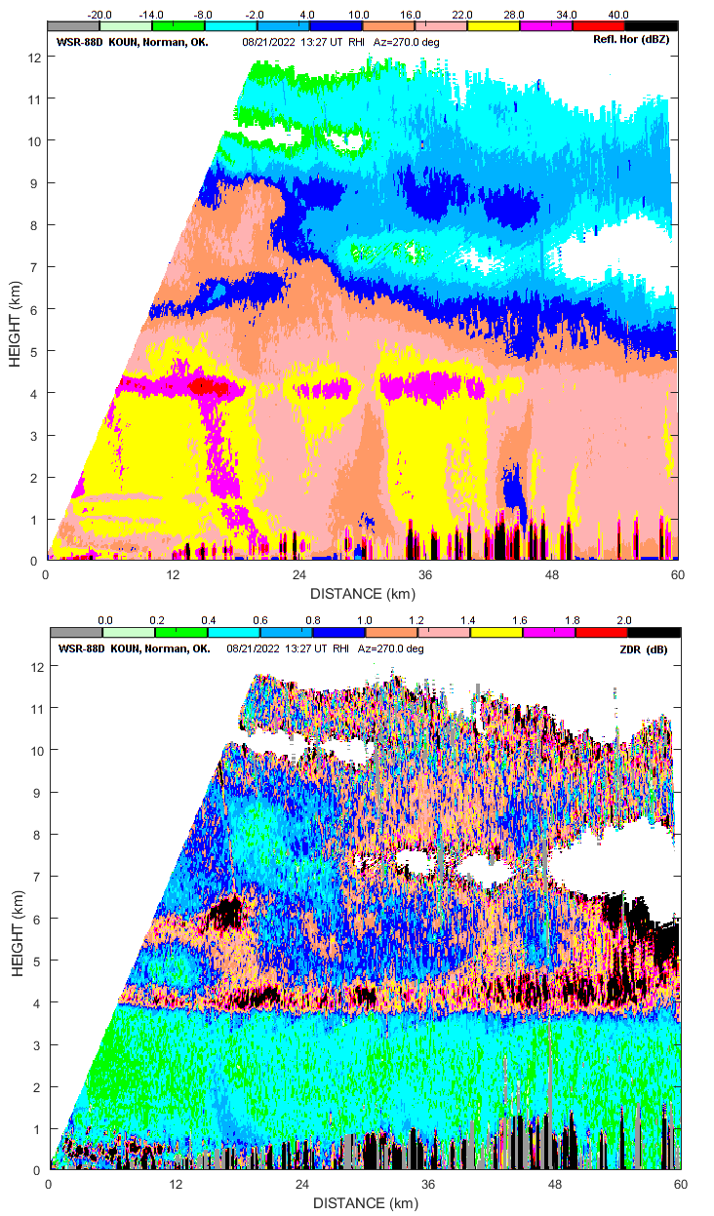
Fig. 5.12. RHI from KOUN collected 21 Aug 2022 at 1327 UTC in an azimuth of 270º.
The modification to the dry snow method can be proposed for areas above the 1-km layer above the ML. ZDR values from all areas above the ML should be analyzed on low ZDR values. Combining this proposition with the one for the case in Fig. 5.8, we conclude that the sanity check should include ZDR values from all distances.
Assessment of ZDR Bias from QVPs could contain the following steps:
- Data Set 1: Collect ZDR data below the ML at distances within 50 km.
- Data Set 2: Collect ZDR data in the 1-km layer above the ML using the dry snow method.
- Data Set 3: Collect ZDR data all the way above the 1-km layer in areas away from the reflectivity cores to avoid areas of possible high electrification.
To create the sets 1 and 3, compact areas of low ZDR should be obtained. Such areas should include a few consecutive radials and several consecutive range gates to obtain sufficient number of ZDR values to calculate the mean ZDR with an accuracy of 0.1 dB. This number can be calculated from the statistics of ZDR (the input parameters are ZDR, CC, SNR, and the number of samples used to obtain the radial data). The output from this processing step would be three mean ZDR values from data sets 1 and 3. The next step would be:
- If set 2 has the minimal ZDR value, this value is taken as the system ZDR Bias.
- If set 3 has the minimal ZDR value, this value is the system ZDR Bias.
- If set 1 has the minimal ZDR value, apply the bias correction procedure designed by the ROC for light rain.
The output from this procedure is the system ZDR Bias.

ZDR measurements at high antenna elevations
The “bird bath” method of ZDR calibration is based on observations of raindrops at vertical incidence. Oblate raindrops appear symmetrical at zenith radar sensing, therefore, ZDR = 0 dB. This is used to calibrate the system ZDR offset.
The WSR-88D can’t raise its antenna to 90º; the maximal antenna elevation is 60º. At 60º, the projection of oblate raindrops onto the polarization plane is close to symmetrical, therefore their ZDR values are significantly lower than those at lower elevation angles. The question is: how are ZDR values from raindrops close to 0 dB at antenna elevations close to 60º? Fig. 6.1 presents dependences ZDR(Z) for various antenna elevations. One can see that for the antenna elevation of 60º, the ZDR values are lower than 0.2 dB at Z < 35 dBZ. This can be used to calibrate ZDR at the antenna elevation of 60º: obtain ZDR values at a 1-km layer below a melting layer. In this layer, if reflectivity Z is lower than 35 dBZ, obtain the mean ZDR value from an azimuthal sweep. This value should be lower than 0.2 dB which is the desired accuracy of ZDR measurements. In this 1-km layer below the melting layer, the probability to have large drops which can bias ZDR is lower than that for low antenna elevations. This method can be extended to higher reflectivities. If Z > 35 dB, subtract the intrinsic ZDR from the measured one and the difference should not exceed 0.2 dB.
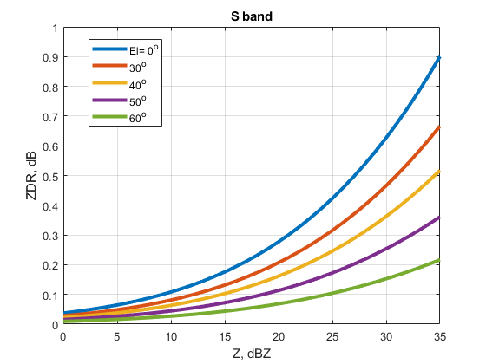
Fig. 6.1. ZDR as a function of Z for various antenna elevations.

Fig. 6.2 presents RHIs of Z and ZDR collected with KOUN on 21 Aug 2022. The parts containing high antenna elevations are shown for better viewing. It is seen that ZDR decreases with increasing antenna elevation. ZDR is presented in the interval 0 – 2 dB to observe the values with finer resolution. One can see that ZDR values at high elevations below the melting layer lay in the interval 0 – 0.2 dB that indicates correct ZDR calibration of KOUN. The system ZDR Bias was 0.25 dB at that time.
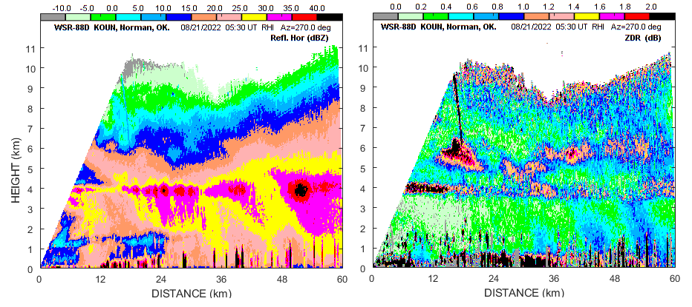
Fig. 6.2. RHIs of (left) Z and (right) ZDR collected with KOUN 21 Aug 2022 at an azimuth of 270º.
Another case is shown in Fig. 6.3. Again, we can see low ZDR values below the melting layer at highest elevations. A disadvantage of this method is that it requires additional time to make an additional sweep at the elevation of 60º. It would require additional 12-15 seconds to complete a VCP.
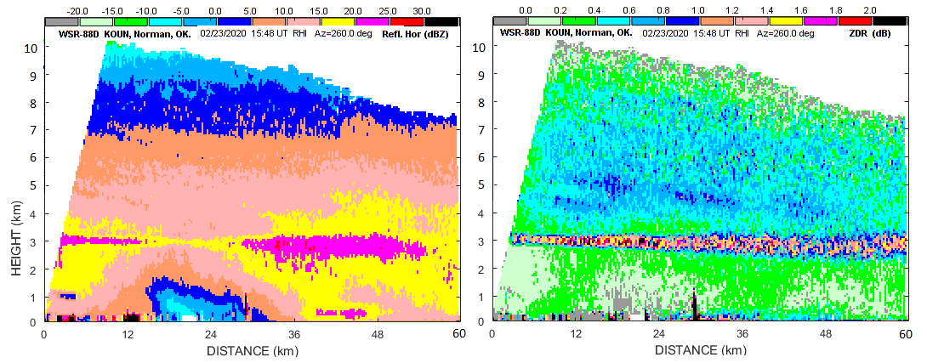
Fig. 6.3. As in Fig. 6.2 but collected 23 Feb 2020 in an azimuth of 260º.

Summary
Engineering measurements of the ZDR receivers’ response on WSR-88D KOUN shows its nonlinearity in the SNR interval 0 – 20 dB. In this interval, ZDR values increase with decreasing SNR. The study of the dependency of ZDR on SNR in clouds and light precipitation shows that the ZDR values also increase with decreasing SNR in the interval of 0 – 20 dB (section 2). The measurements from weather targets confirm nonlinearity of the KOUN receiver.
The study of temperature dependencies of the system ZDR offset (ZDR_{off}) shows that ZDR_{off} depends on the temperature (T) in the radome (section 3). 79% of the CONUS radar sites exhibit such a dependence. Various temperature dependencies ZDR_{off}(T) have been observed that can be explained by various temperature dependencies of the LNAs in the polarization channels. The systems constantly measure ZDR_{off} and utilize it in the ZDR calculations. The study of ZDR Bias from weather targets does not show any dependence on temperature which indicates that the systems correctly account for the temperature variations in ZDR_{off}.
Some systems exhibit strong temporal variations in ZDR_{off} and ZDR_{Bias} the source of which is unknown (section 4). To make ZDR measurement more stable, these variations should be eliminated or significantly reduced. Further study on the subject is recommended..
The method of assessing ZDR from areas of aggregated snow needs a refining (section 5). The presented observations show that there are situations where ZDR values from areas below and above melting layers are smaller than those obtained in the 1-km layer above melting layers. Possible modifications to the method are proposed.
ZDR values measured at an antenna elevation of 60º in rain below the melting layer are lower than 0.2 dB at Z < 35 dBZ. This can be used to calibrate the system ZDR offset. About 10-12 seconds are needed to take such measurements.

Appendix
In this appendix, results on temperature dependencies ZDR_{off} and ZDR_{Bias} for the COUNS sites are presented.

Sites with correlations between ZDR_{off} and temperature.
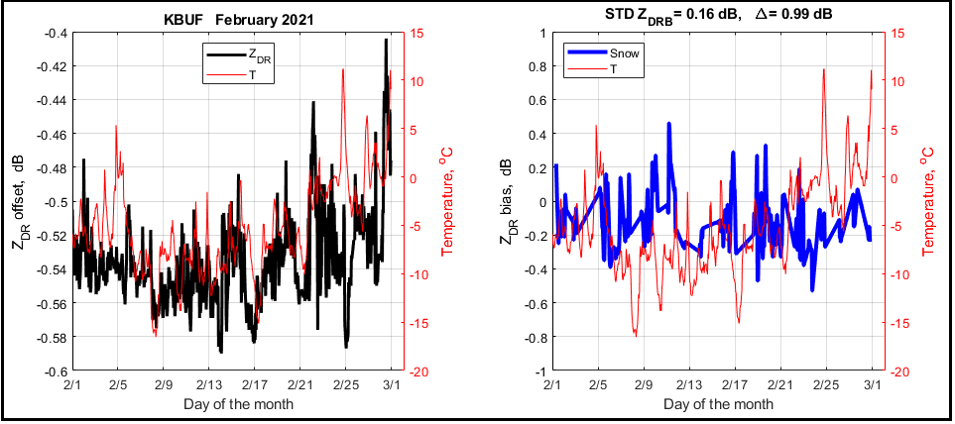
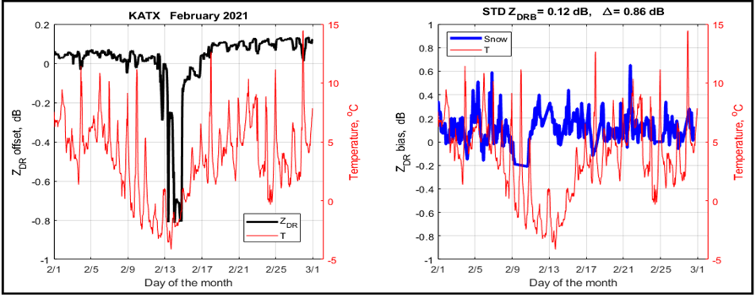

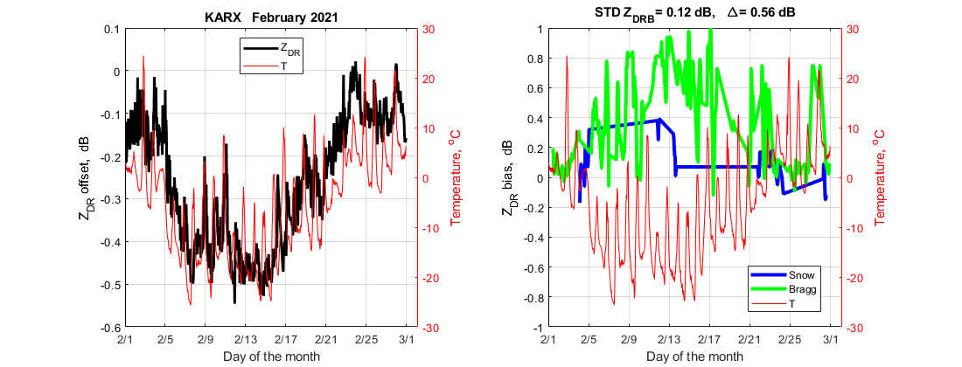
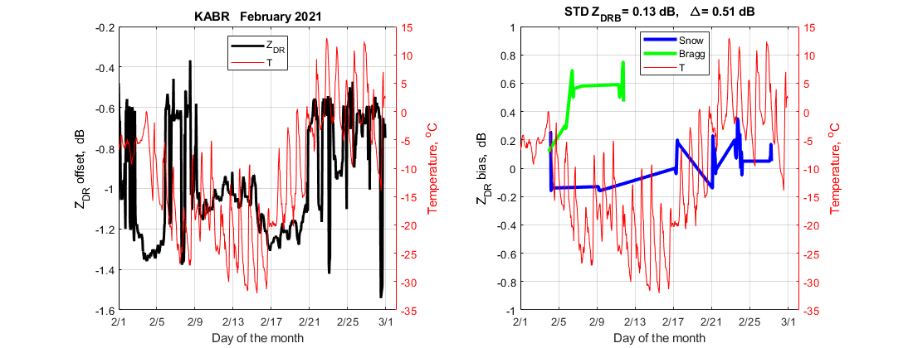
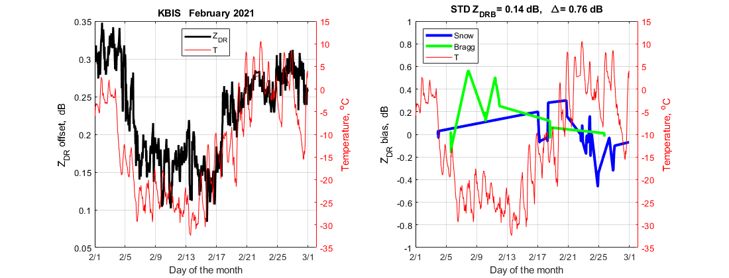

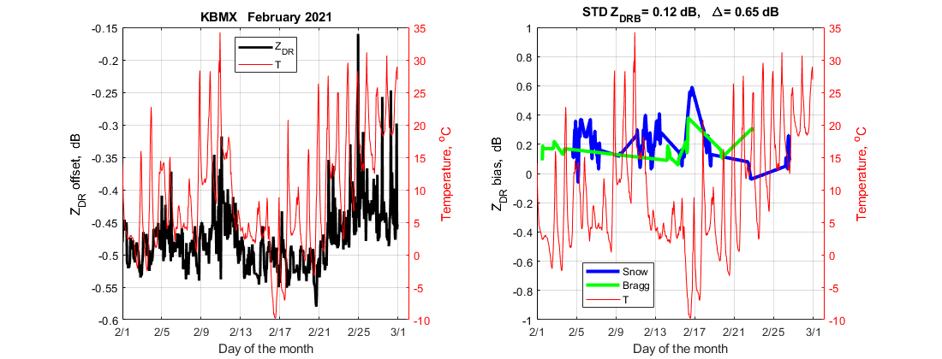
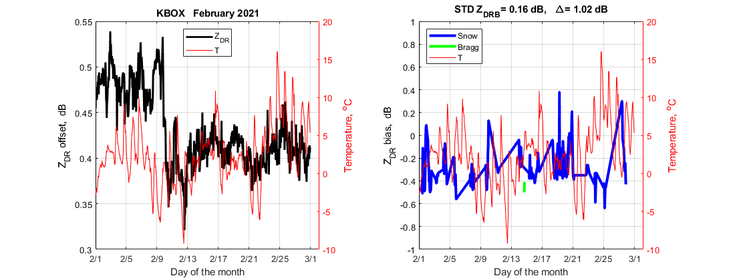
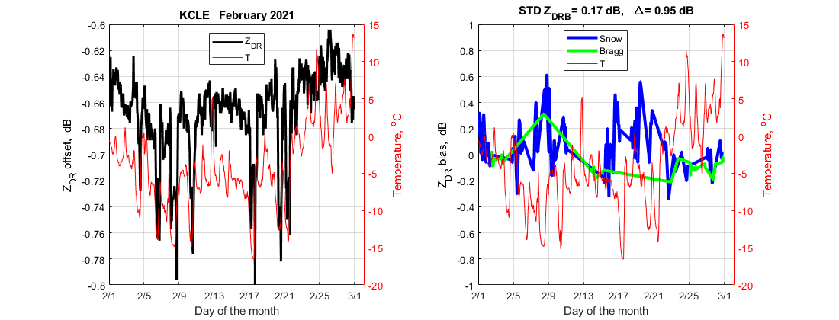
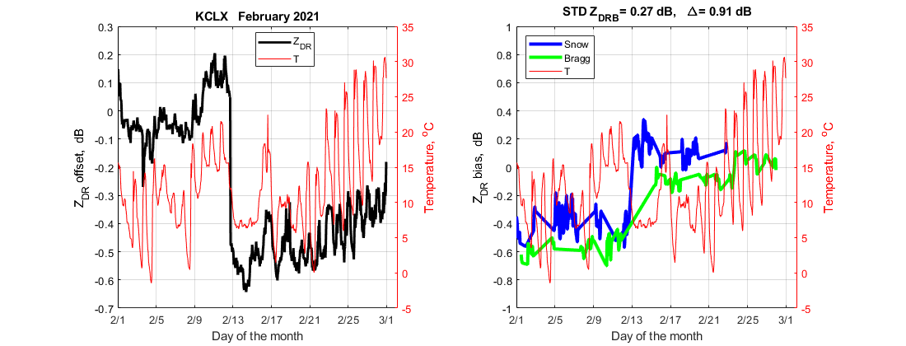
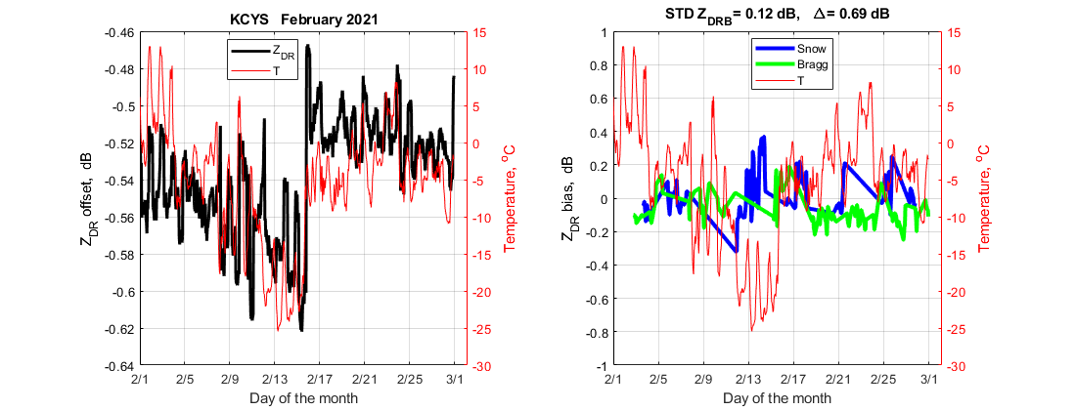
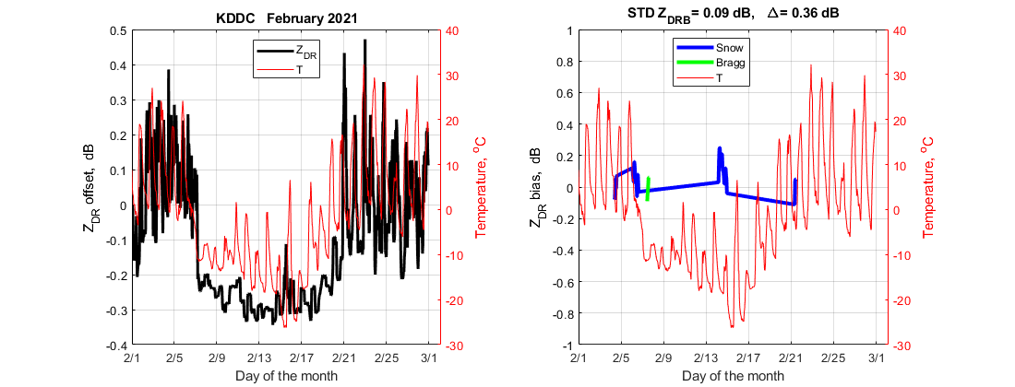
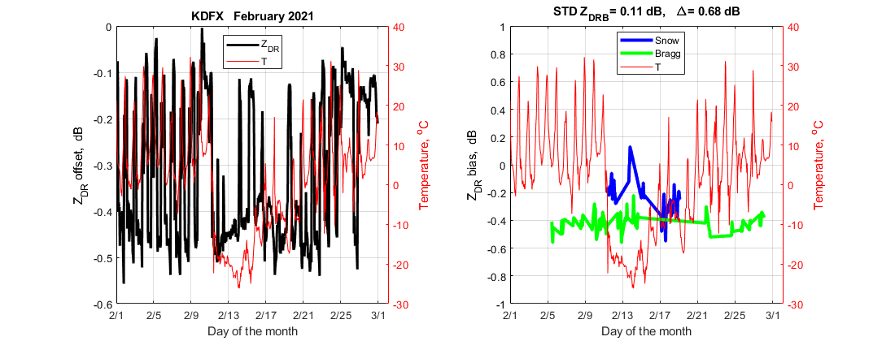
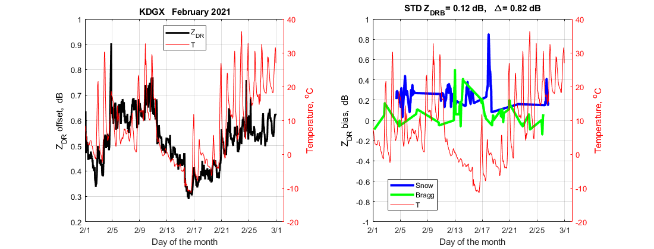
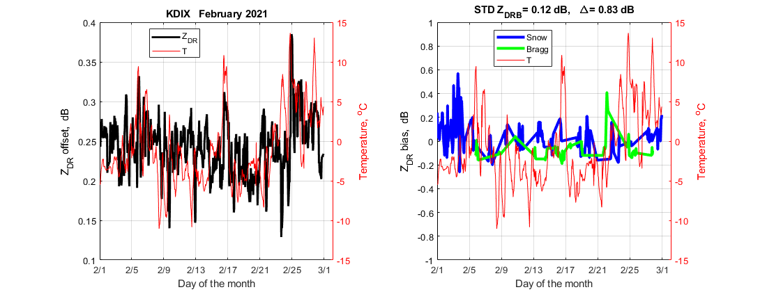

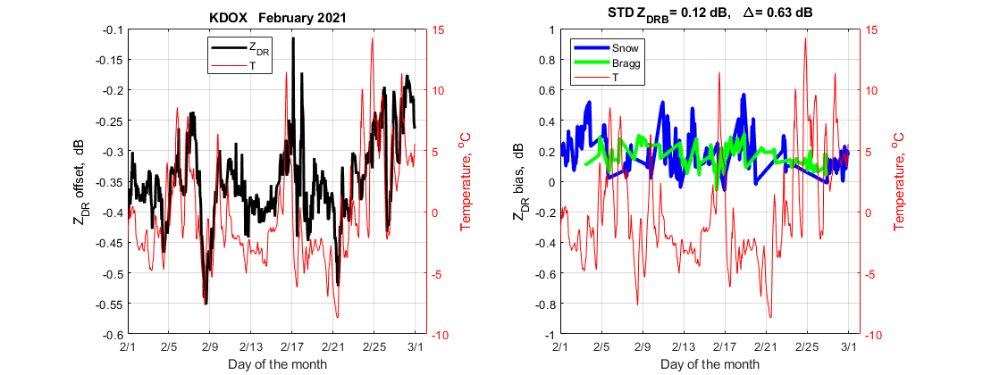
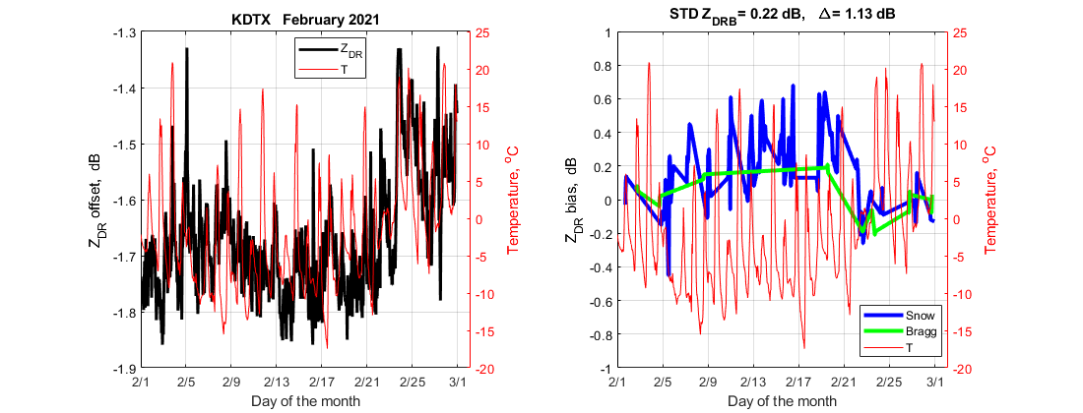
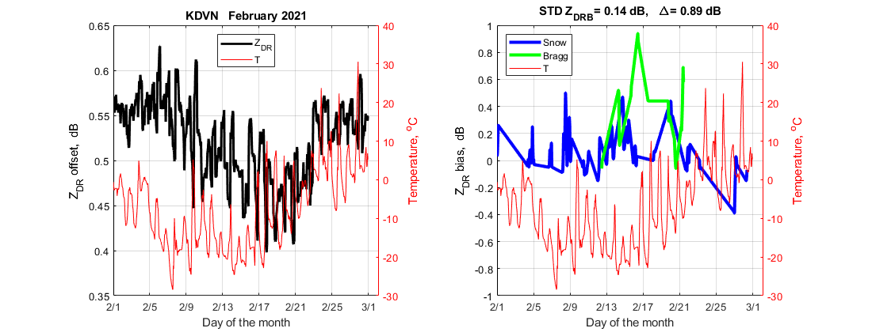
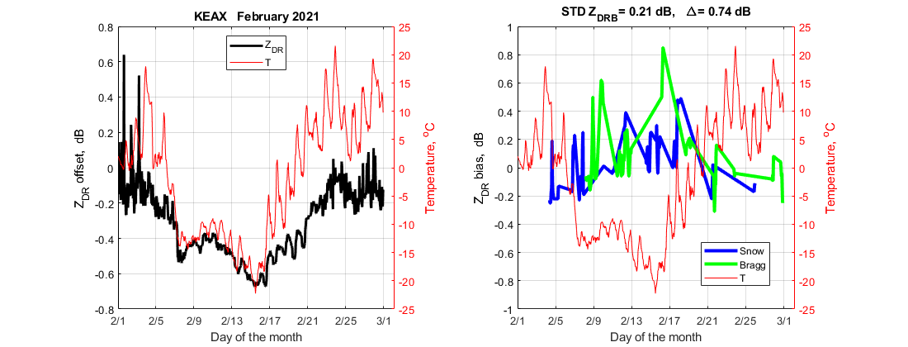
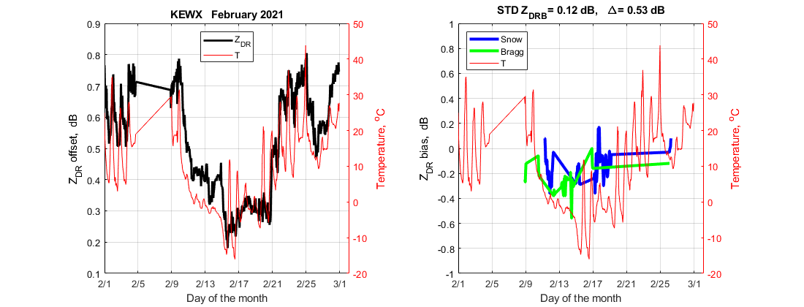
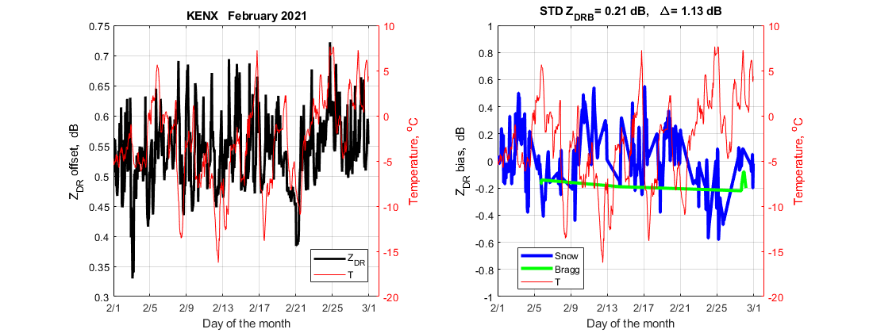
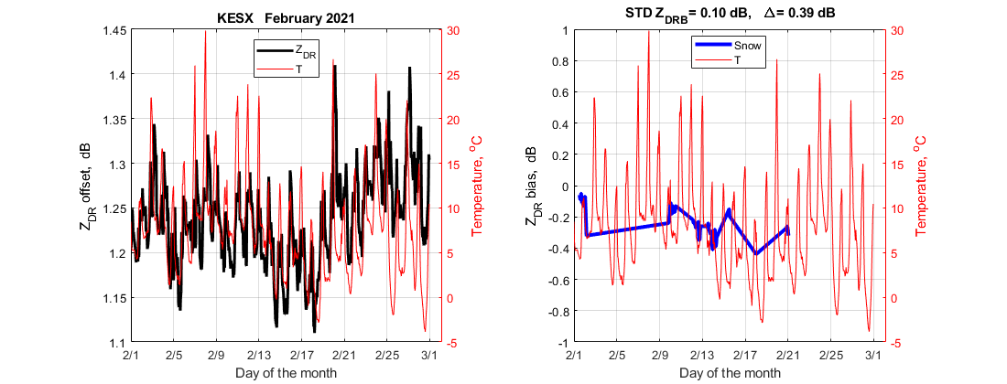
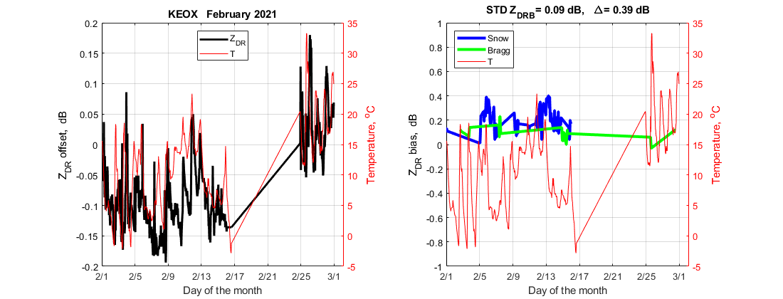
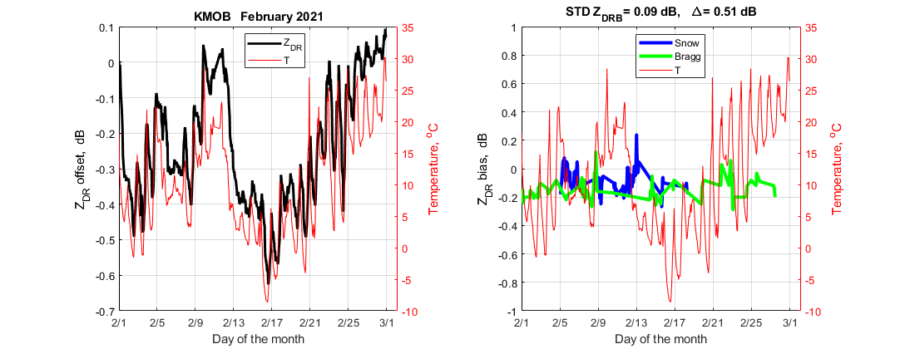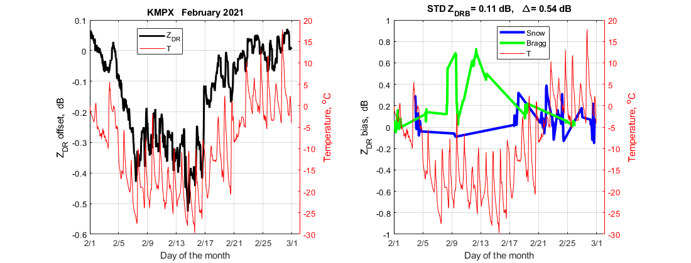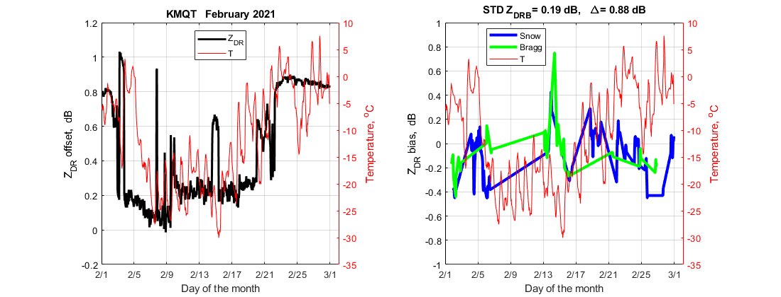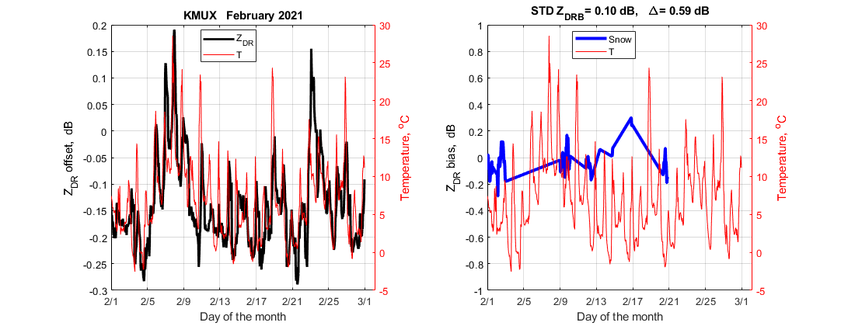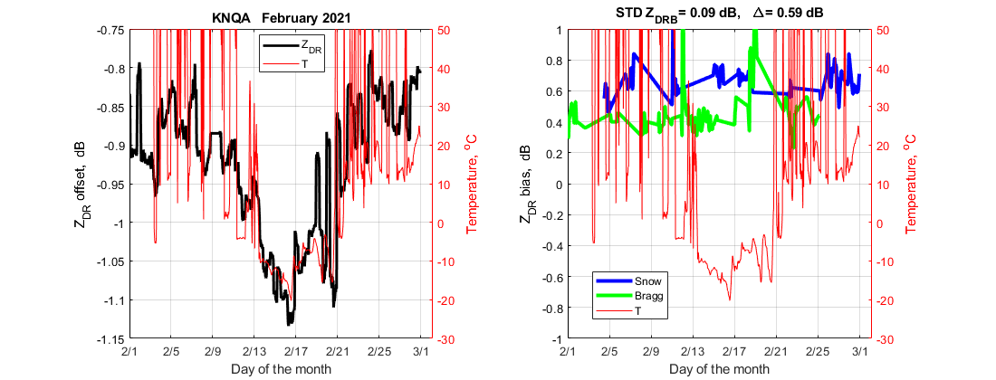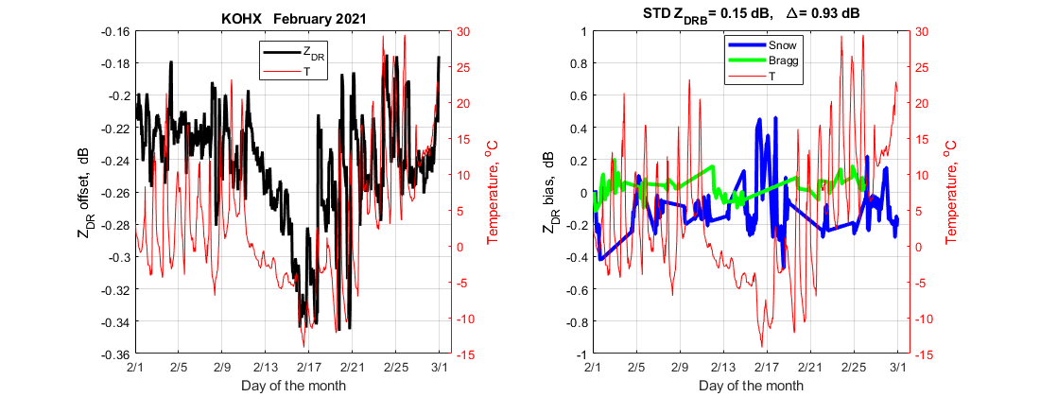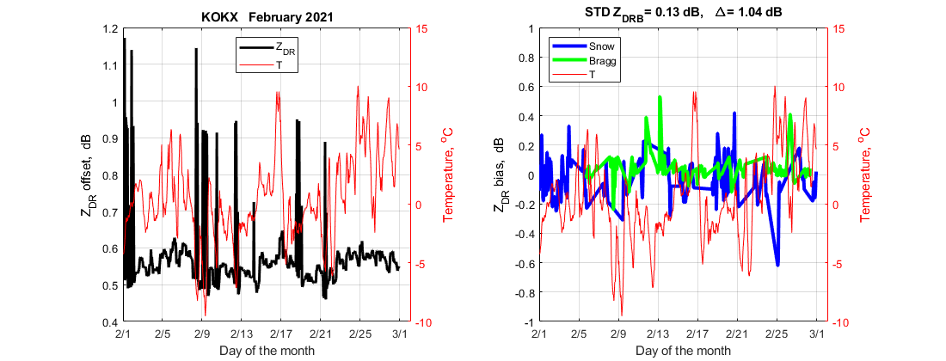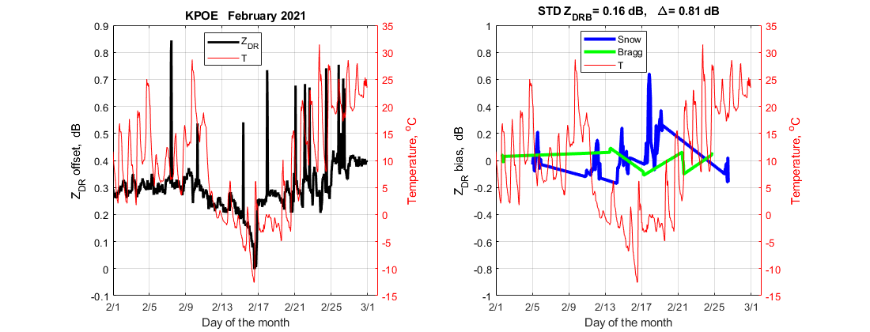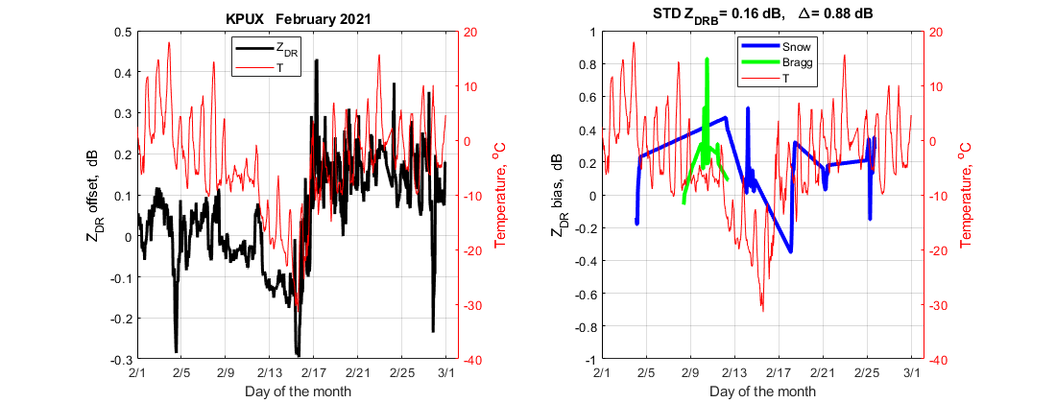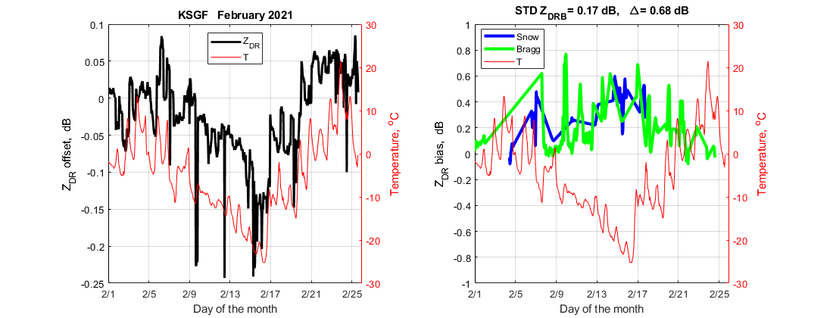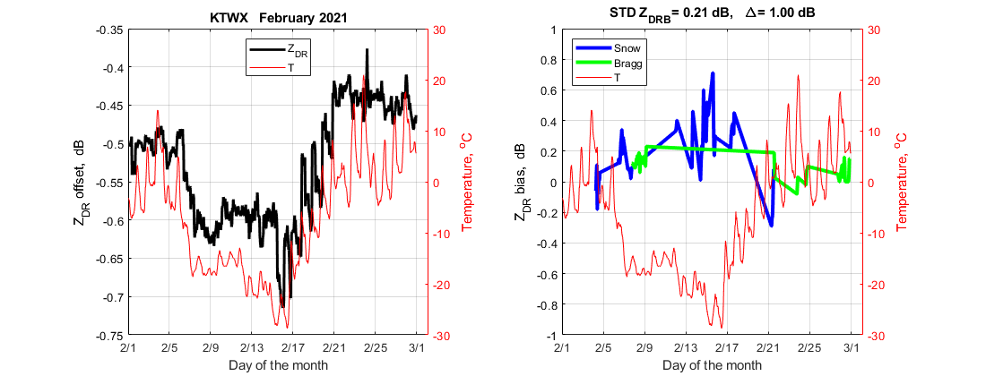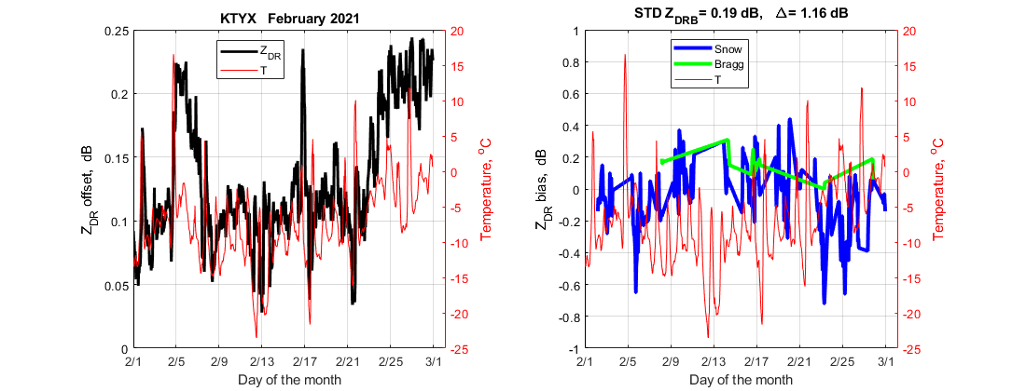
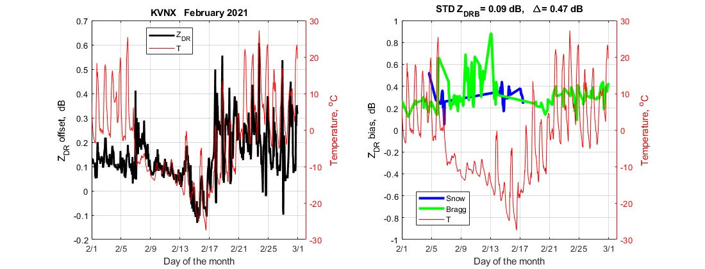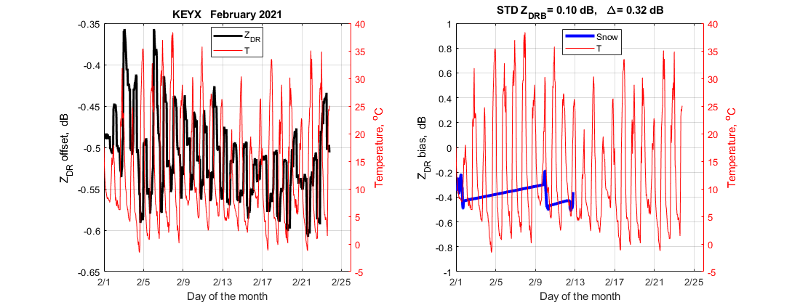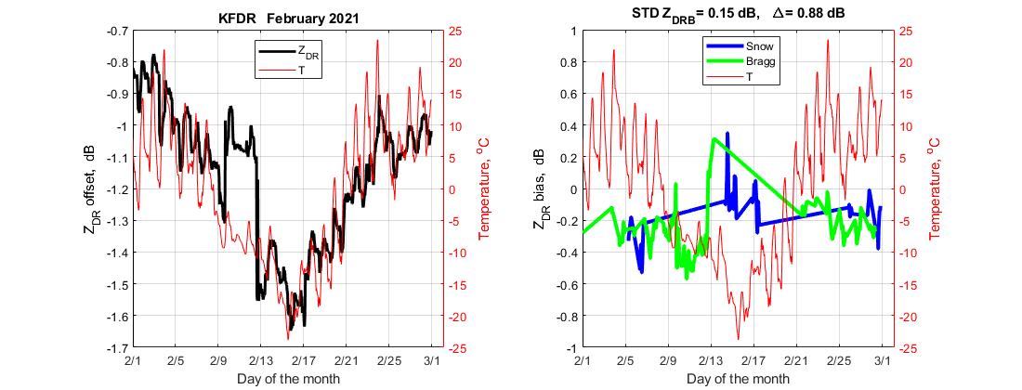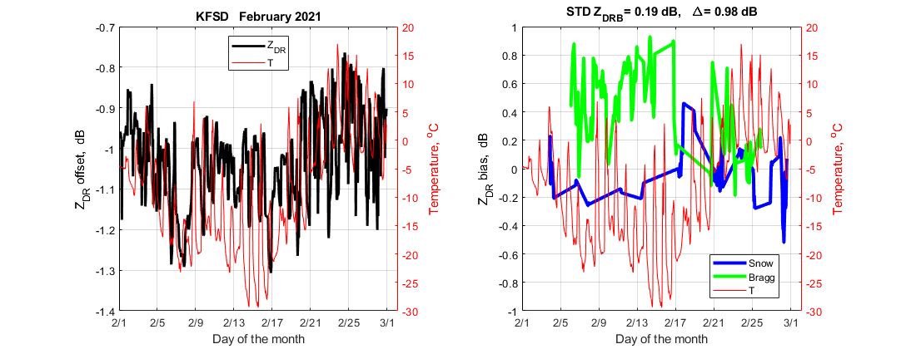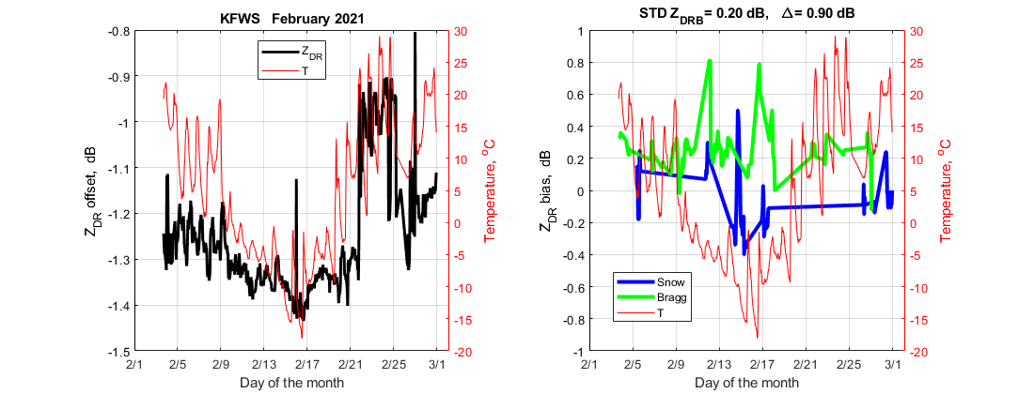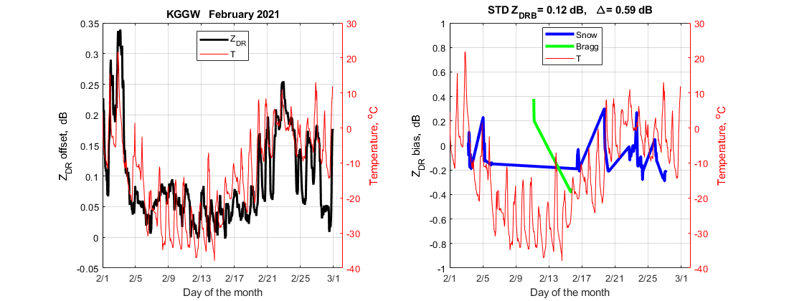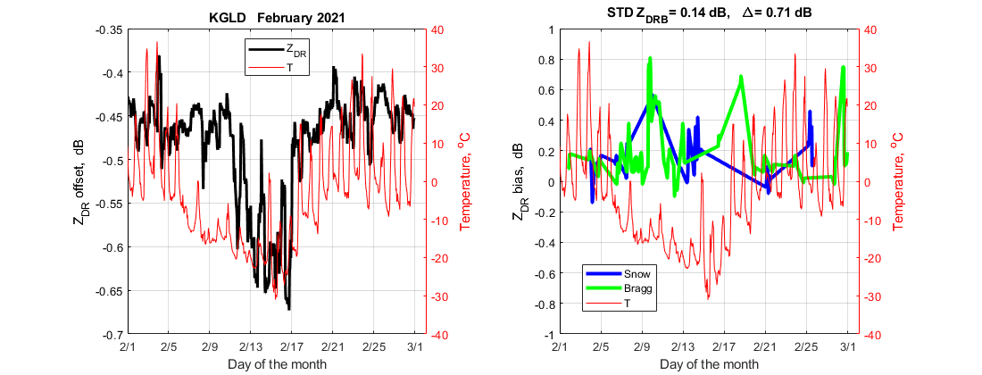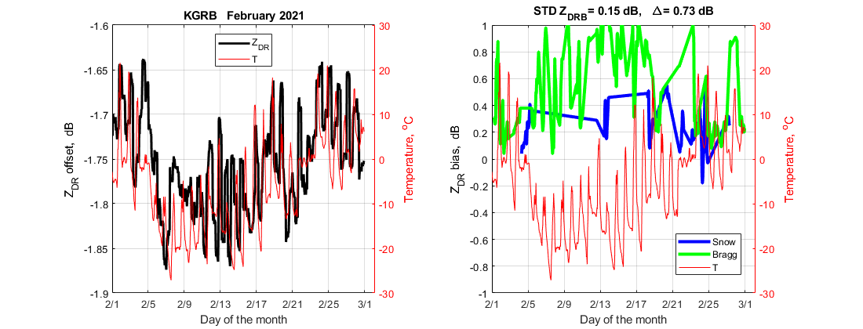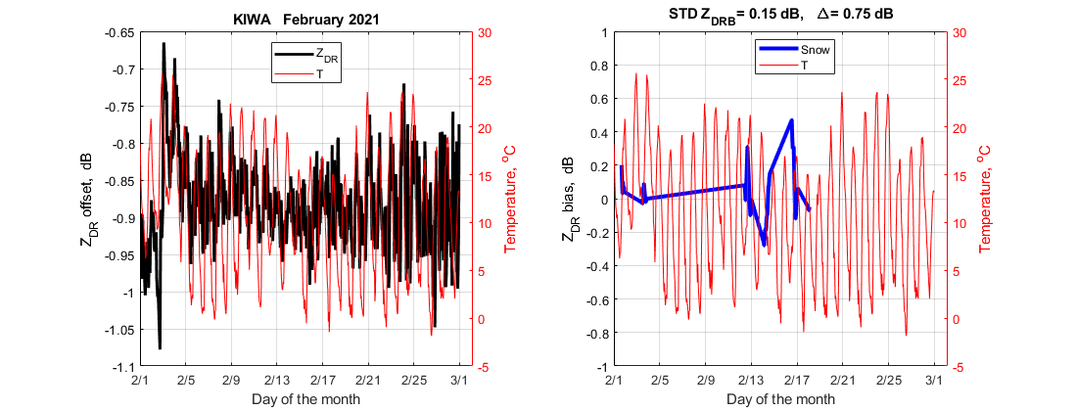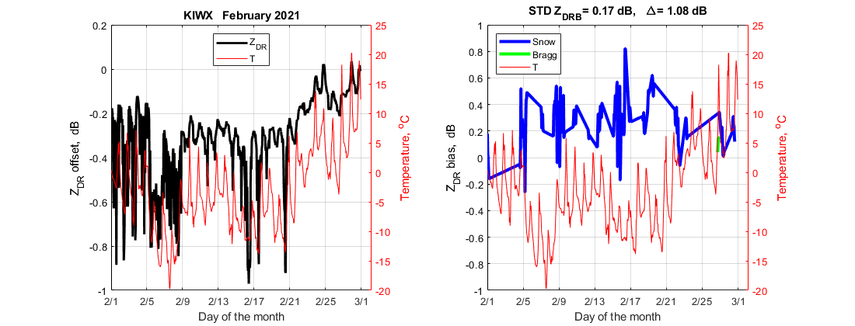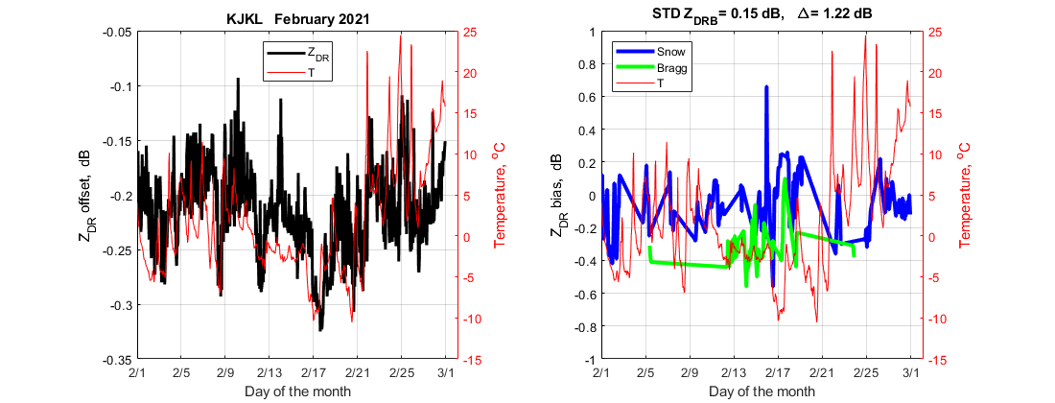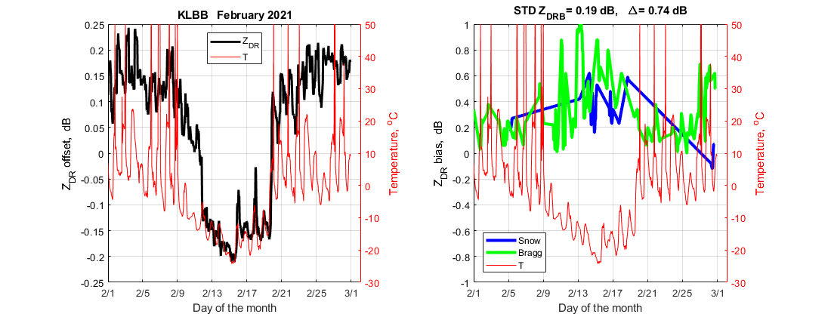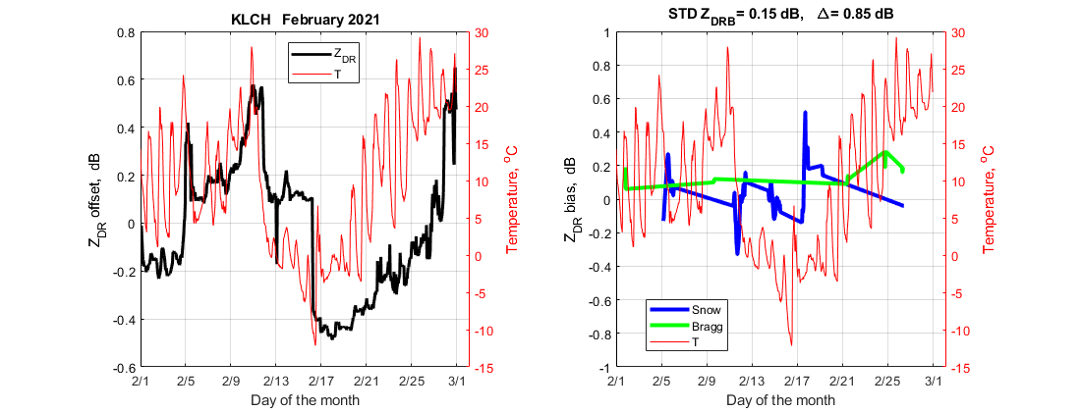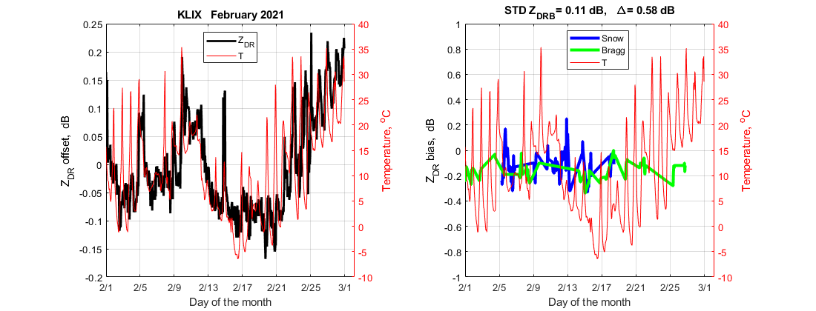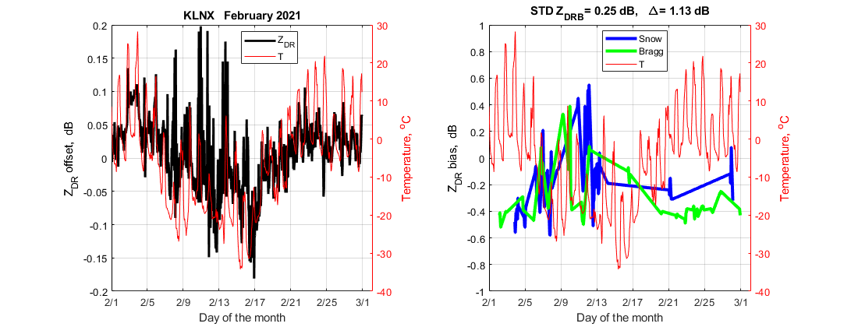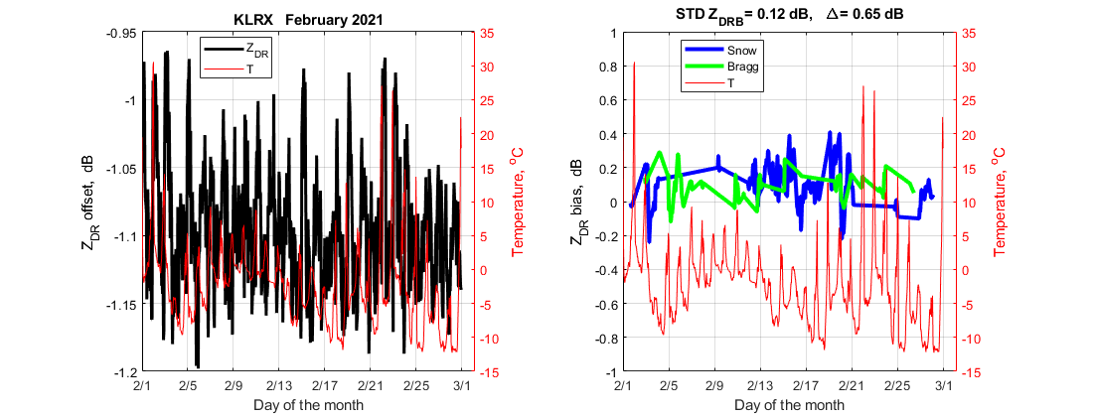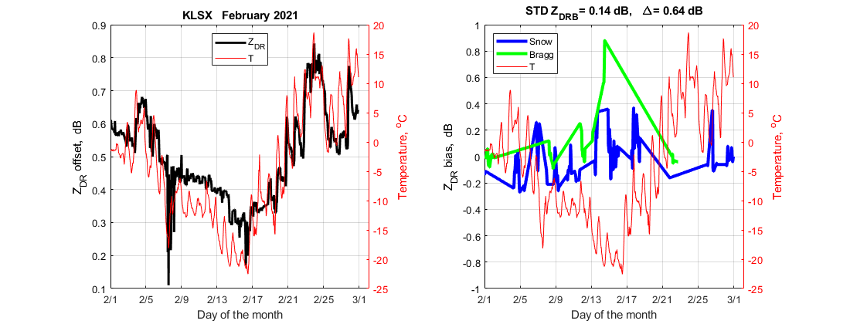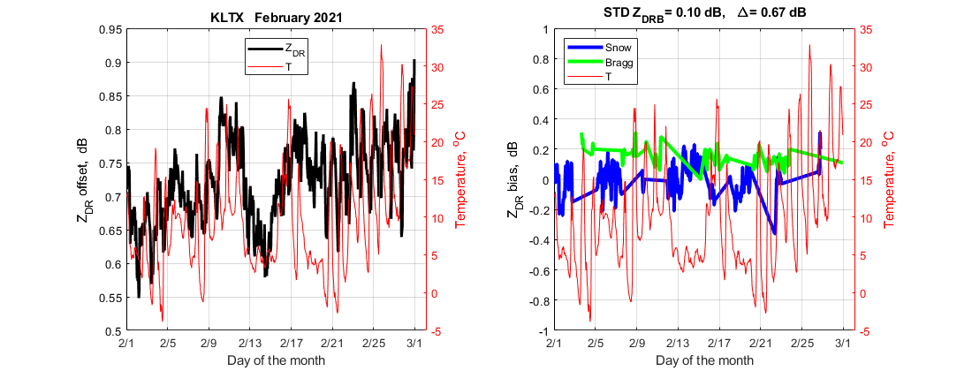

Sites with anti-correlations between ZDR_{off} and temperature
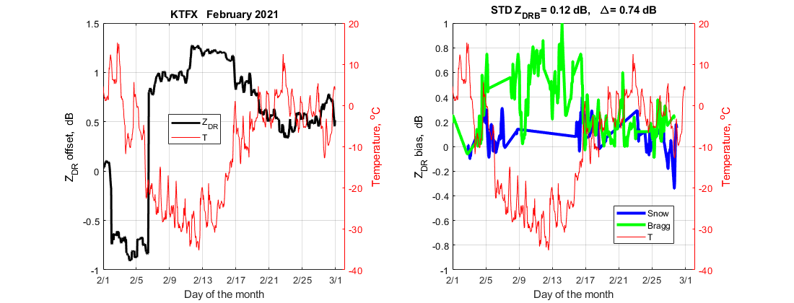

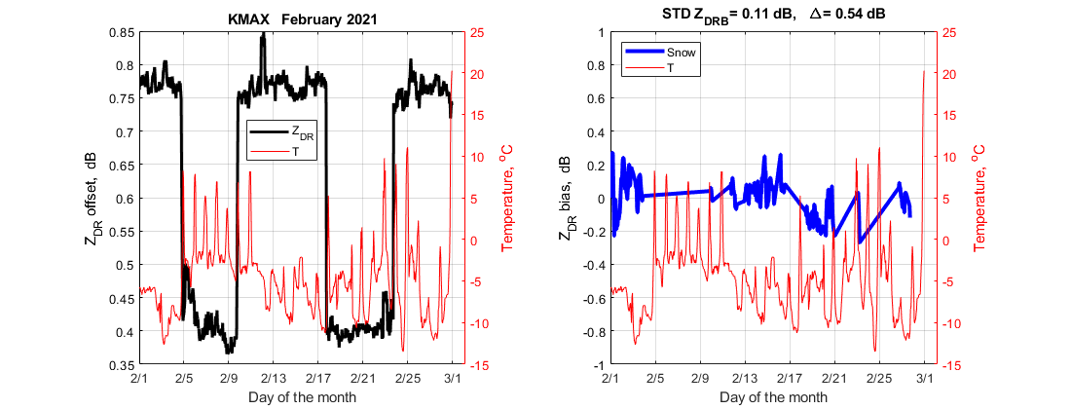
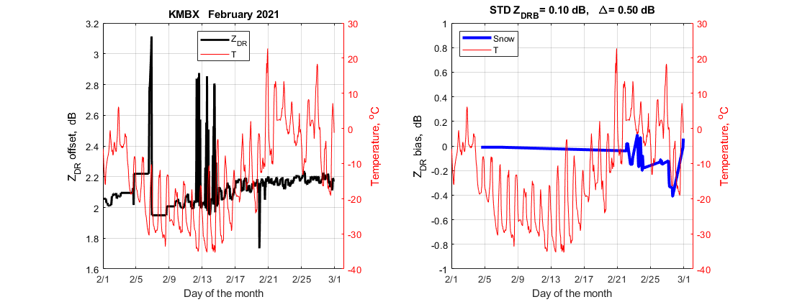
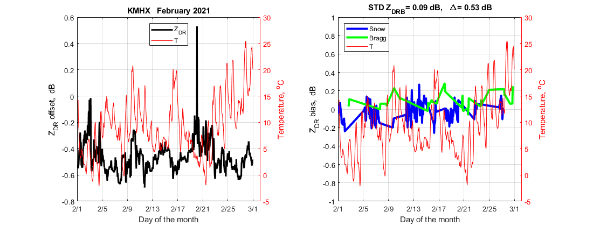
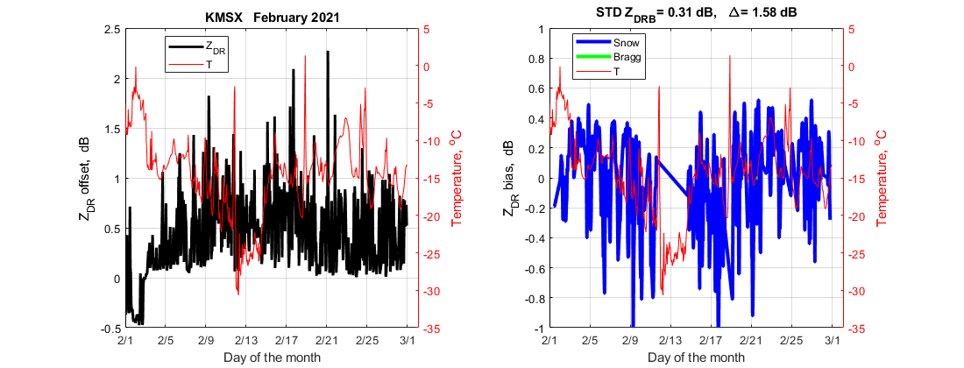
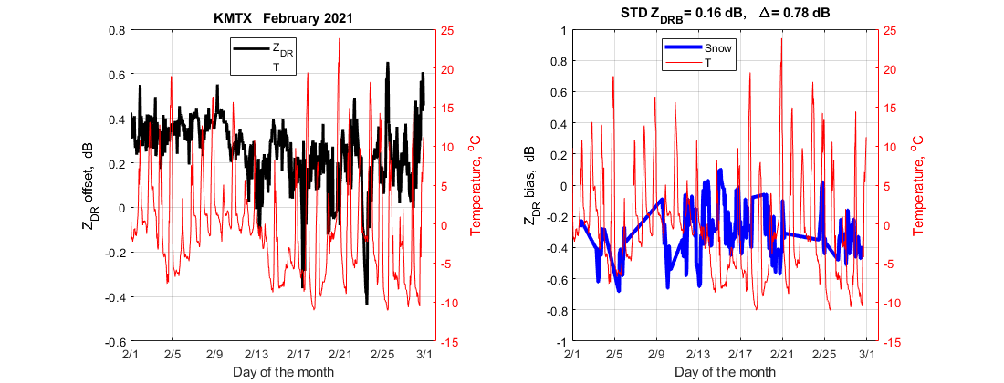
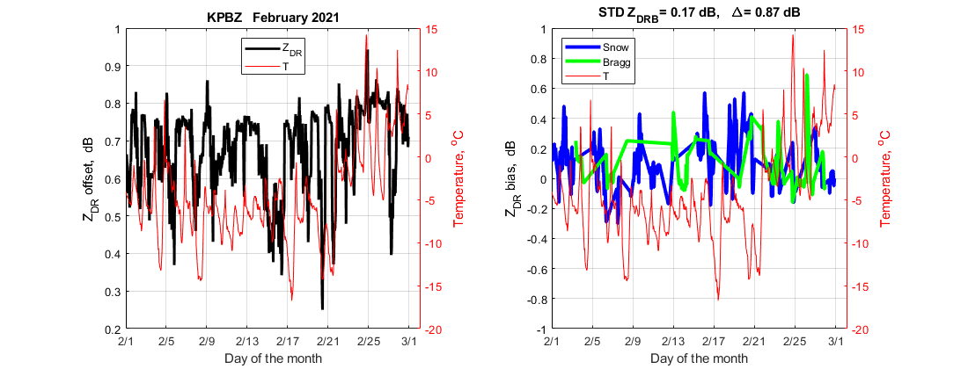
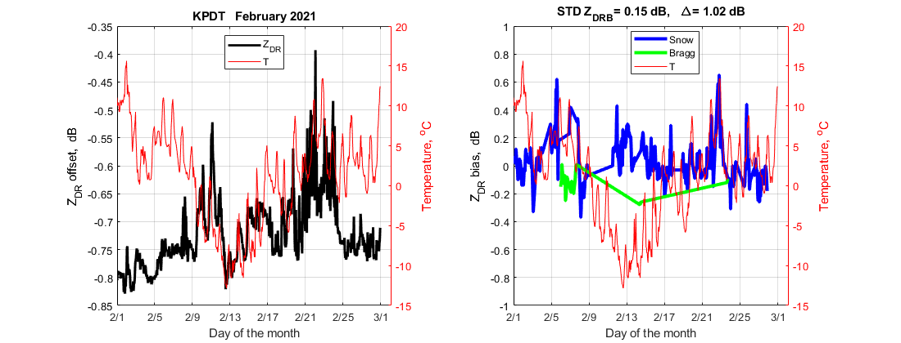
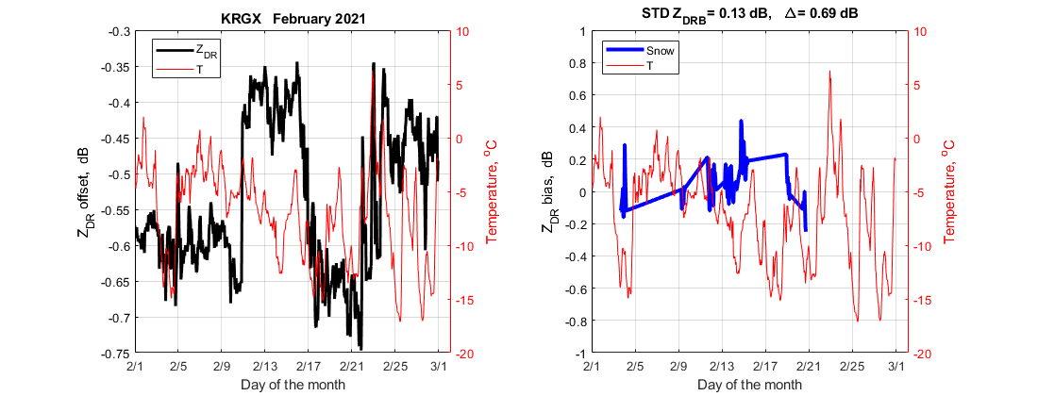
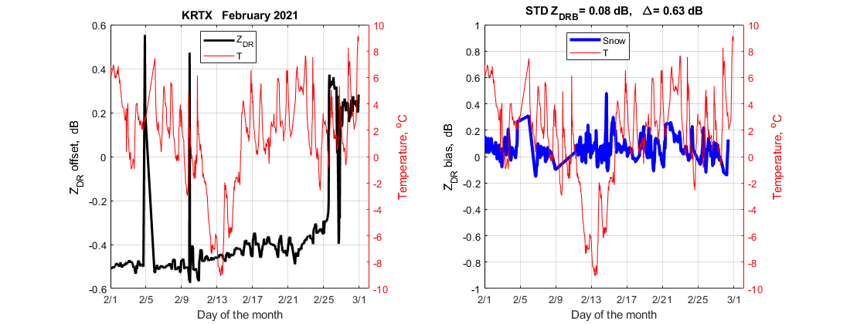
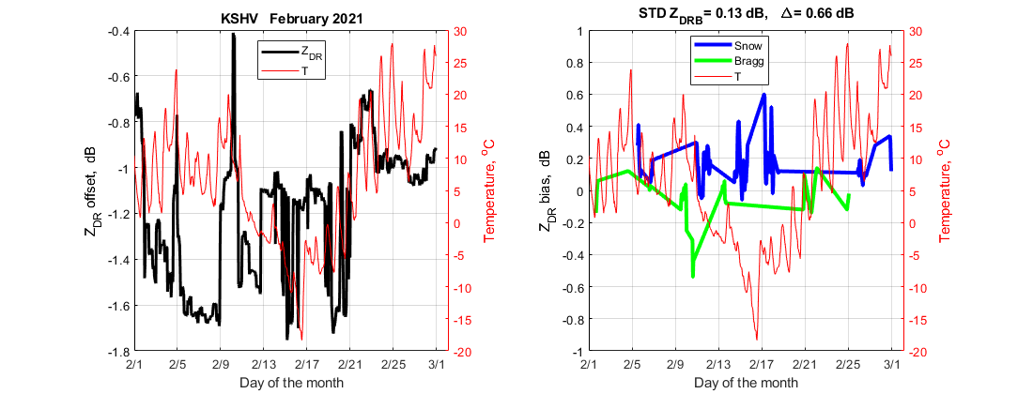
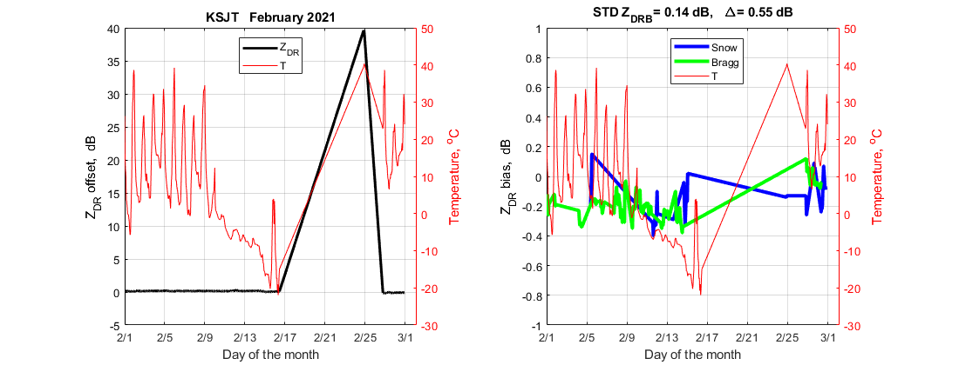
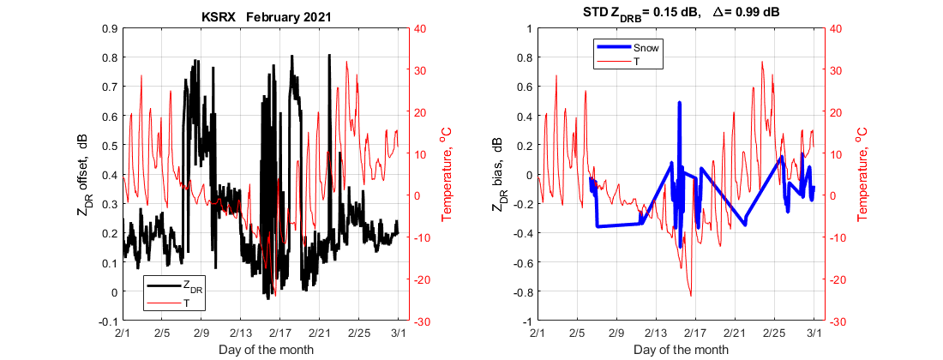

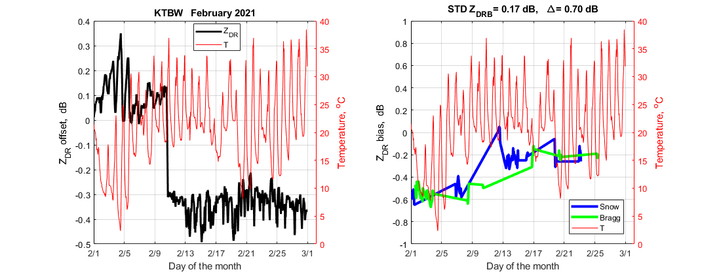
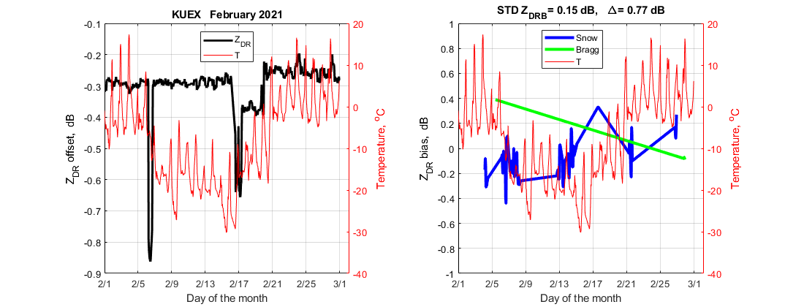
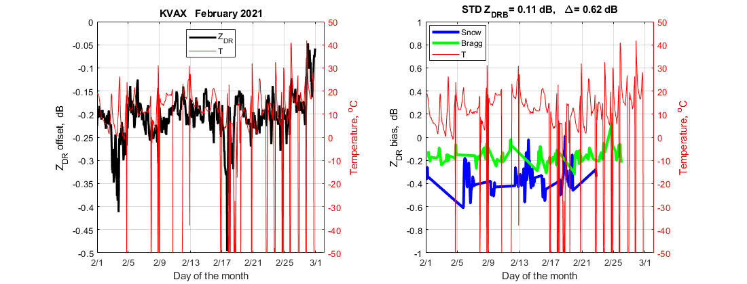
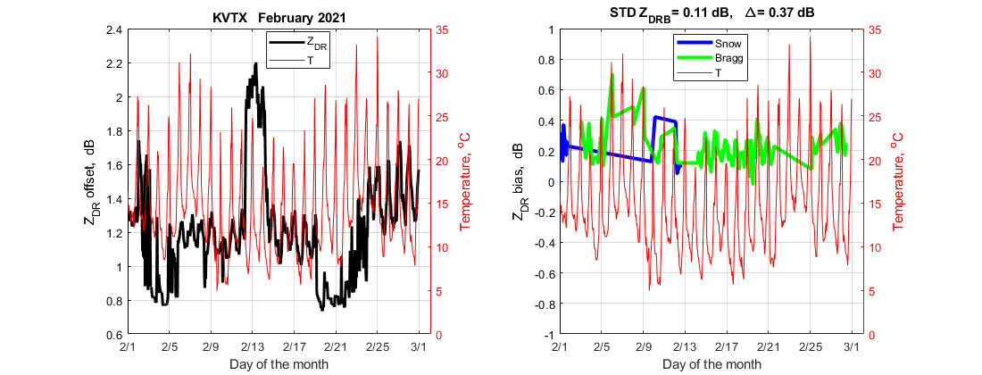
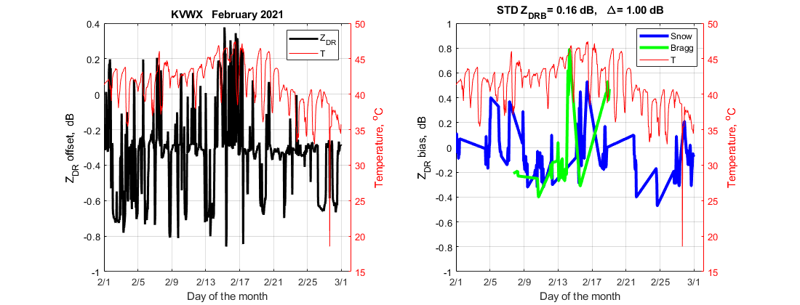
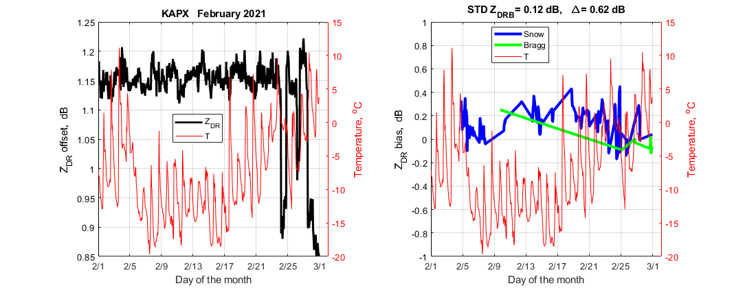
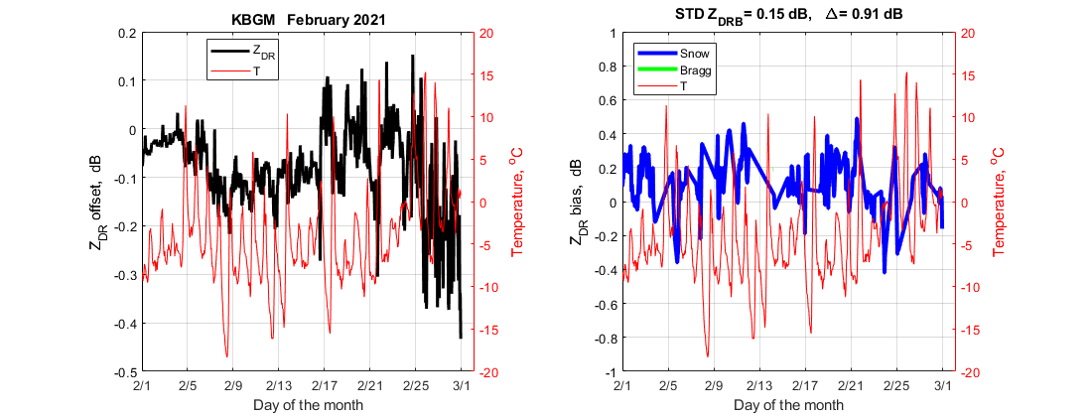
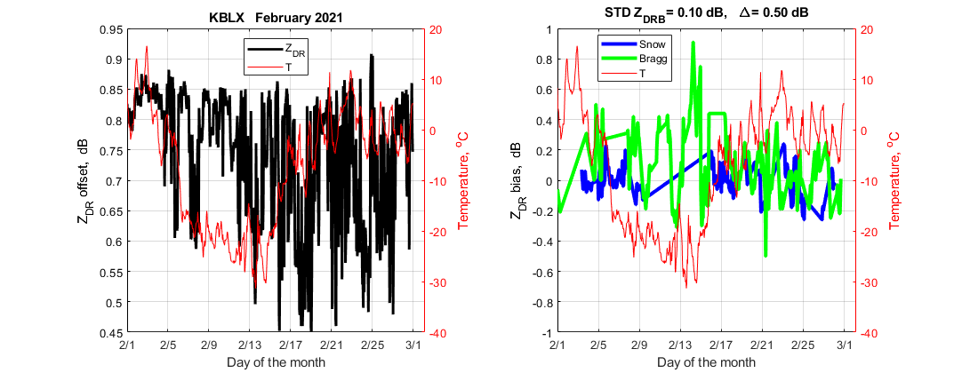
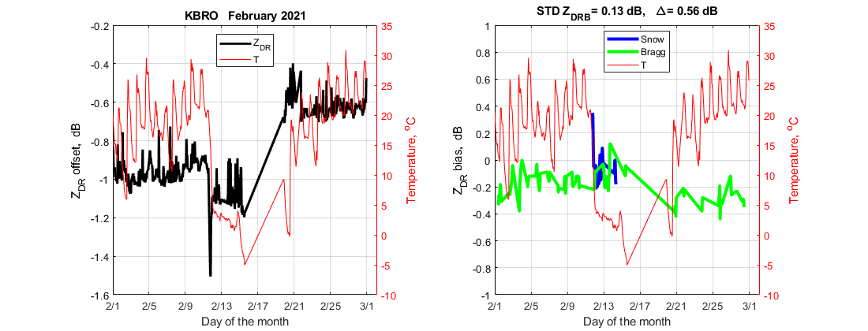
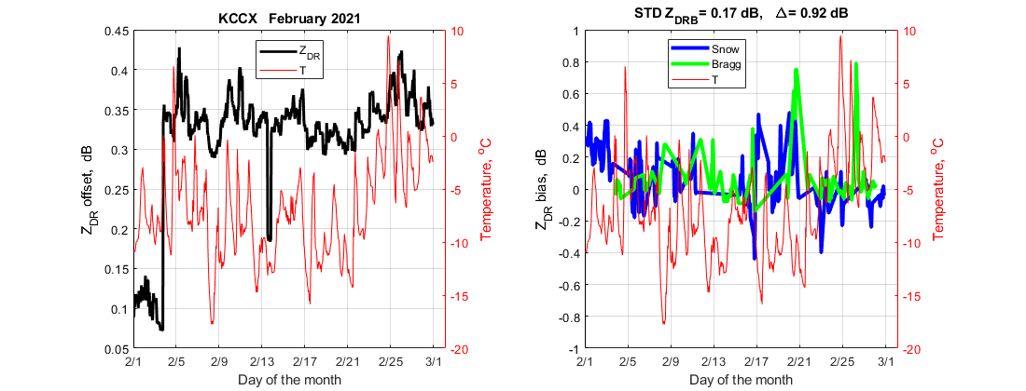
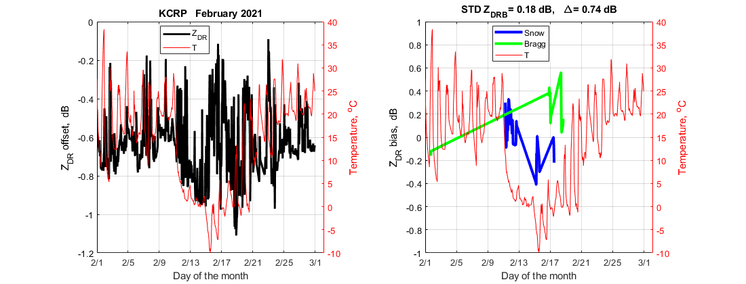

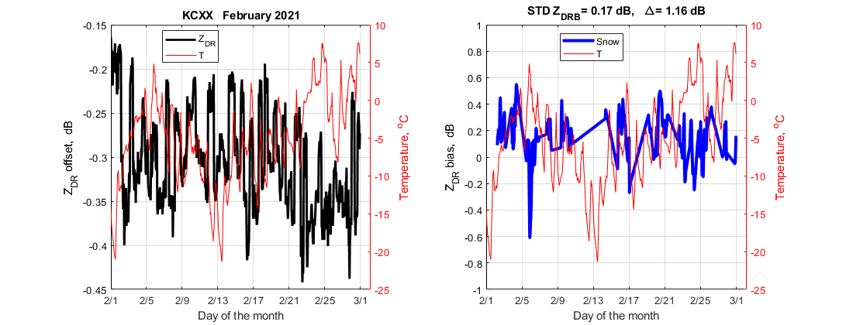

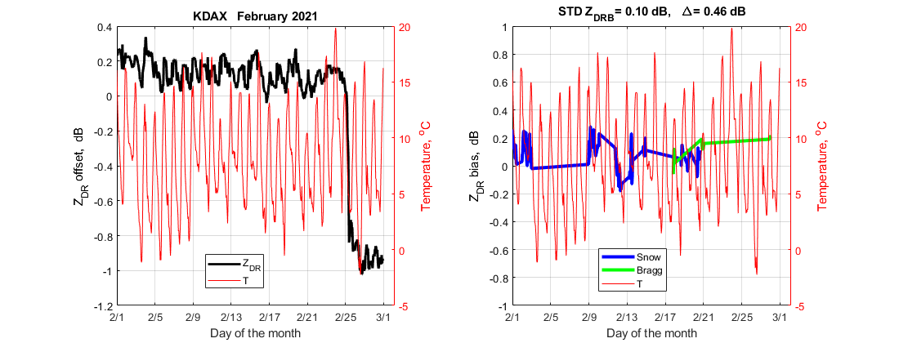
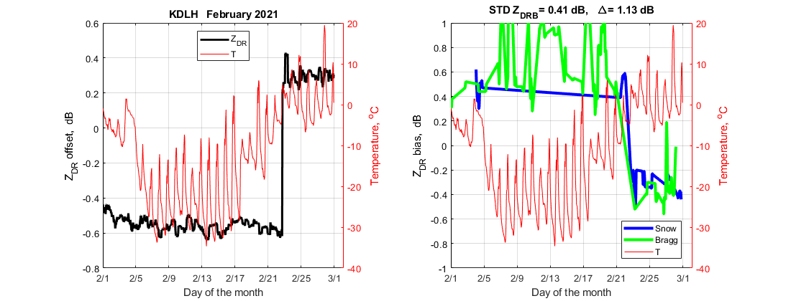
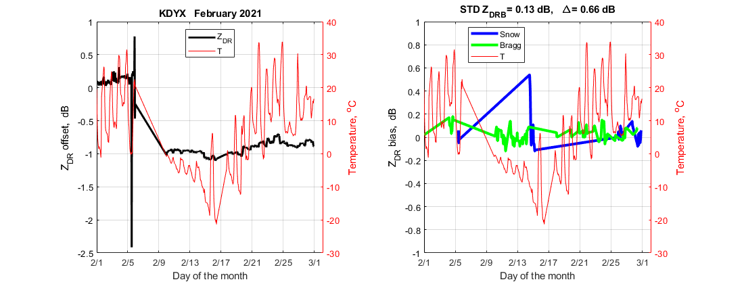
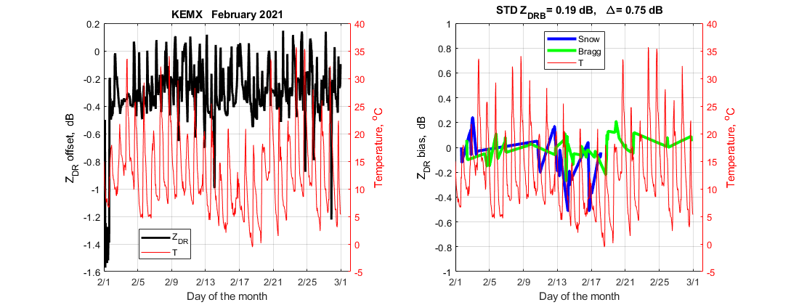
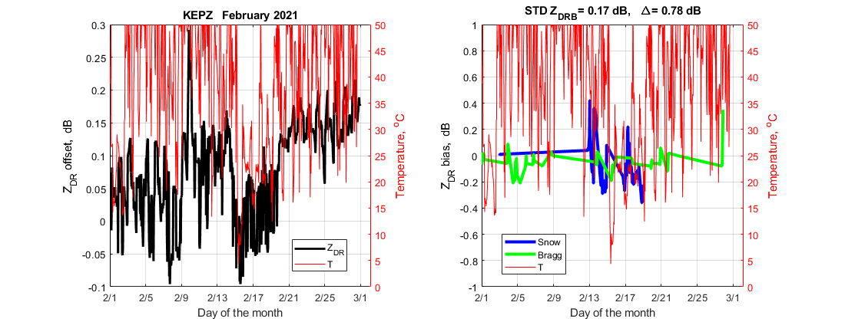
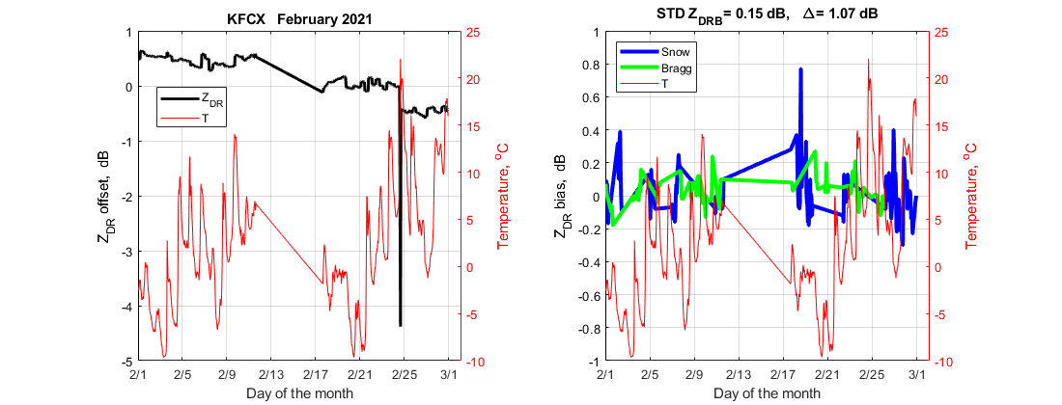
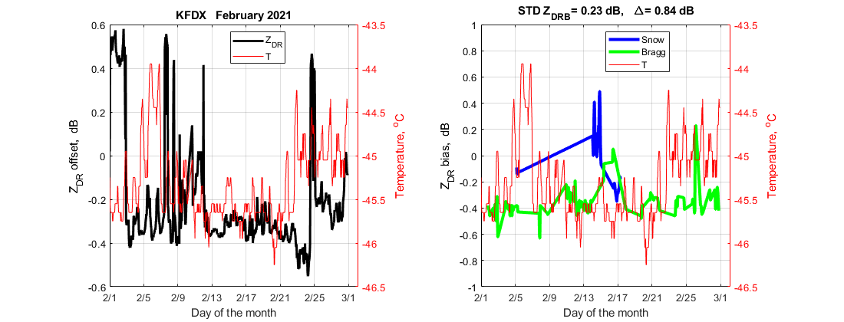
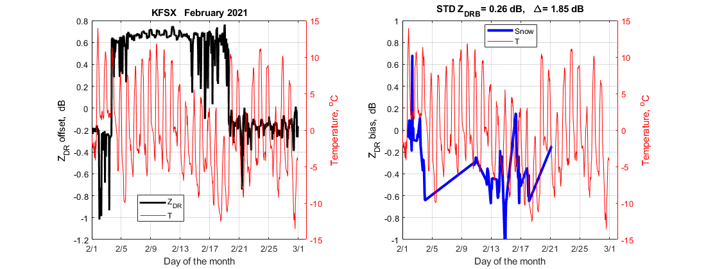
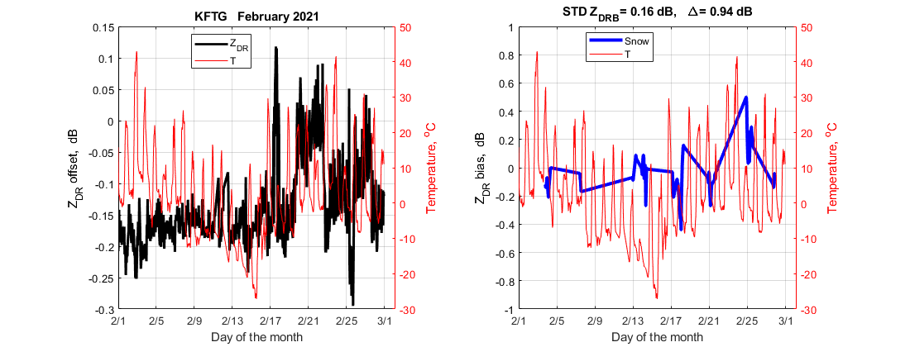
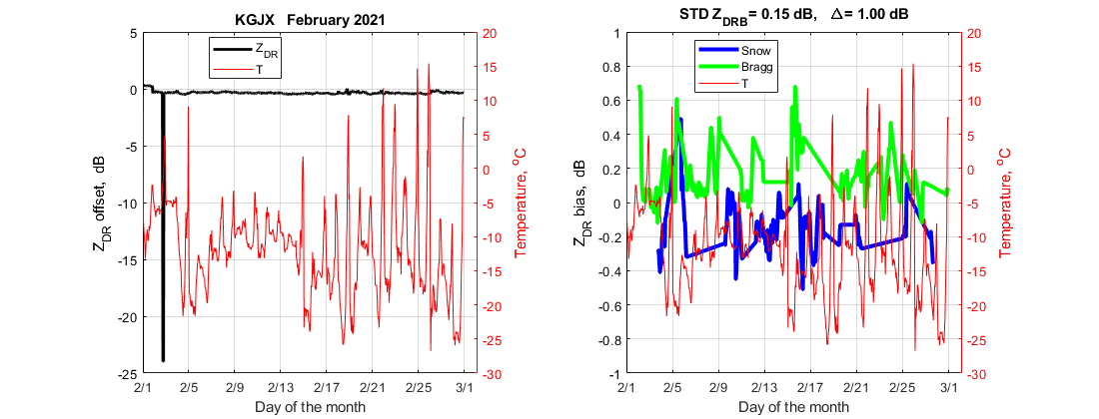
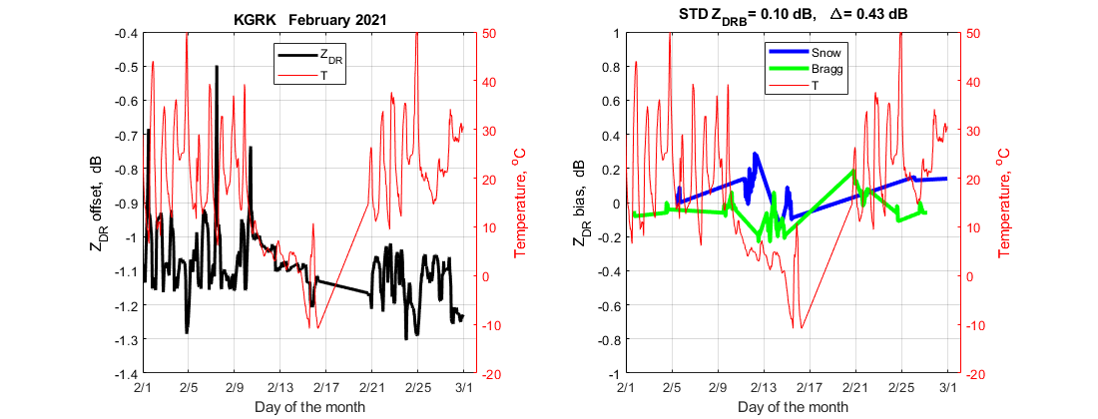
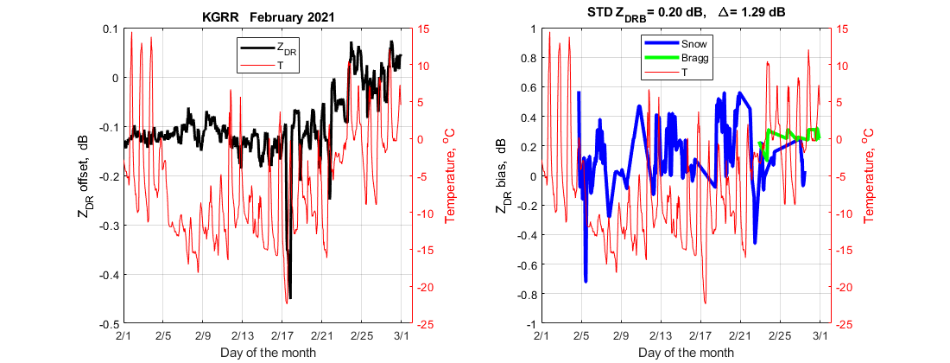
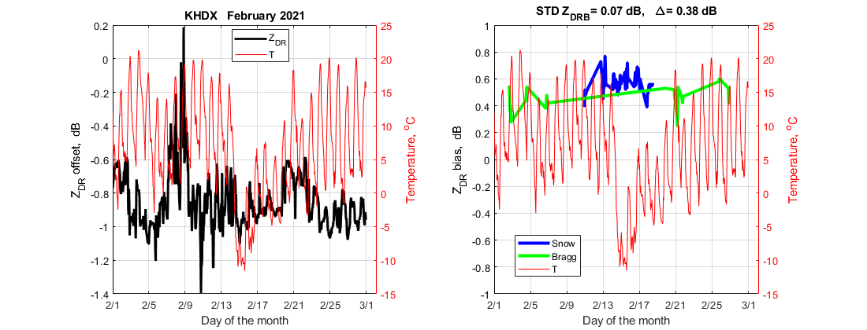
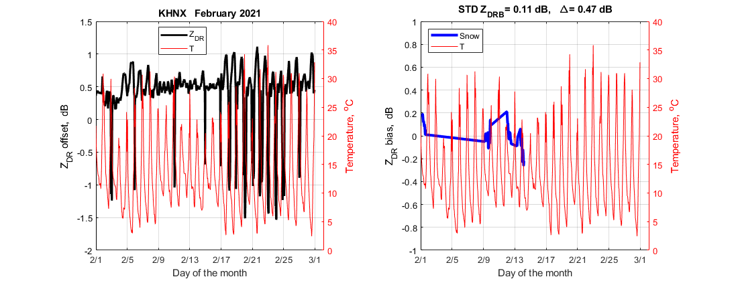
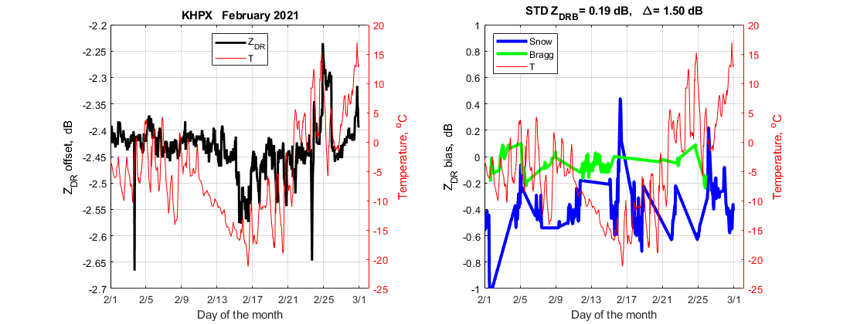
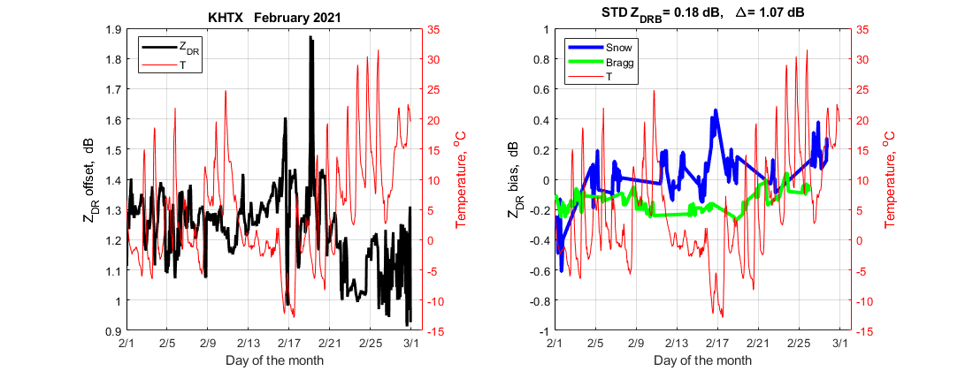
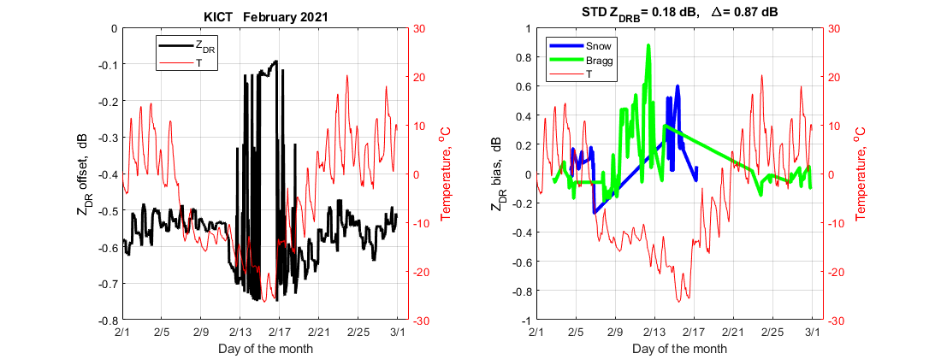
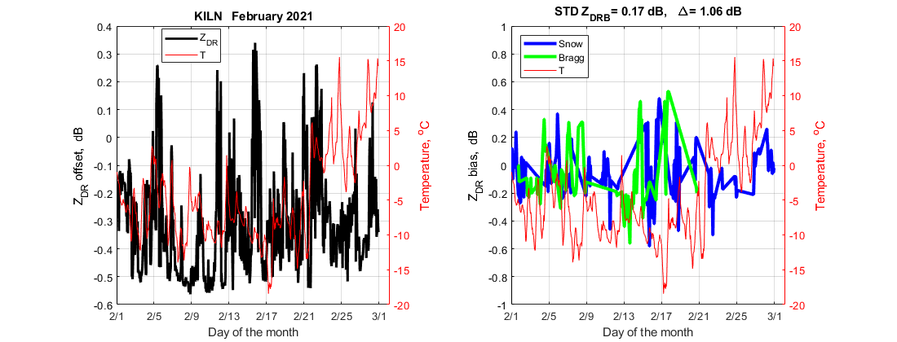
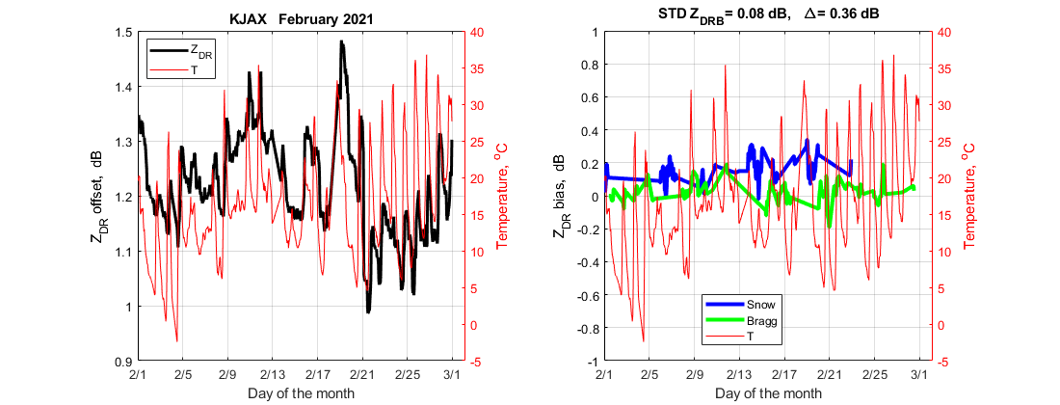
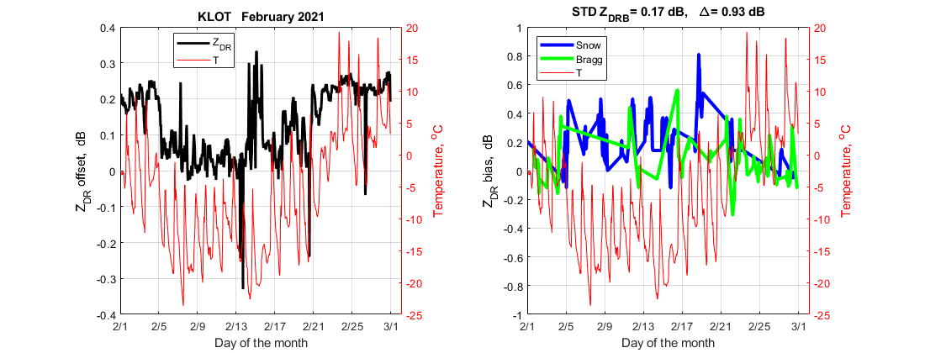
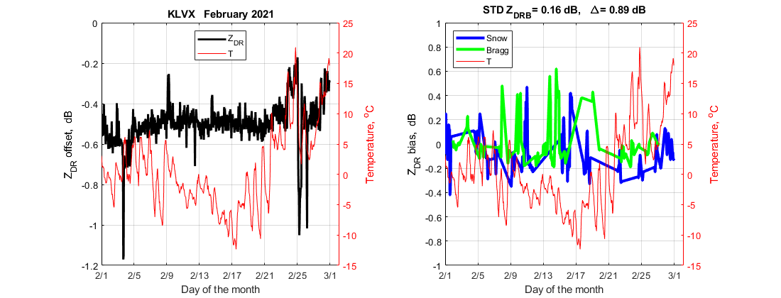
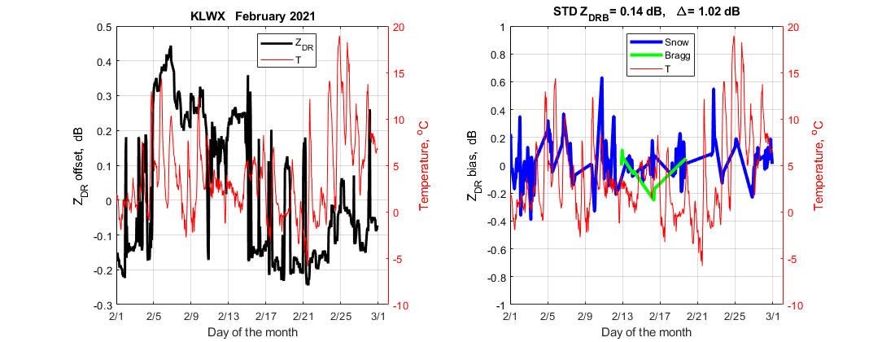
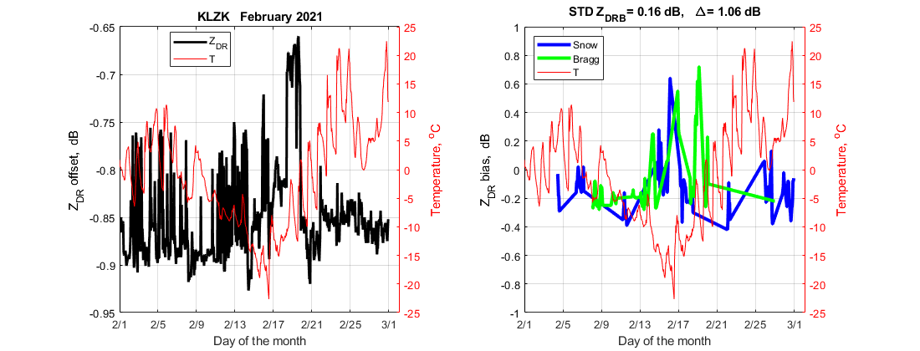
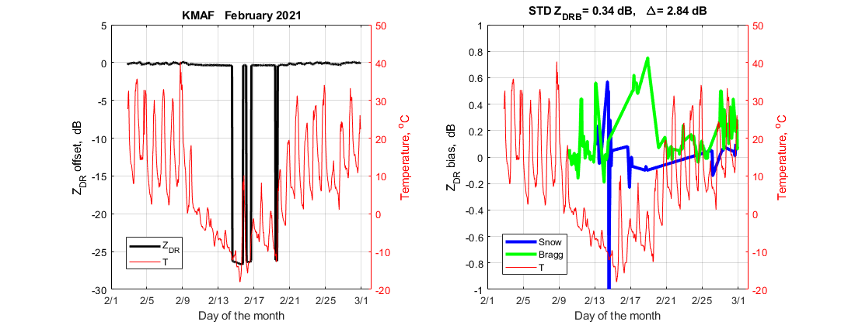
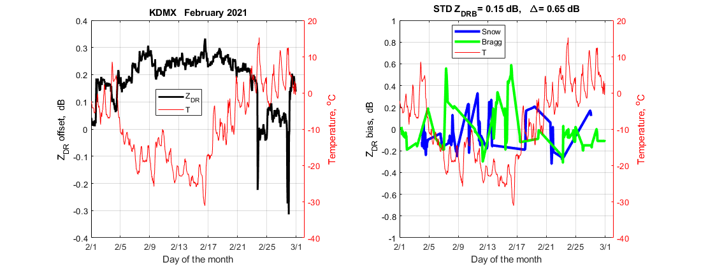

Sites with undetermined correlation between ZDR_{off} and temperature.

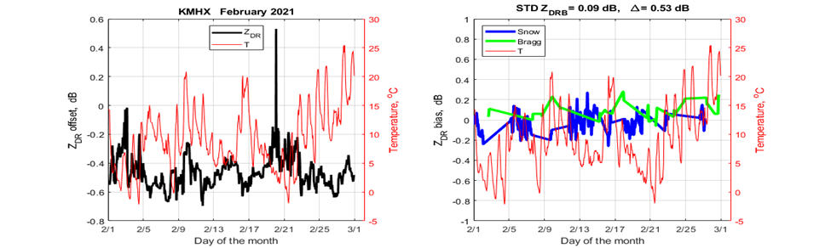

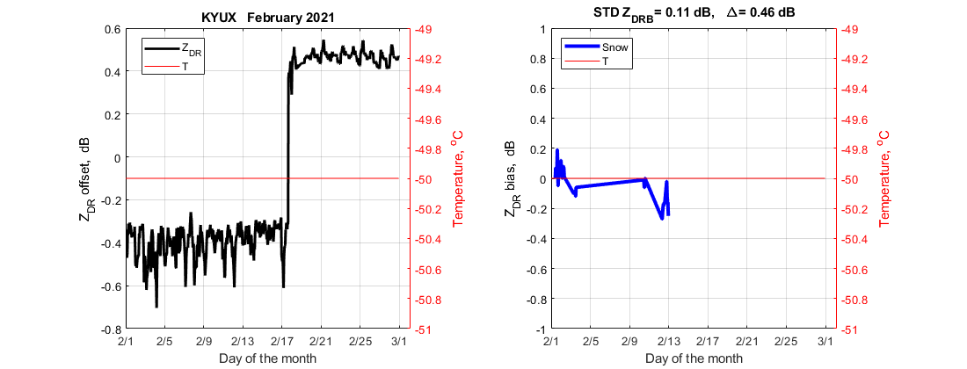

Sites with no temperature impact on ZDR_{off}

